**Transition Metal Free C-C Bond Formation via Ipso Nucleophilic Substitution Reaction on Aryl Benzotriazolyl Derivative by Active Methylene Compounds**

Ankita Paul, Sandip Mondal and Bhubaneswar Mandal*

Department of Chemistry, Indian Institute of Technology Guwahati, Guwahati-781039, India.

E-mail:[bmandal@iitg.ac.in](mailto:bmandal@iitg.ac.in)

**Abstract**

Alkylation of active methylene compound to an aromatic ring is a fundamental requirement in organic synthesis.1 In 1929, Hurtley first reported the C-alkylation of active methylene compounds, such as malonic esters with ortho-substituted aromatic halides using a catalytic amount of copper acetate.2 Recently, a massive exploration has been done in this area of synthesis. Since the transition metal catalyst cross-coupling procedure was discovered, the arylation of active methylene compound became easier than earlier. However, expensive catalyst and ligand requirements, toxic waste, by-product formation, and harsh reaction conditions are the drawbacks of all those protocols. Recently, we have reported the transition metal-free alkylation of active methylene compound on 2,4-dinitrobenzene sulfonic acid with moderate yield.3 Here we have developed a strategy for the arylation of active methylene compound on aryl benzotriazolyl derivative with high yield (upto 98%) in transition metal-free condition. This is a highly efficient protocol for incorporating various active methylene compounds into an aryl benzotriazolyl analog. C-C bond formation occurs by substitution of benzotriazolyl anion.

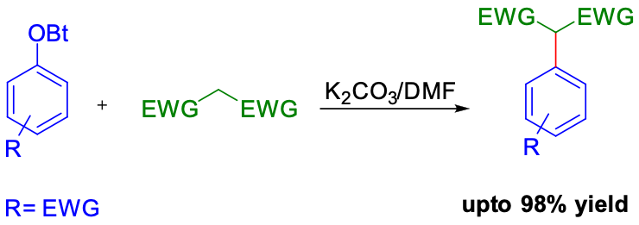

**Scheme 1**: General scheme of arylation of active methylene compound

**Key words:** Ipso-substitution, C-Arylation

**References:**

1. Xie, X.; Cai, G.; Ma, D. *Org. Lett.* **2005**, *7*, 4693-4695.

2. Hennessy, E. J.; Buchwald, S. L. *Org. Lett.* **2002**, *4*, 269-272.

3. Mondal, S.; Dolai, G.; Mandal, B. *ACS Omega,* **2023**, *8*, 1401−1409.