

**Student Academic Board (SAB), Indian Institute of Technology Guwahati, Guwahati, Assam, India**

Spring-assisted speed Adaptive Polycentric knee joint

J.Antonyjefri1, Vaibhav jaiswal2, S. Kanagaraj2

1 Department of Medical Devices, National Institute of Pharmaceutical Education and Research Guwahati, Guwahati- 781101, Assam, India.

2 Department of Mechanical Engineering, Indian Institute of Technology Guwahati, Guwahati-781039, Assam, India.

**E-mail:** [*jantonyjefri007@gmail.com*](mailto:jantonyjefri007@gmail.com)

**Abstract**

According to the 2011 global population data sheet, over 30.6 million persons have a locomotive disability. From that 87% of the individuals have lower extremity disabilities, and 38% of them have above-knee amputations (AKA). For walking, these individuals have to generate 60% more metabolic energy, three times more excess power, and excessive torque from the hip than a healthy individual. Commercially available prosthetic devices can generate functional joint movements equivalent to the human lower limb with a few limitations, such as affordability and variable walking speed. In order to overcome the above limitations, an attempt is made to design and develop an affordable semi-active polycentric knee joint, which is expected to mimic the walking speed of the sound limb of the users. The 2nd generation knee joint developed by IITG is selected to incorporate the proposed work. These functionalities are integrated into the prosthetic knee joint by using a hydraulic damper and the extension spring is in parallel with the damper [Fig.1]. The swing phase and variable walking speed are found to be controlled with the proposed integration. The developed mechanism is expected to provide stance phase stability and knee flexion with speed control without increasing the metabolic cost of the amputee. Nylon and stainless steel are chosen to develop the polycentric knee joint. The static stress analysis is done at P3 (1610N) loading condition as per ISO 10328:2016; the maximum Von Mises stress is observed to be 32.32 MPa, and the safety factor is found to be 1.856 [Fig.2]. The design has been analysed using FEA and the prototype is fabricated.

**Keywords:** SPEED ADAPTIVITY, STANCE PHASE STABILITY, AFFORDABILITY

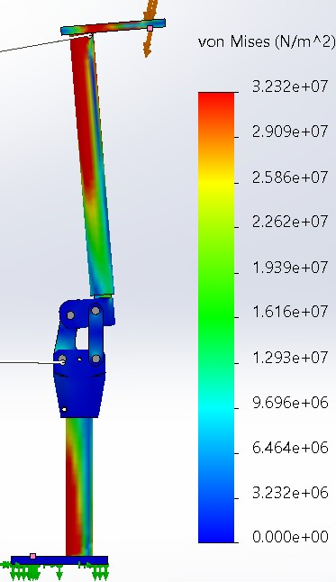

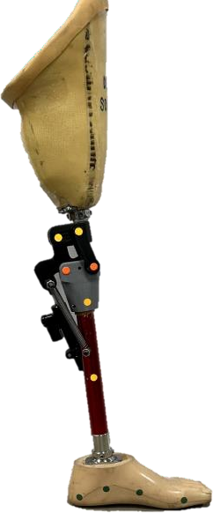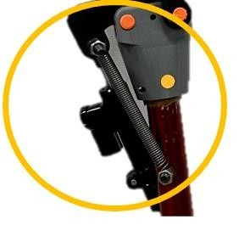

Parallel attachment of damper and spring

Fig. 1. Speed adaptive prosthetic knee joint Fig. 2. Static stress analysis

References:

[1] S.Kanagaraj et al. (2017). *Trends and challenges in lower limb prostheses*. IEEE Potentials https://Digital Object Identifier 10.1109/MPOT.2016.2614756