**An Approach of Source-Sink Mapping for Sustainable Carbon Capture**

**Utilization & Storage (CCUS) and CO2-EOR in Assam Shelf Basin**

Anupam Jyoti Dutta1, *Dr. Ranjan Phukan2

1,2 Department of Petroleum Technology, Dibrugarh University, Dibrugarh, Assam

Email: 1*anupamjyotidutta@gmail.com,* 2*r.phukan@dibru.ac.in*

**Abstract**

CCUS, which stands for carbon capture utilization and storage, encompasses a range of technological solutions that can have a wide-ranging impact on achieving global energy and climate objectives.Carbon dioxide for enhanced oil recovery (CO2-EOR) can significantly increase oil production while keeping a consistent amount of the CO2 injected in the reservoir sequestered, which is advantageous for lowering greenhouse gas emissions. The appropriate integration of sources and sinks is essential for the effectiveness of CO2-EOR sequestration. A rigorous analysis of earlier literature suggests that sedimentary basins in India, especially the Assam Shelf Basin, have strong prospectivity for CCUS. However, until recently, little attention had been paid to the CO2 source-sink mapping in the Basin. The literature also lacks the mapping of basin oil fields that are appropriate and their quantitative evaluation for CCUS application on a reservoir-by-reservoir basis.

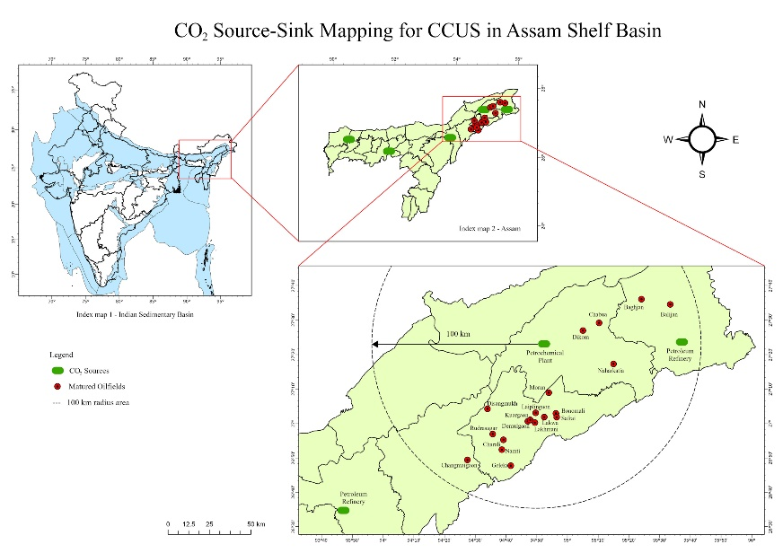 The methodology employed in this study was broken down into three steps: choosing the best CO2 sources, choosing the right sinks, and creating links between sources and sinks. The selection process involves data collection and criteria development to score and rank potential CO2 sources that can be captured and transported for injection. On such basis, the most attractive source considered is a large petrochemical plant capable of supplying up to 0.1 Mt CO2 per year. Selecting the best sink involves compiling a list of probable CO2 EOR sites and their related CO2 storage capacity, followed by screening and ranking using specially developed criteria. Reservoirs are initially screened based on their intrinsic reservoir and fluid properties (including API gravity, MMP, reservoir pressure and temperature, and Sor). The performance of the screened reservoirs' CCUS compatibility was further assessed based on their estimated incremental oil recovery and CO2 storage potential. The lists of independently scored and ranked sources and sinks utilized for the source and sink linkage. Some other important factors to consider during making links for source and sink are administrative boundary, road network, field location, and pipeline network. Oil fields that have been ranked are matched to CO2 source by plotting into the geographical information system (GIS) on the Map Info platform as shown in the figure below. 19 matured oilfields were recognized accordingly within a range of 100 km from the CO2 source. Further, the selected oilfields can be evaluated for CO2 storage capacity and its potential recovery under EOR.

**Student Academic Board (SAB), Indian Institute of Technology Guwahati, Guwahati, Assam, India**

**Student Academic Board (SAB), Indian Institute of Technology Guwahati, Guwahati, Assam, India**

Figure: CO2 Source-Sink Mapping for CCUS in Assam Shelf Basin

Keywords: CCUS, CO2-EOR, Source-sink, Oil Recovery, Storage Capacity