**IoT based Flood Monitoring & weather monitoring System**

* **INTRODUCTION**

Flood is one of the major well-known Natural Disasters. When water level suddenly rises in dams, river beds, city etc. A lot of Destruction happens at surrounding places. It causes a huge amount of loss to our environment and living beings as well. So, in these cases, it is very important to get emergency alerts of the water level situation in different conditions in the river bed, lake, wetland, smart city, ponds etc.

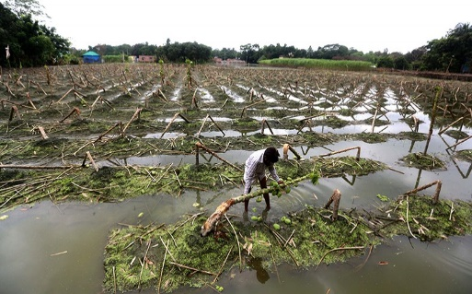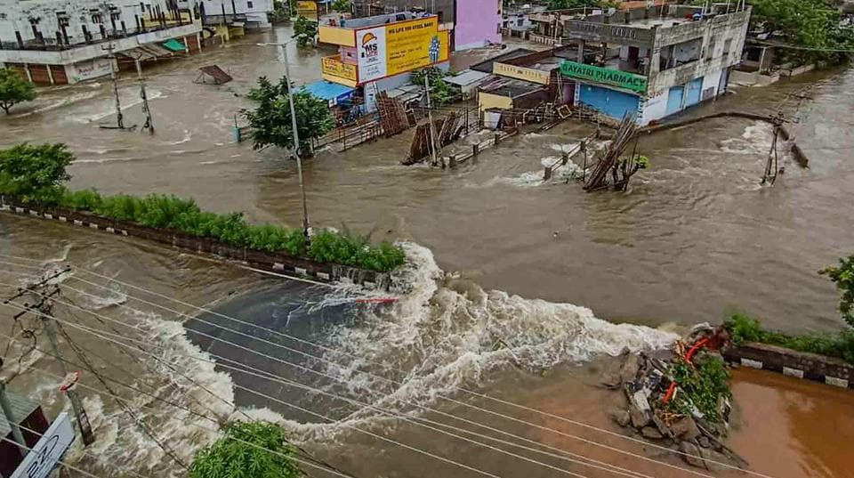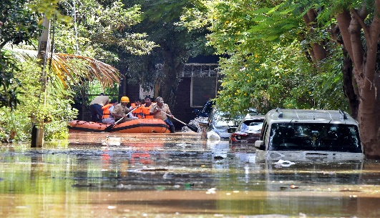

Bangalore

Agriculture crops

Assam

* 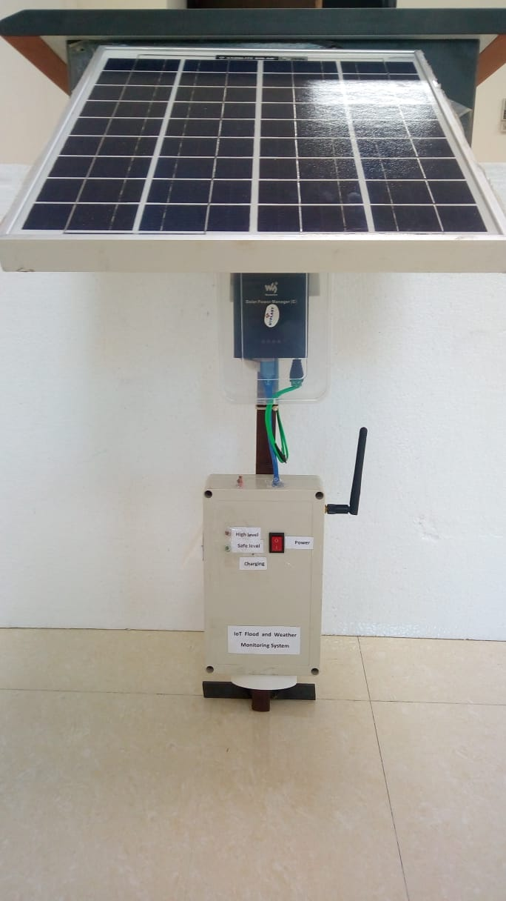**System overview**

The purpose of this device is to sense the water level in river beds and check if they are in normal condition. If they reach beyond the limit, it alerts people through internet and mobile alerts when the water level reaches beyond the limit. This device is based on an IoT Sensor Network. It is able to detect the water level every 30 second interval and rapid changes of the water present in the lake, rivers, wetlands, and ponds so that wide-area monitoring is possible.

Benefits –

* Early flood and weather prediction/forecasting
* Disaster management, water monitoring,
* Smart city, irrigation, and optimal use of water resources where their availability is low or high.
* A**RCHITECTURE AND OPERATION**

This system is using modern “Internet of Things” (IoT) technologies today available, detects information about presence and real-time availability of water resources in the area where WSN-based monitoring system is installed and sends the detected data, also relative to environmental parameters, to the nearby tablets and smartphones that uses developed application. By means of a tablet or smartphone, moreover it’s possible to share information read from each sensor with all users who use the same website, through peer to peer Wi-Fi connection or any other Internet connection.

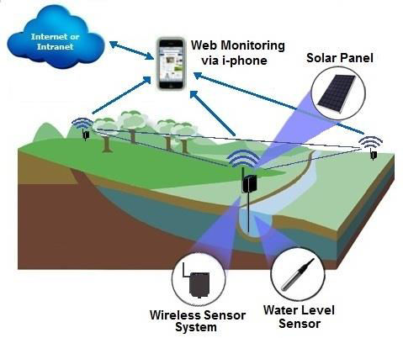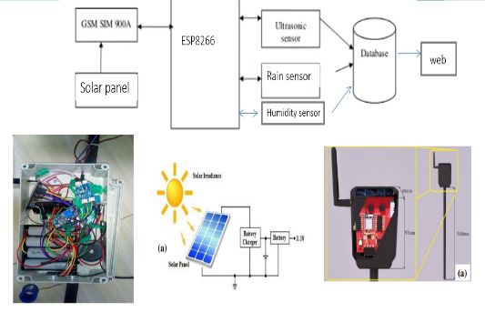

In this system Ultrasonic sensor to sense the water levels and Rain sensor will see the condition of rain and Humidity sensor measure weather condition. Microcontroller to process these data. The data will be uploaded to IoT cloud, then we can monitor from anywhere in the world.

Schematic diagram

* **Technical specification and Design:**

***Specifications:***

* Connectivity : Wi-Fi or 2G/3G SIM
* Power: solar or 5v ,2A DC Supply
* Battery :8000mah Lithium Ion
* Temperature : 0-50°C / ± 2°C
* Humidity : 20-80% / 5%
* Pressure : 300 to 1100 hPa

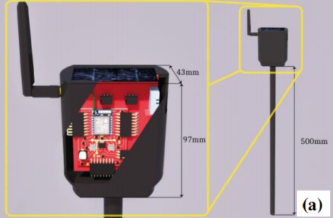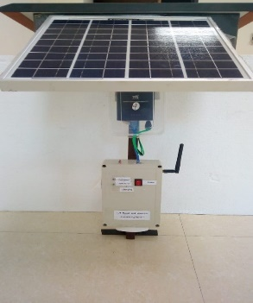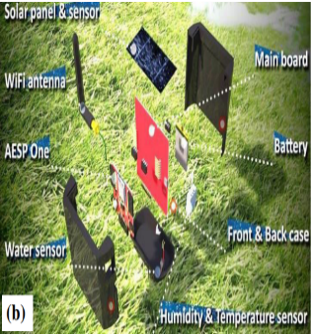

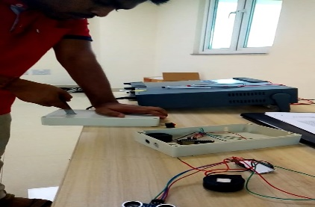

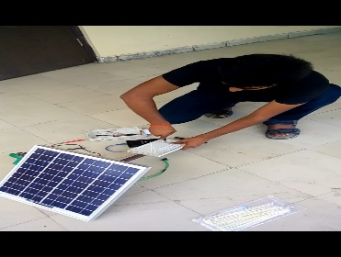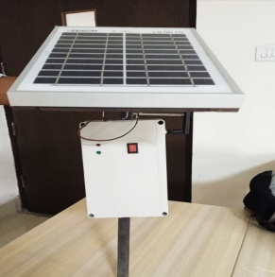

Fabrication

* **TESTING IN LAB SCALE:**

The developed flood monitoring and early warning system that utilizes ultrasonic sensor to detect water level, humidity, temperature, atm. pressure functions perfectly according to the specification. It successfully passed several tests based on the different parameters. As you can see the result in the below in website-based data.

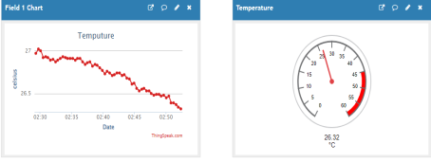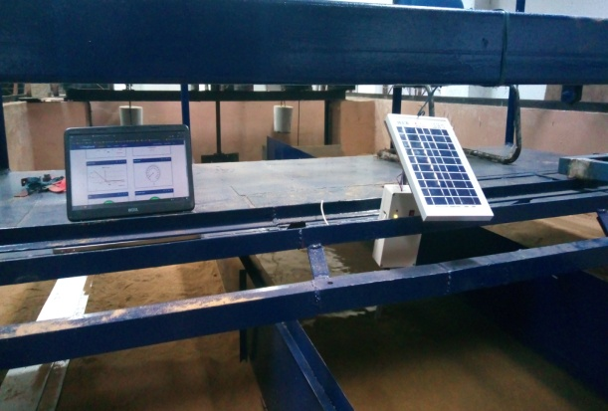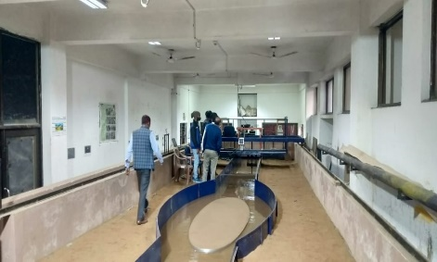

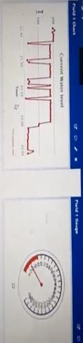

* **Installation and outdoor weather testing:**

After successful testing at the lab level, this device was tested various location we installed for a long time in the Brahmaputra River and besides in IITG various lake it was also successfully installed.

