**Graphitic carbon nitride catalyzed visible-light mediated synthesis of **-keto sulfones under sustainable conditions**

**Binoyargha Dam**,a Ashish K. Sahoo and Bhisma K. Patel* a

*a Department of Chemistry, Indian Institute of Technology Guwahati, 781039, Assam, India.*

Email id: patel@iitg.ac.in

Owing to their easy handling, high stability, and recyclable nature, carbon-based materials have emerged as effective catalytic systems in synthetic organic chemistry.1 Among others,graphitic carbon nitride (g-C3N4) is a metal-free polymer, synthesized by thermal polymerization of easily accessible and cheap starting materials like urea.2 Graphitic carbon nitride absorbs light in the visible region (band gap of 2.7 eV; λmax460 nm) and because of which they have utilized extensively as photocatalyst.1,3 Visible-light-mediated reactions are one of the trending topics in modern synthetic chemistry.4 Herein, this polymeric recyclable heterogeneous photocatalyst was synthesized, characterized and applied for the synthesis of biologically important **-keto sulfones in presence of blue light irradiation (Firgure 1).5 **-keto sulfones, were disclosed by using commercially available phenylacetylenes or ketones as precursors and sodium sulfinates, as the sulfonyl source. Potent biologically active compounds like anti-analgesic agents and CES1 inhibitors were synthesized by the present protocol. To explore the applicability, a few post-synthetic modifications of **keto sulfones were also carried out. Finally, to show the greener aspects of the protocol, green chemistry metrics was also calculated. The eco-scale value of the current procedure was also found to be acceptable (with both acetylene and acetophenone). Besides this, metal, base and ligand-free reaction conditions, recyclable photocatalyst (up to five cycles) and wide substrate variability are some additional advantages of this methodology.

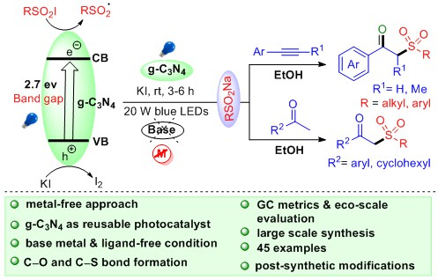

**Figure 1.** Graphical abstract for *g*-C3N4 mediated synthesis of **keto sulfones

**References**

[1] S. K. Verma, R. Verma, Y. R. Girish, F. Xue, L. Yan, S. Verma, M. Singh, Y. Vaishnav, A. B. Shaik, R. R. Bhandare, K. P. Rakesh, K. S. S. Kumar, K. S. Rangappa, *Green Chem.* **2022**, *24*, 438.

[2] F-L. Zeng, H-L. Zhu, X-L. Chen, L-B. Qu, B. Yu,*Green Chem.* **2021**, *23*, 3677.

[3] J. Guo, Y. Wang, Y. Li, K. Lu, S. Liu, W. Wang, Y. Zhang, *Adv. Synth. Catal.*  **2020**, *362*, 3898.

[4] a) X. Zhu, Y. Lin, J. San Martin, Y. Sun, D. Zhu, Y. Yan, *Nat. Commun.* **2019**, 10, 2843; b) Y. Yuan, H. Zhu, K. Hills- Kimball, T. Cai, W. Shi, Z. Wei, H. Yang, Y. Candler, P. Wang, J. He, O. Chen, *Angew. Chem., Int. Ed.* **2020**, *59*, 22563; c) A. K Sahoo, A. Rakshit, A.Dahiya, A. Pan, B. K. Patel, *Org. Lett,* **2022**, *24*, 1918; d) N. Chakraborty, K. K. Rajbongshi, A. Dahiya, B. Das, A. Vaishnani, B. K. Patel, *Chem. Commun*., 2023,59, 2779.

[5] B. Dam, A. K. Sahoo, B.K.Patel, *Green Chem.*, **2022**, *24*, 7122.