**Optimization of factors affecting rate of in vitro secondary embryogenesis in suspension cultures of**

***Camellia* sp**

Chetna Sharmaand Rakhi Chaturvedi*

Department of Biosciences & Bioengineering, IIT Guwahati, India

E-mail: [*rakhi_chaturvedi@iitg.ac.in*](mailto:rakhi_chaturvedi@iitg.ac.in)

Tea (*Camellia* s*p*.) is a socio-economic evergreen crop species belonging to the plant family theaceae. Major barriers in tea propagation are the lack of genetically superior, consistent varietals and lack of advance farming practices. This can be overcome by implementation of plant tissue culture cultivation methods of plant propagation by increasing in vitro development as well as germination rate of embryos as plant propagules. In the present study, MS basal medium supplemented with various growth regulators like 6-benzylaminopurine (BAP), gibberellic acid (GA3), L-glutamine and L-serine were added in embryo development medium. The in vitro development potential of embryogenic cultures of *Camellia* sp were observed for improving secondary embryogenesis and overcoming the hyperhydricity caused by excess volume of liquid medium. The initial inoculum size of 20 embryos was fixed throughout the experiment. After 4 weeks of culture; a considerable amount of secondary embryogenesis was observed with reduced hyperhydricity which is generally caused by running cultures in liquid medium for prolonged time, type of culture vessel also affect the growth of cultures. The best results were obtained in suspension culture medium raised in 500 ml capacity erlenmeyer flask with working volume of 100 ml liquid medium in which hyperhydricity is reduced upto 20%. From the above experiment it is concluded that embryogenic cultures grown in a higher medium volume of erlenmeyer flask showed the improved secondary embryogenesis as well as reduced hyperhydricity. Hence, optimized volumes of liquid medium, optimized inoculum size and frequent subculturing has helped in obtaining greater amount of secondary embryogenesis. The above method can be utilized for efficient propagation of elite tea plant lines in commercial scale.

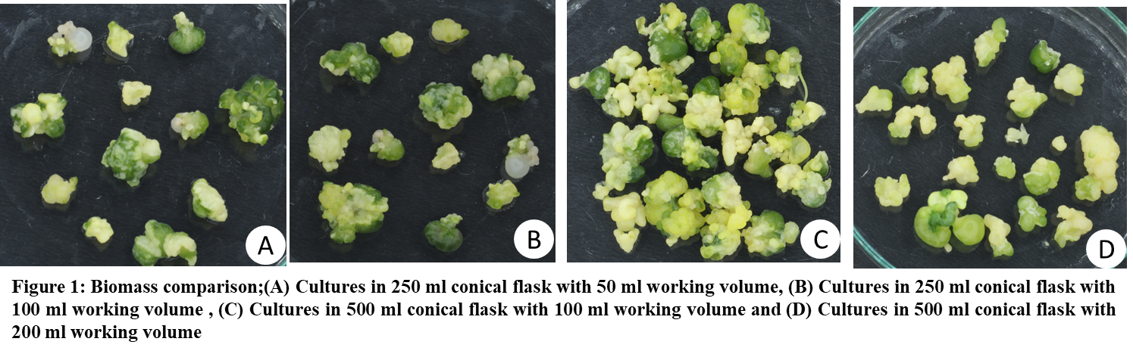**Keywords:** *Camellia sp,* development, embryos, germination, juvenile, propagules, theaceae.

|  |  |  |  |  |  |
| --- | --- | --- | --- | --- | --- |
| **Srl. No.** | **Volume of conical flask** | **Working volume of conical flask** | **Fresh weight** | **Dry weight** | **Hyperhydricity** |
| 1 | 250 ml | 50 ml medium | 3213 mg | 382 mg | 80% |
| 2 | 250 ml | 100 ml medium | 8838 mg | 938 mg | 65% |
| 3 | 500 ml | 100 ml medium | 6963 mg | 778 mg | 20% |
| 4 | 500 ml | 200 ml medium | 6243 mg | 609 mg | 90% |

**Table 1:** Culture statistics