**Effect of Periodic Oscillation and Swinging Motion of Twin Turbulent Slot Jets - A CFD Study**

**Student Academic Board (SAB), Indian Institute of Technology Guwahati, Guwahati, Assam, India**

K.Charan1 , K.Santhosh2 and C.Rohan and Prasanth A K Lam

1 Department of Mechanical Engineering, NIT Warangal, India

E-mail:*kataba_931935@student.nitw.ac.in*

**Abstract**

In the modern era, where cooling systems are being constantly improved to match the increasing amounts of heat transfer taking place in modern industrial applications such as automobiles, aeronautical and electronic systems etc. One of the best methods of heat transfer is the application of Jets of working fluid to cool a heated surface. It has seen numerous applications due to its high heat transfer and mass transfer rates when compared to its single phase heat transfer process counterparts [1]. Cooling of turbine blades, electronic equipment, heating and cooling of food products in the food industry, heating ventilation and air conditioning (HVAC) are few such applications. Improvements to these impinging jet systems takes us to a system of multiple jets, impinging on a surface with a periodic oscillation and swinging motion between the jets. These jets provide a periodic disruption to the boundary layer instead of a stagnant boundary layer which improves the rate of heat transfer between the surface and the jets.

**Research & Industrial Conclave 2023 "An amalgamation of Academia, Industry & Start-up”**

**"**

**Student Academic Board (SAB), Indian Institute of Technology Guwahati, Guwahati, Assam, India**

The purpose of the present study is to investigate the flow and thermal characteristics of twin jet impingement with periodic oscillation and swinging motion onto an isothermal surface. The governing equations for continuity, momentum and energy have been solved in the Cartesian framework through *OpenFOAM*, an open-source finite volume algorithm. The simulations have been performed using a transient, incompressible and turbulent flow solver *modifiedBuoyantBoussinesqPimpleFoam* which has been developed and provided with an added capability of calculating the surface temperature gradient at every time step. The RANS based two-equation k-Omega SST turbulence model has been employed to solve the Reynolds time averaged equations. The current solver has been validated against the case of turbulent slot jet impingement on an isothermal surface at *Re* = 20000 for different jet to impingement surface spacing (*H/B = 4, 9.2*). [2][3].

The heat transfer and flow behaviour has been examined and compared for different Reynolds numbers, frequencies of periodic oscillations, frequencies of swinging motion, phase shift angles and maximum angles of swinging motion. Also the geometric parameters such as the jet to impingement plate distance, spacing between the jets and width of the jet slots have been varied to observe the flow and thermal characteristics. The results such as streamlines, vortex structures, Nusselt numbers are explained and discussed in detail.

**Keywords:** modifiedBuoyantBoussineqPimpleFoam, k-Omega SST model, frequency of oscillation and swinging motions

 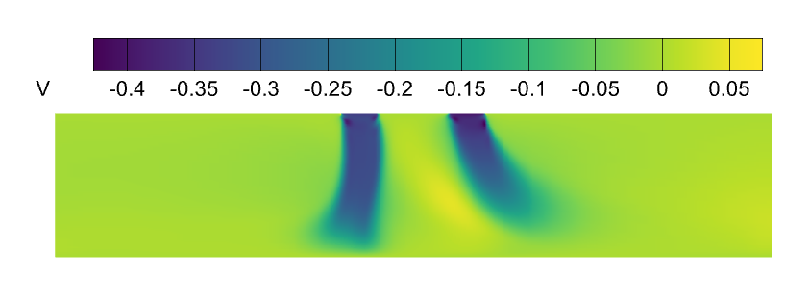

1. **(b)**

**Fig1.** **(a)** **Streamlines and** **(b)** **y-component of velocity** of the jet impingement system at a particular timestep

References:

[1] A. Dewan, R. Dutta, B. Srinivasan, Recent trends in computation of turbulent jet impingement heat transfer, Heat Transfer Eng. 33 (4–5) (2012) 447–460.

[2] Huakun Huang, Tiezhi Sun , Guiyong Zhang, Da Li, Haipeng Wei, Evaluation of a developed SST k- turbulence model for the prediction of turbulent slot jet impingement heat transfer, International Journal of Heat and Mass Transfer 139 (2019) 700–712.

[3] N. Zuckerman, N. Lior, Impinging heat transfer: correlations and numerical modeling, J. Heat Transfer 127 (5) (2005) 544–552.