**Bifurcations in the Dynamics of a Meromorphic functions involving sine function**

G. Kumar1 and M. Guru Prem Prasad*2

1 Department of Mathematics, IIT Guwahati, India

2 Department of Mathematics, IIT Guwahati, India

E-mail: *gaurav_kumar@iitg.ac.in*

**Abstract**

We study the dynamics of functions ${ f}_{λ }\left(x\right)=\sin{x} /(x^{2}+ λ)$ for $x∈ R$, where $λ >0$ is a real parameter. We exhibit that different types of bifurcation occur in the dynamics of ${ f}_{λ }$. Further ${ f}_{λ }$ becomes chaotic for certain range of values of the parameter.

**Research & Industrial Conclave 2023 "An amalgamation of Academia, Industry & Start-up”**

**"**

**Student Academic Board (SAB), Indian Institute of Technology Guwahati, Guwahati, Assam, India**

**Keywords:** Bifurcation, chaos.

Figures: 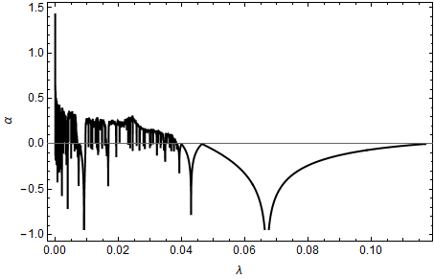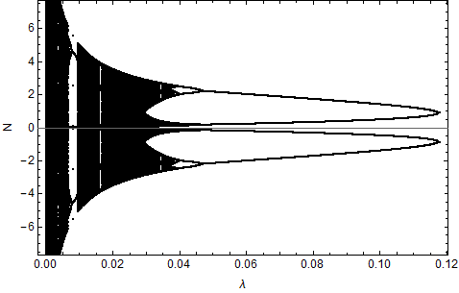

**Figure 1: The Lyapunov exponent of ${ f}_{λ }\left(x\right)$ for $λ ∈(0,0.12)$. Figure 2: The orbit diagram of ${ f}_{λ }\left(x\right)$ for $λ ∈(0,0.12)$.**

**References:**

Coppel, L. S. (2006). *Dynamics in one dimension.* Springer.

Devaney, R. (2018). *An introduction to chaotic dynamical systems.* CRC press.

May, R. (1976). Simple mathematical models with very complicated dynamics. *nature*, 459-467.

Strogatz, S. H. (2018). *Nonlinear dynamics and chaos: with applications to physics.* CRC press.