**Emulsion Behaviour of Nanofluids for Enhanced Oil Recovery Applications**

Gill Basumatari1, Dr. Ranjan Phukan1,*

1 Department of Petroleum Technology, Dibrugarh University, Dibrugarh, Assam

Email: [*basumatari0000@gmail.com*](mailto:basumatari0000@gmail.com)(G Basumatari)

[*r.phukan@dibru.ac.in*](mailto:r.phukan@dibru.ac.in)(R Phukan)

**ABSTRACT**

An emulsion is defined as two immiscible liquids wherein droplets of one phase (the dispersed phase) are encapsulated within sheets of another phase (the continuous phase). Emulsions are a critical aspect of EOR, as they can improve the displacement of oil from porous media. Nanosolutions, which are composed of nanoparticles and surfactants, have recently emerged as a promising technology for EOR due to their unique ability to alter the interfacial tension between oil and water.

In this study, we investigated the emulsion behaviour of nanosolutions in the context of EOR. The conventional oilfield *polymer-* Polyacrylamide (PAM), *surfactants* such as- Sodium Dodecyl Sulfate (SDS), Alpha Olefin Sulphonate (AOS), N-Cetyl Trimethyl Ammonium Bromide (CTAB), TERGITOL, TX-100 and *nanoparticle-* SiO2 are used.

**Student Academic Board (SAB), Indian Institute of Technology Guwahati, Guwahati, Assam, India**

**Student Academic Board (SAB), Indian Institute of Technology Guwahati, Guwahati, Assam, India**

**Table**: Nanoparticle-Surfactants-Polymer formulations

|  |  |
| --- | --- |
| **Sample** | **Formulations** |
| F1 | 2000 ppm(PAM) + 0.3wt% SiO2 + 0.04wt% CTAB |
| F2 | 2000 ppm(PAM) + 0.3wt% SiO2 + 0.25wt% SDS |
| F3 | 2000 ppm(PAM) + 0.3wt% SiO2 + 0.12wt% AOS |
| F4 | 2000 ppm(PAM) + 0.3wt% SiO2 + 0.006wt% TERGITOL |
| F5 | 2000 ppm(PAM) + 0.3wt% SiO2 + 0.02wt% TX-100 |

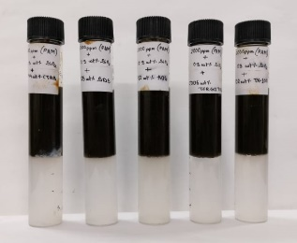 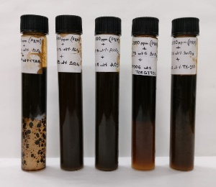 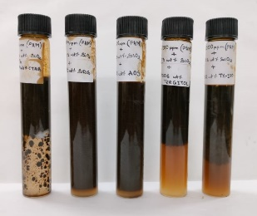 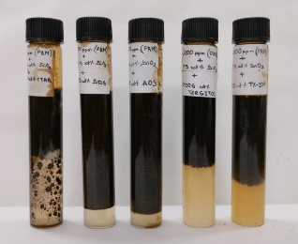

1. (b) (c) (d)

**Figure 1**: State of emulsification (a) Before mixing (b) Immediately after mixing

(c) After 12 hrs of mixing (d) After 24 hrs of mixing

Oil in water emulsions are observed in two samples with surfacants AOS & SDS under polarised microscope. The sample with AOS has large no of microemulsions than sample with SDS.

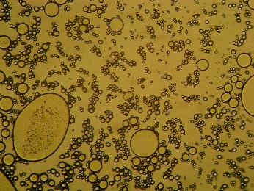 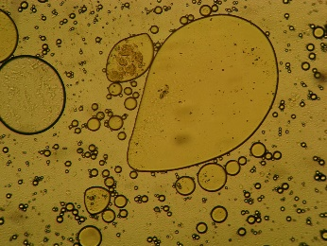

a) AOS + SiO2 + PAM b) SDS + SiO2 + PAM

**Figure 2-** Microscopic images of formulations