**Fabrication of functionalized composite membrane for removal of CO2 from flue gas**

Kartik Mehta*, Shubham Kumar,

Bishnupada Mandal, Animes K Golder

*Department of Chemical Engineering, IIT Guwahati, India

E-mail: *j.kartik@iitg.ac.in*

**Abstract**

The use of fossil fuels like coal, natural gas, and petroleum products has revolutionized the energy sectors to fulfil the increasing energy demands across the globe. Fossils share about 80% of total global energy supply even in the year 2020. As a result, the burning of a mammoth amount of fossil fuels has led to increased emission of CO2 in the atmosphere. The increase in concentration of CO2 is largely responsible for the Greenhouse Gas Effects. The atmospheric temperature is increased by about 1.1°C within a span of 142 years (1880-2022) mostly due to uncontrolled and unregulated releases of CO2 in the atmosphere by the energy sectors.

**Research & Industrial Conclave 2023 "An amalgamation of Academia, Industry & Start-up”**

**"**

In the present era, the global climate change poses a serious threat to the existence of the human society. CO2 capture and its conversion to some useful chemicals is gaining a lot of interest among the researchers to control CO2 emission along with revenue addition. Membrane-based technologies are advantageous because of its low cost, modular and compact design, and secondary pollution free operation. Among different types of membrane, the use of mixed matrix membrane can give an edge for CO2 removal because it can simultaneously add the benefits of both inorganic and organic phases for efficient CO2 separation. In particular, the use of metal organic frameworks (MOFs) can enhance adsorption of CO2 by providing high surface area and faster transport of CO2 across the membrane owing to facilitated transport mechanism along with solution diffusion mechanism. The addition of functionalized group like amines with MOFs also can help in increasing CO2 permeance.

In this work, Pebax-1657 was selected as the bulk phase for the fabrication of membrane. It has around 40% polyamide(PA) section and 60% polyethylene oxide(PEO) section. Zirconium-based MOF (UiO-66) was selected as the dispersed phase for the fabrication of mixed matrix membrane. It was functionalized by adding amine and amide groups resulting in the formation of UiO-66-NH2 and UiO-66-NH-COCH3, respectively. All three synthesized MOFs were mixed separately with Pebax-1657 solution, and three variants of mixed matrix membrane were fabricated. Figure 1 shows the schematic fabrication process. The characterizations test like X-ray diffraction (XRD), Field emission scanning electron microscopy (FESEM), Thermal gravimetric analysis (TGA), Fourier transform infrared (FTIR) spectroscopy, etc, were done to confirm the membrane structure, morphology, stability, and its functionality targeting CO2.

**Keywords:** Mixed matrix membrane; MOFs fabrication; CO2 separation; High selectivity

**Student Academic Board (SAB), Indian Institute of Technology Guwahati, Guwahati, Assam, India**

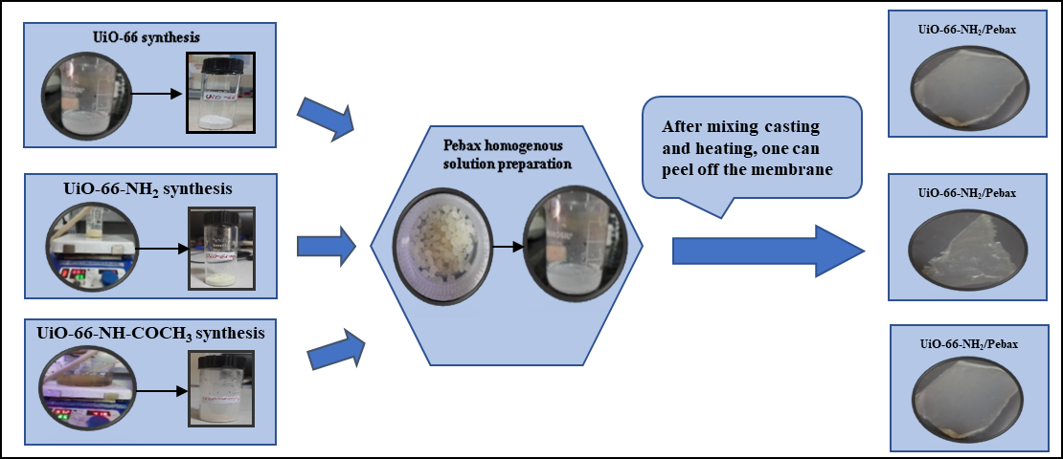

Figure – 1– Steps involved in fabrication of mixed matrix membrane with different MOFs