**Research and Industrial Conclave Integration 2023**

**IIT GUWAHATI**

**ENERGY PRODUCTION**

**FROM**

**BIOMASS CHARACTERIZATION OF CASTOR OIL PLANT LEAVES AND KITCHEN WASTE**

**KIME CHADA, RATHOD SANDEEP, MANJULA DAS**

DEPARTMENT OF MECHANICAL ENGINEERING, NIT ARUNACHAL PRADESH

**ABSTRACT**

This experimental study focusses on finding solution to advance energy sources from biomass where the research is carried on finding the most effective and economical way of converting biomass into efficient advanced energy sources like biofuels and syngas which has great potential to be used as a standalone fuel for power production like direct generation of heat and electricity or as an intermediate product in chemical industry for the production of liquid fuels like diesel and gasoline, synthetic natural gas, synthetic liquid petroleum, ammonia, and methanol, etc.

Biomass valorization technology comes with few drawbacks and limitations like generation of energy inefficient components which has been a focus area of this project and experimental work. Feedstock materials used in this study are kitchen waste which includes waste vegetable peels of cabbage, carrot etc. and Ricinus communis plant’s leaf which naturally grows in region around NIT Arunachal Pradesh. The crux of this work includes proximate and ultimate analysis of these feedstock material to find moisture, ash, volatile matter, fixed carbon content along with CHNO analysis (Carbon, Hydrogen, Nitrogen and Oxygen). The composition of feedstock and ratio of different parametric inputs like temperature, feedstock binder ratio, binder type are also experimented and analyzed. All these factors affect the energy production effiency in biomass pyrolysis process and by altering these factors the all-round best possible conditions for conversion of biomass into an efficient fuel can be found. This paper presents the characterization of two types of biomass.

Keywords: Biomass characterization, waste to energy, pelletization, ultimate analysis, proximate analysis

Figure 3: Biomass Briquette Feedstock 2

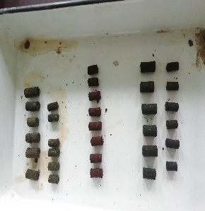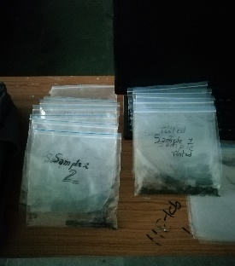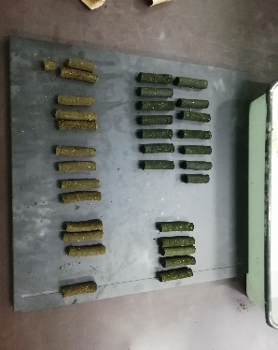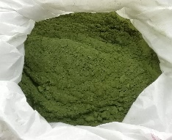

Figure 4: prepared samples

Figure 2: Biomass Briquette Feedstock 1

Figure : powdered feedstock