**Machine learning-based detection of valvular heart diseases using seismocardiogram signals**

* Moirangthem James Singh, LN Sharma and Samarendra Dandapat

Department of Electronics & Electrical Engineering, IIT Guwahati, India

E-mail: [*m.james@iitg.ac.in*](mailto:m.james@iitg.ac.in)*,* [*lns@iitg.ac.in*](mailto:lns@iitg.ac.in) *,samaren@iitg.ac.in*

**Student Academic Board (SAB), Indian Institute of Technology Guwahati, Guwahati, Assam, India**

**Abstract**

**Research & Industrial Conclave 2023 "An amalgamation of Academia, Industry & Start-up”**

**"**

Valvular heart disease (VHD) is the abnormal heart valves conditions, including mitral stenosis (MS), regurgitation (MR), aortic stenosis (AS), and regurgitation (AR), with an estimated prevalence of approximately 2.5% in the general population [1]. These conditions can result in impaired blood flow and serious complications. Seismocardiogram (SCG) signals, which capture the vibrations of the heart and chest wall resulting from the cardiac activity, have shown promise as a non-invasive tool for diagnosing VHD, as stenosis and regurgitation of the heart valves can cause changes in the timing, intensity, and duration of the vibrations captured by the SCG [2].

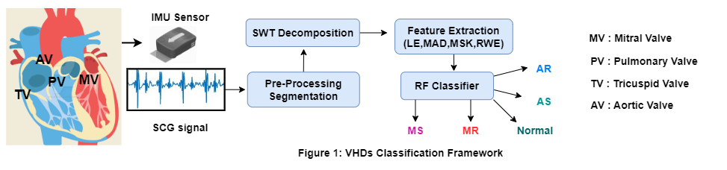

This study presents a novel approach to diagnosing VHD using SCG signals and machine learning algorithms. Our methodology (as shown in Figure 1) involves preprocessing and segmenting SCG signals into cardiac cycles, decomposition of each cycle into subbands using SWT, and extracting statistical features (log-energy entropy, relative wavelet energy, multi-scale kurtosis, and median absolute deviation) from each subband. These features can capture relevant both time and frequency domain information indicating the presence of VHD. It allows a more comprehensive and accurate analysis of the SCG signals. The extracted features are then fed into a random forest classifier, a robust machine learning algorithm, for automated VHD detection.

The model demonstrated excellent performance in accurately classifying five categories of VHD (AS, AR, MS, MR) and normal cases [2] [3], with an overall accuracy of 93.25%. The high area under the receiver operating characteristic (ROC) curve score of 99.37% indicates the model's discriminatory solid power in distinguishing between different classes. The F1 scores for each class, AS, AR, MS, and MR, were 93.67%, 87.01%, 83.29%, and 91.43%, respectively. Notably, the normal class achieved a perfect F1 score of 100%. These results are comparable to the current state-of-the-art VHD detection techniques [4][5], demonstrating our approach's effectiveness as a reliable and non-invasive diagnostic tool.

The proposed framework has the potential to complement existing diagnostic tools and provide additional diagnostic information, contributing to improved patient outcomes and reduced healthcare costs. By utilizing stationary wavelet-based features and machine learning algorithms, our approach takes advantage of the unique characteristics of SCG signals, which capture the mechanical vibrations of the heart and chest wall. This innovative approach has the potential to significantly enhance the efficiency and accuracy of VHD diagnosis, providing clinicians with a reliable and non-invasive method for early detection and intervention. Overall, our study highlights the promising potential of our approach in enhancing VHD diagnosis and ultimately improving patient care.

**Keywords: Seismocardiogram (SCG), Stationary Wavelet Transform (SWT), Random Forest, Valvular Heart Diseases**

**References:**

[1] C. Yang, F. Fan, N. Aranoff, P. Green, Y. Li, C. Liu, and N. Tavassolian, “An open-access database for the evaluation of cardio-mechanical signals from patients with valvular heart diseases,” Frontiers in Physiology, vol. 12, 2021.

[2] M. Garc´ıa-Gonzalez ´ et al., “Combined measurement of ecg, breathing and seismocardiogram (cebs database),” 2013

[3] J. S. Aluru, A. Barsouk, K. Saginala, P. Rawla, and A. Barsouk, “Valvular heart disease epidemiology,” Medical Sciences, vol. 10, no. 2, p. 32, 2022

[4] M. J. Singh, S. Das, L. N. Sharma and S. Dandapat, "Stationary Wavelet Transform Based Detection of Aortic Stenosis Using Seismocardiogram Signal," 2023 National Conference on Communications (NCC), Guwahati, India, 2023.

[5] C. Yang, N. Aranoff, P. Green, and N. Tavassolian, “Classification of aortic stenosis using time–frequency features from chest cardiomechanical signals,” IEEE Transactions on Biomedical Engineering, vol. 67, no. 6, pp. 1672–1683, 2019.