**Frustration Driven Short-range Antiferromagnetic Correlations in ZnTiCoO4 Spinel**

Mouli Roy-Chowdhury1, Prativa Pramanik2, Sayandeep Ghosh3 and Subhash Thota1

1Department of Physics, IIT Guwahati, India

2Uppsala university, Sweden

3Chungnam National University and Kunsan National University, South Korea

E-mail: [*mouli.roy@iitg.ac.in*](mailto:mouli.roy@iitg.ac.in)

**Abstract**

The doubly-diluted spinel ZnTiCoO4 = (Zn2+)*A* [Ti4+Co2+]*B*O4 looks quite simple at first glance, however, a great complexity lies in its magnetic structure when examined microscopically. Here the divalent Co2+ occupies the octahedrally coordinated *fcc* sites alone contributes to the overall magnetic ordering. The presence of non-magnetic Zn2+ and Ti4+ ions significantly alters their exchange interactions (*J*AA, *J*AB and *J*BB) and such dilution leads to magnetic frustration (MF) in the lattice. The MF phenomena is manifested in the form of a Spin-glass state present below the short-range antiferromagnetic ordering as seen from the H-T phase diagram given in figure 1(a).Existing literature on this system reported conflicting results related to its magnetic ordering where few authors reported ferrimagnetic ordering below 13 K while othersreported spin-glass behaviour below 14.4 K [1,2]. To mullover such discrepancies in the present work we reinvestigated the magnetic properties of this interesting compound in great detail.

Temperature and field dependent dc and *ac* magnetic measurements were performed to unveil the nature of magnetic ordering in the system. The peak in the differential dc-magnetic susceptibility plot (∂(χT)/∂T vs. T) yielded an antiferromagnetic Néel temperature, TN = 13.9 K which shifted to lower temperatures up on increasing the magnitude of external magnetic field (H). The specific heat (Cp vs. T) measurements allowed us to conclude that the dominant antiferromagnetic ordering was short-ranged. The λ-type anomaly in the Cp vs. T data near TN was absent for ZnTiCoO4 contrary to what was expected for typical AFM systems. Hence, a short-range ordering is expected in the investigated system. In its place, a broad hump near 20 K was observed in the Cp -T data. Further, the magnetic entropy loss calculated from the heat capacity data between 50 K and 1.9 K have its magnitude nearly five times less than the theoretically estimated value for a complete long-range ordered system of ground state spin S = 3/2 (Fig 1(b)). Such features indicate the co-existence of spin-glass phase and short-range ordering in ZnTiCoO4, which was confirmed by further analysis of the frequency and temperature dependent ac-susceptibility (χac(*f*,T)) data using the two empirical scaling laws such as *(i)* Power law: τ = τ0[(T − TSG)/TSG]−zν and *(ii)* the Vogel-Fulcher law: τ = τ0exp[Ea/kB(T−T0)]. Hence, all these considerations unambiguously support spin-glass state and short-range ordering in ZnTiCoO4 as both the *A*–*A* and *A*–*B* exchange interactions are absent and only the *B*–*B* exchange interactions dominate the magnetic properties.

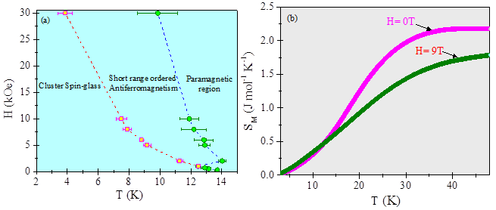

**Figure 1:** (a) The magnetic phase diagram mapped onto the H-T plane for ZnTiCoO4. (b) Temperature variation of magnetic entropy (*SM*) calculated by the numerical integration of *C*mag/*T* data for both *H* = 0 and 9 T.

**Keywords:** Antiferromagnetic, Spin-glass, Exchange Interaction, Spinels

**References:**

1. D. Ruiz- Léon, F. Mompean, J. Prado-Gonjal, J. F. Marco, M. García-Hernandez and R. Schmidt, *J. Eur. Ceram. Soc.* **38,** 4986 (2018).

2. Y. Li, X. Kan, X. Liu, S. Feng, Q. Lv, W. Wang, C. Liu, X. Wang and Y. Xu, *J. Supercond. Novel Magn.* **33,** 3745 (2020).

3. M. Roy Chowdhury, M. S. Seehra, P. Pramanik, S. Ghosh, T. Sarkar, B. Weise and S. Thota, *J. Condens. Matter Phys.* **34**, 275803 (2022).