**Novel magnetic responsive microactuator for microfluidic-based point of care**

**Neeru Yadav1, Prathu Raja Parmar1, Nafisa Arfa1, Saurabh Dubey2, Dipankar Bandyopadhyay1,2,3**

1Department of Chemical Engineering, Indian Institute of Technology Guwahati, Assam, India

2Centre for Nanotechnology, Indian Institute of Technology Guwahati, Assam, India

3School of Health Sciences and Technology, Indian Institute of Technology Guwahati, Assam, India

E-mail: *dipban@iitg.ac.in*

**Abstract**

**Student Academic Board (SAB), Indian Institute of Technology Guwahati, Guwahati, Assam, India**

A novel intelligent magnetorheological elastomer (MRE) composite-based microactuator has been developed. MRE uses an inventive actuation mechanism including pumps, mixers, and without any delicate components into a modular microfluidic chip based on revolutionary manipulation principles is provided to accelerate the microfluidic-based POC (Point of care) systems. MRE is composed of a suspension of ferromagnetic filler as magnetically polarizable particles embedded in the non-polarizable matrix of deformable elastomers. An external field is used to magnetize the composite, and the magnetization will completely vanish when the field is turned off. MREs' magneto-mechanical performance can be maximized by choosing an appropriate particle mixing ratio (nearly 10%). The magnetic field that is being applied has a significant impact on the material's viscoelastic properties. Due to the attraction of a modifiable magnetic field, the MRE body gets deformed. Altering magnetic fields are used to control the fluids flowing through the microchannels. Thus, MRE has been utilized in microfluidic systems as an actuation mechanism for controlling fluid flow and manipulating particles and droplets. The demonstrated MRE microactuators are compact, straightforward, and efficient systems with easily adjustable mechanical properties that hold a considerable potential to improve the state-of-the-art study of sophisticated microfluidic systems significantly.

**Research & Industrial Conclave 2023 "An amalgamation of Academia, Industry & Start-up”**

**"**

**Keywords:** microactuator magnetically polarizable particles, elastomer, magnetic field

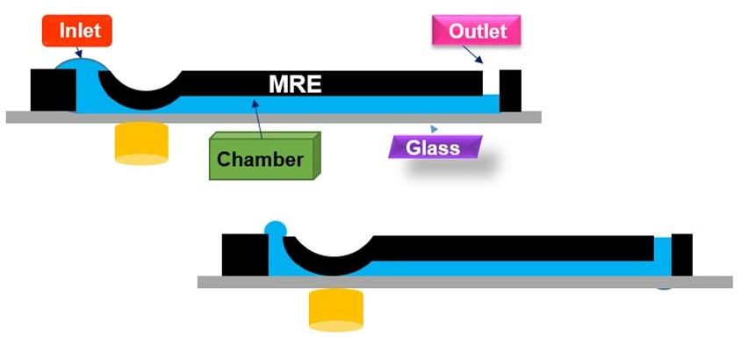

**Figure 1.** Schematic illustration of the working mechanism of MRE.