**Study of Exchange Bias effect in Nd2CoMnO6 Double Perovskite**

Nibedita Nayak and S Ravi

Department of physics, Indian Institute of Technology Guwahati, Guwahati-781039, India

Email: **nibedita_nayak@iitg.ac.in**

**Abstract**

Single phase polycrystalline samples of Nd2CoMnO6 (NCMO) double perovskite was prepared by using conventional solid state reaction route and it’s structural and magnetic properties were analysed. The compound is of monoclinic structure having space group P21/n. Using Rietveld refinement technique, the obtained lattice parameters for NCMO sample are (a, b, c) = (5.416 Å, 5.526 Å, 7.678 Å). The average grain size is calculated from the FESEM images. Temperature variation of magnetization measurements show that the prepared samples exhibit ferromagnetic (FM) transition with transition temperature Tc1 =140K and Tc2 =171K. The FM transition is attributed to strong super exchange interaction in Co2+-O- Mn4+ networks. The M-H loops recorded at 5K show saturation magnetization (Ms) of 3.6 µB/f.u. We have measured the typical M – H loops under FC condition with an externally applied field of 0.5T at 5K temperature. A clear shift in the M – H loops towards negative side is observed which indicates the presence of EB effect. The exchange bias field is measured to be 725Oe for the NCMO sample.

**Keywords:** Super exchange interaction, Ferromagnetic transition, exchange bias effect

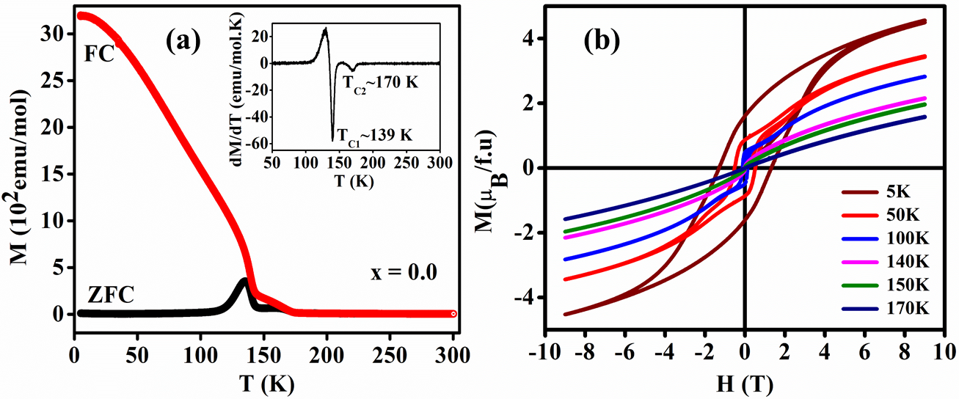

**Fig. 1** (a) ZFC and FC, M versus T plot at an applied field of H = 100 Oe with inset figure of dM/dT plot. (b) M – H loops measured at different temperature.

**Reference**

1. R.R Das, P.N Lekshmi, J. Alloys Compd. 773 (2019) 770-777.
2. K. P. Patra, S. Ravi, J. Magn. Mag. Mater. 540 (2021) 168476.
3. D. Mazumdar, I. Das, J. Appl. Phys. 129 (2021) 063901.
4. J. B. Goodenough, Phys. Rev. 100 (1955) 564–573.