APNEA MONITORING JACKET FOR BABIES

Nishanta kakati

Department of Medical Devices , Niper Guwahati, India

E-mail: md22mt3030@niperguwahati.in

**Abstract**

Apnea is temporary cessation of breathing , it is one of the risk factor of Sudden Infant Death Syndrome (SIDS) . According to theory. 15 million babies born preterm globally and 3.5 million in India , they are at higher risk of sleep apnea. Increased newborn safety and early disease detection are made possible by infant breath monitoring and quick apnea detection, both in hospitals and at home. Apnea monitoring jacket is a device that monitors the breathing , it alarms when the baby is not breathing. A three-axis MEMS (Micro Electro-Mechanical Systems) accelerometer (ADXL345) with a digital output, a microprocessor (Arduino Uno R3), and some alert buzzers make up this novel apnea detection system. There are many clinical methods for respiration monitoring but all those methods are uncomfortable for the baby. The  device enables monitoring of the child's abdominal breathing movement, The abdominal wall's movement and vibration are all picked up by the accelerometer sensor and if there is movement less than the threshold value in the Y-axis value from the MEMS accelerometer for more than 15 second ,it starts the alarming instrument indicating apnea.

**Student Academic Board (SAB), Indian Institute of Technology Guwahati, Guwahati, Assam, India**

**Research & Industrial Conclave 2023 "An amalgamation of Academia, Industry & Start-up”**

**"**

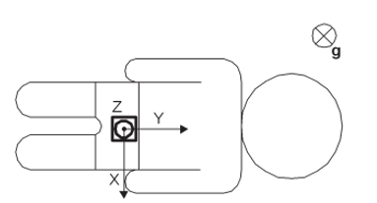

**Fig :-** Placement of accelerometer on the subject

**Keywords:** : Apnea, MEMS, accelerometer, SIDS, ADXL345,Arduino Uno R3

**References** :-

1. Tewel, N. (2010). Application of MEMS accelerometer for baby apnea monitoring under home conditions. *Acta Bio-Optica et Informatica Medica. Inżynieria Biomedyczna*, *16*(4), 389-393.
2. Wisana, I. D. G. H., Nugraha, P. C., & Estiwidani, D. (2021). The Effectiveness Obstructive Sleep Apnea Monitoring Using Telemedicine Smartphone System (TmSS). In *Journal of Biomimetics, Biomaterials and Biomedical Engineering* (Vol. 50, pp. 113-121). Trans Tech Publications Ltd.