**Nature-Based Solutions to Address Lean Period Water Intake Challenges at Brahmaputra Ghat**

Om Prakash Maurya1, Dr. Chandan Pradhan2, Avinash Kumar2, Prof Subashisa Dutta1

1 Department of Civil Engineering, IIT Guwahati, India

2 Technology Innovation Hub, IT Guwahati, India

E-mail: *om1996@iitg.ac.in*

**Abstract**

**Student Academic Board (SAB), Indian Institute of Technology Guwahati, Guwahati, Assam, India**

The present study aims to provide nature-based solutions for the challenges faced by IIT Guwahati in maintaining sustainable water management practices at Brahmaputra Ghat during the lean period flow. The primary issue is the formation of sandbars near the intake location during the recession period of the river flow, which causes water scarcity from December to March almost every year. Additionally, the outlet of the sewerage effluent, located just 0.5 km upstream of the intake location, deteriorates water quality during the lean period flow. To tackle these challenges, considering the around 4 km reach from Maj Gaon (upstream) to Brahmaputra ghat (downstream), the river width is around 1.5 km at Maj Gaon and at Brahmaputra ghat is around 1 km, analyzed the various datasets such as discharge data, rainfall data, and satellite imagery. The analysis showed that left bank (outer bank) sandbar erosion (near Maj Gaon) may play an important role in sandbar formation at the right bank (outer bank sandbar erosion happening due to the sinuosity effect) and eroded sediment from upstream deposited downstream. Currently, dredging techniques are used to mitigate the problem, but they are costly. The proposed solution may involve creating a low-cost barrier of woody debris and rocks at the river’s left bank near Maj Gaon. The barrier will work as an energy dissipater, leading to sediment deposition and sandbar formation, which can eventually become stable sandbars with the growth of vegetation, and maybe river thalweg will be shifted towards the right bank. This solution reduces the cost of dredging, preserves the natural habitat, and improves water quality. This study can further utilize such types of consequences in the river systems.

**Student Academic Board (SAB), Indian Institute of Technology Guwahati, Guwahati, Assam, India**

**Keywords:** Nature-based solution, Lean period, Brahmaputra ghat, Sustainable water management, Sandbar

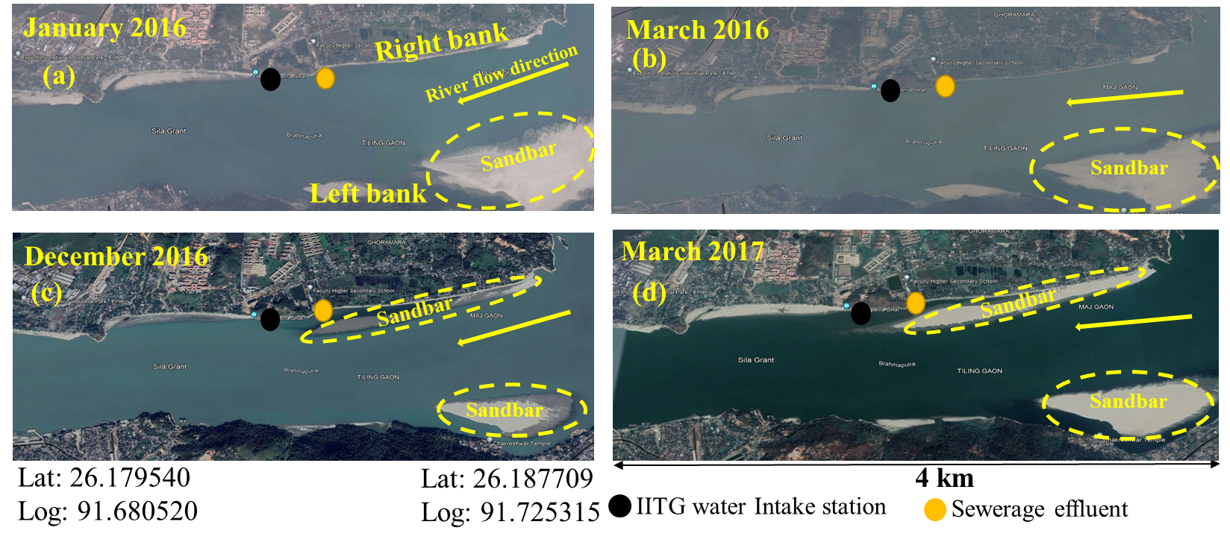

**Figure 1:** Sand bar formation process near Brahmaputra Ghat (source: Google Earth Pro)

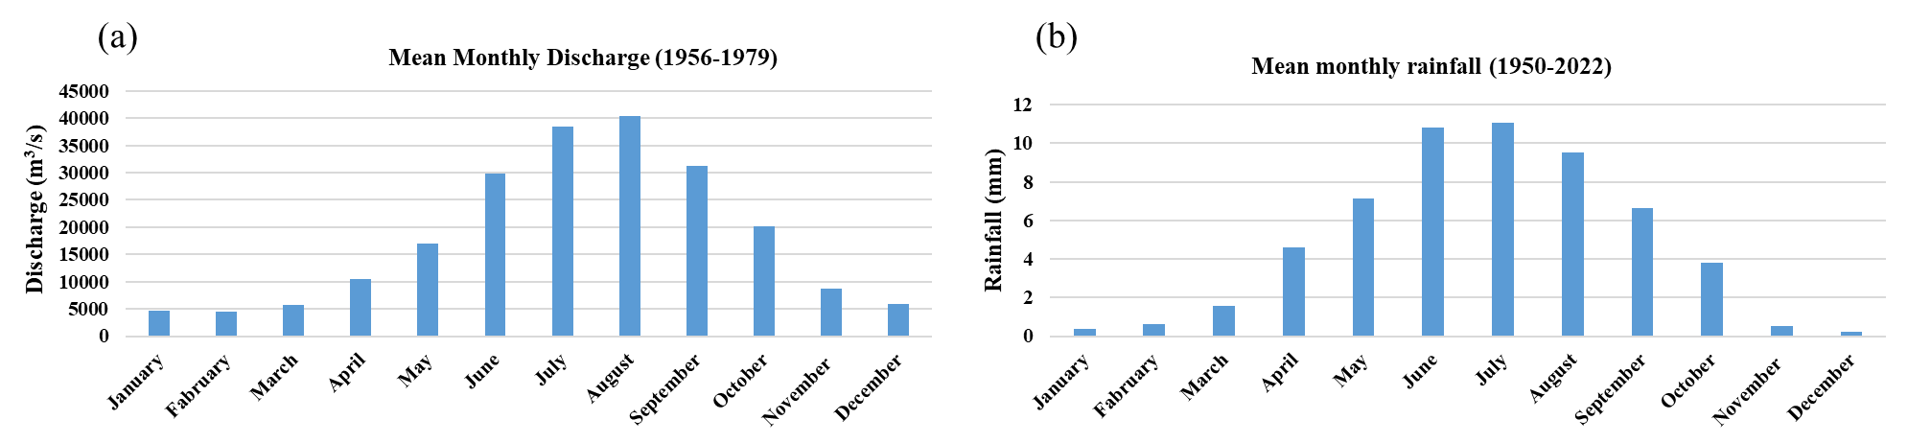

**Figure 2:** Mean monthly Discharge (GRDC data) at Pandu Guwahati and mean monthly rainfall (IMD gridded data) at Guwahati

**Reference:**

Ahmed, Ishita Afreen, et al. "Implications of changes in temperature and precipitation on the discharge of Brahmaputra River in the urban watershed of Guwahati, India." *Environmental monitoring and assessment* 193 (2021): 1-21.

Bennett, Sean J., Janine M. Castro, and Andrew Simon, eds. Stream restoration in dynamic fluvial systems: Scientific approaches, analyses, and tools. John Wiley & Sons, 2013.

McComas, Robert M., et al. "Techniques for developing bars and islands in incising channels." (2022).

Maurya, O. P., et al. "Effect of Sinuosity Variation on Flow Characteristics of Sand Mined Sinuous Channel Using Numerical Modeling." (2022).

Nandi, Ketan Kumar, et al. "How dynamic is the Brahmaputra? Understanding the process–form–vegetation interactions for hierarchies of energy dissipation." *Ecohydrology* 15.3 (2022): e2416.

Pradhan, C., et al. "A process-based recovery indicator for anthropogenically disturbed river system." *Scientific Reports* 12.1 (2022): 1-14.

Modalavalasa, Suresh, et al. "Laboratory investigation on flow structure and turbulent characteristics in low sinuous compound channels with vegetated floodplains." *Journal of Hydrology* 618 (2023): 129178.

Van der Meulen, Frank, Stéphanie IJff, and Rien van Zetten. "Nature‐based solutions for coastal adaptation management, concepts and scope, an overview." *Nordic Journal of Botany* 2023.1 (2023): e03290.