**Columnar Self-Assembled Ambipolar Hetero Atom Bay-Annulated Perylene Bisimides Exhibiting a Highly Stable Deep Red-to-NIR OLEDs with an External-Quantum Efficiency of 4.9%**

**Paresh Kumar Behera**,a Mangey Ram Nagar,c D. S. Shankar Rao,b Jwo-Huei Jou c and Ammathnadu Sudhakar Achalkumar*a,d

*aDepartment of Chemistry, Indian Institute of Technology Guwahati, Guwahati, 781039, Assam, India. bCentre for Nano and Soft Matter Sciences, Arkavathi Campus, Survey No.7, Shivanapura, Dasanapura Hobli, Bengaluru – 562162, India. cNational Tsing Hua University, Department of Materials Science & Engineering, 101, Sec. 2, Kuang-Fu Road, Hsinchu 30013, Taiwan, R.O.C. dCentre for Sustainable Polymers,*

**Research & Industrial Conclave 2023 "An amalgamation of Academia, Industry & Start-up”**

**"**

*Email: pares176122019@iitg.ac.in*

**Abstract:**

A series of electron deficient perylene bisimides (PBIs) bearing 3,4,5-tridecylphenyl substituents on the imide N-atoms and bay-annulated with the hetero atoms like N, S, Se in the bay positions of the perylene core via Cadogan reaction have been synthesized. These compounds were liquid crystalline at room temperature exhibiting columnar hexagonal phase exclusively, with the exception of S-annulated PBI which exhibited columnar oblique phase. These self-organizing organic semiconductors in one-dimensional (1D) columnar structures, are unique by having better solubility, ease of purification, reproducibility and ease of handling in comparison to polymers or single crystals. Detailed photophysical studies of these compounds show that they exhibit high molar extinction coefficients with wide absorption spectra covering most of the visible spectrum and bright red fluorescence, makes them promising candidates for organic electronics. Further, they exhibited technologically important red electroluminescence. One of the solution-processed host-guest OLEDs (CBP as host at 1 wt% **PBI-N10**) exhibited a maximum EQE of 4.9%, a lifetime of 12.4 h with an initial brightness of 2900 cd/m2 and a deep red/NIR emission. These results indicated that these materials exhibit significant potential in the field of columnar liquid crystal-based deep red/NIR emitters. The charge carrier mobility of these PBIs were tested by space charge limited current method and found that they exhibit ambipolar conductivity. This is in contrary to the vast body of literature, where most of the PBI based semiconductors exhibit electron transport behaviour only. Especially, the ambipolar *S*-annulated PBI, **PBI-S10** exhibited highest hole (8.39 **×** 10−3 cm2/ V.s) and electron (1.5 **×** 10−2 cm2/ V.s) mobility values and promising for the application in organic electronics.

**Student Academic Board (SAB), Indian Institute of Technology Guwahati, Guwahati, Assam, India**

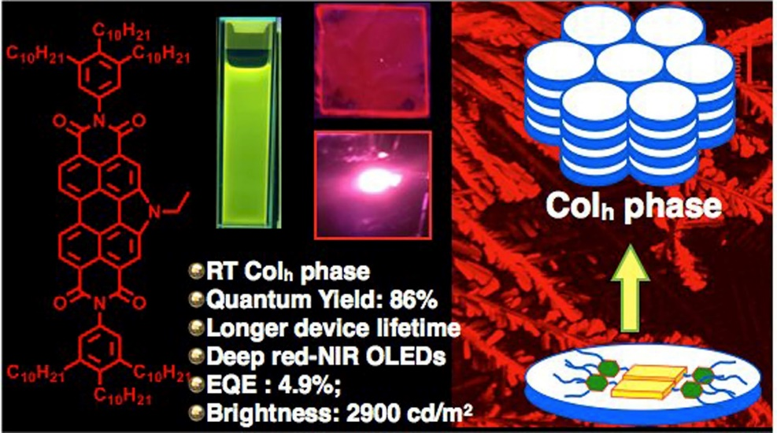

**References and Notes:**

1. P. K. Behera, M. R., Nagar, R. K, Gupta, S. Pradhan, D.S. Rao, S.K. Prasad, A. Choudhury, J. H. Jou, A. A. Sudhakar, *J. Mater. Chem C*. **2022**, *10*, 18351-18365.
2. P. K. Behera, K. Yadav, D. S. Shankar Rao, U. K. Pandey, and A. S. Achalkumar, *Chem. Asian* *J*. **2023**, e202300086.