**Imidazolium Functionalized Polyelectrolyte Assisted Perovskite Crystallization for Efficient and Stable Perovskite Solar Cells**

Mayur Patel1 , Himangshu Baishya2 , Sushant Sharma1, Nehal Zehra1 , Maimur Hossain3, Ramkrishna Das Adhikari2,Parameswar K. Iyer1,2

1Department of Chemistry, IIT Guwahati, India

2Centre for Nanotechnology, IIT Guwahati, India

3Department of Chemical and Biological Engineering, Drexel University, USA

*E-mail: *p.mayur@iitg.ac.in* *and* *pki@iitg.ac.in*

**Abstract**

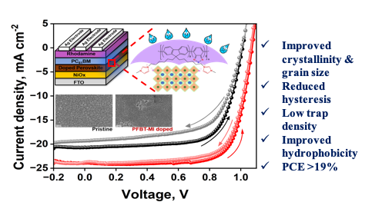In order to maximize the performance of Hybrid Organic Inorganic Perovskite Solar Cells (HOIP-PSCs), it is crucial to minimize the intrinsic defect states to enhanced film quality and morphology. An efficacious approach to achieve improved photovoltaic parameters is incorporation of an additive in the perovskite framework. In this work, an imidazolium containing cationic conjugated poly-electrolyte (CPE), PFBT-MI, with bromide as counter ion was employed in varying concentration that effectively passivated the ionic defects in the MAPbI3 structure resulting in improved morphology and charge transport of perovskite film. Incorporating PFBT-MI CPE imparted higher crystallinity with reduced defect states and lower charge recombination. The 1% doped perovskite device achieved the highest power conversion efficiency (PCE) of 19.23% in comparison to the pristine device. The counter bromide ion reduced the iodine vacancies and minimized ion migration resulted lower hysteresis in the modified device. Moreover, the PFBT-MI modified device resulted better hydrophobic surface retaining 85% normalized PCE upon ambient exposure as compared to pristine contributed to the device long term stability.

**Keywords:** Additive engineering, passivation, conjugated polyelectrolyte, morphology, stability





Figure 3. (a-b) FESEM top-view images and (c-d) AFM height profile of pristine and D1 film.

Figure 2**.** (a) XRD pattern of pristine and doped perovskite film with varied concentration of PFBT-MI, (b) UV-vis absorption profile and (c) TauC plot of pristine and doped perovskite film.

Figure 1. (a) Schematic representation of device architecture, (b) thin film coating process of the active layer, (c) molecule structure of PFBT-MI and (d) ESP Profile of PFBT-MI.



|  |  |  |  |  |
| --- | --- | --- | --- | --- |
| Device | *Jsc* , mA cm-2 | *Voc* , V | *FF* , % | PCE % |
| Pristine | 20.67 | 1.012 | 69.8 | 14.60 |
| D0.5 | 23.58 | 1.048 | 73.4 | 18.14 |
| D1 | 23.90 | 1.073 | 75.0 | 19.23 |
| D1.5 | 22.71 | 1.030 | 72.9 | 17.05 |
| D2 | 21.71 | 1.026 | 71.0 | 15.82 |

Figure 4**.** (a) *J-V* curve of the devices with varying dopant concentration, (b) Hysteresiscurve of pristine and D1 modified device, (c) EQE and Integrated *JSC* curve of pristine and D1 modified device and (d) steady-state *JSC* for 300s light illumination of pristine and D1 modified device.

Table 1 Photovoltaic parameters for pristine and PFBT-MI passivated devices