**Effect of oxygen-containing functional groups of layered graphene oxide membrane on the removal of amoxicillin: a molecular dynamics study**

P. Rajasekhar Reddy1) *, Abhijit Gogoi2), K. Anki Reddy3)

1)Department of Chemical Engineering, Indian Institute of Technology, Guwahati, Assam, India

2)Department of Mechanical Engineering, Indian Institute of Technology, Guwahati, Assam, India

3)Department of Chemical Engineering, Indian Institute of Technology, Tirupati, Andhra Pradesh, India

* Corresponding Author: [*rajasekh@iitg.ac.in*](mailto:rajasekh@iitg.ac.in)

The removal of amoxicillin (AMX) from the pharmaceutical industrial wastewater with a non-lamellar graphene oxide (GO) membrane has been investigated using non-equilibrium molecular dynamics (MD) simulations via forward osmosis (FO) process (shown in Fig.1). The influence of oxygen-containing functional groups of the GO nanosheets on the separation of AMX molecules is investigated by considering three different membranes. These membranes are GO, reduced GO, and extended reduced GO which differ in the number of oxygen-containing functional groups on the GO nanosheets. AMX solution is used as the feed solution, and a mixture of 3.0 M MgCl2 and 0.05 M Al2(SO4)3 solution is used as a draw solution. This study reveals that the water and ion permeance depend on the number of oxygen-containing functional groups and pore sizes of the membranes. Reducing the number of oxygen-containing functional groups of the membranes leads to smaller pore sizes and lower water permeance. The retention and dynamics of AMX molecules reveal that the AMX molecules are likely to be retained on the basal plane of the membrane. This can be attributed to a strong interaction between hydroxyl and epoxy functional groups of the GO nanosheets with AMX molecules.

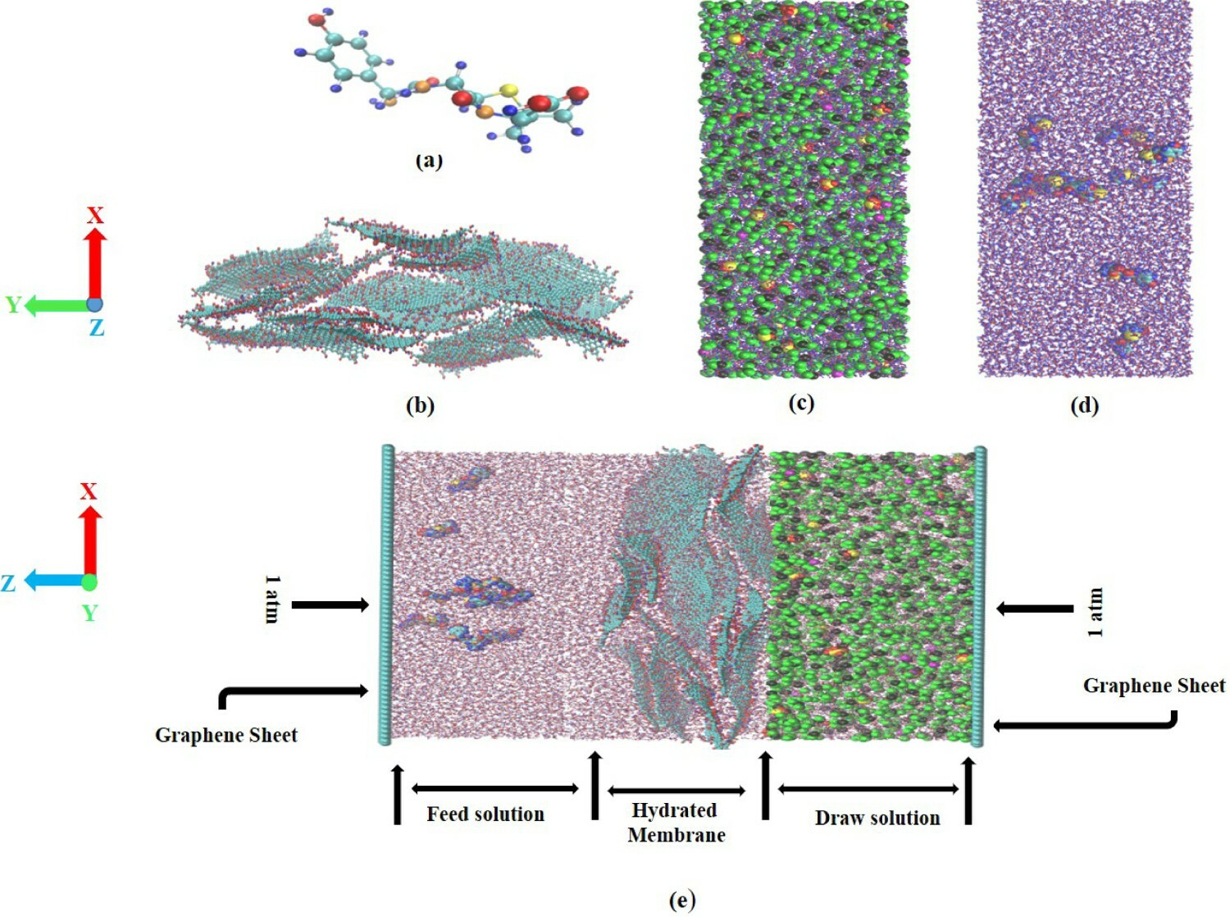

Fig. 1: (a) Amoxicillin molecule. (b) GO membrane. (c) Draw solution. (d) Feed solution. (e) Simulation system. Cyan colour is for carbon atoms, red colour is for oxygen atoms, blue colour is for hydrogen atoms, black colour is for Mg**2+** ions, green colour is for Cl**−** ions, magenta colour is for Al**3+** ions, yellow colour is for sulphur atoms and orange colour is for nitrogen atoms.