**A Python-based program for image reconstruction in a STORM-based Super Resolution Microscope**

Pranjal Choudhury1 and Bosanta R. Boruah1

1 Department Physics, IIT Guwahati, India

E-mail: [*p.choudhury@iitg.ac.in*](mailto:p.choudhury@iitg.ac.in)

**Abstract**

Stochastic optical reconstruction microscopy (STORM) is a method used to overcome the diffraction barrier in optical microscopy, providing a lateral resolution approximately ten times higher than conventional optical microscopes. Single-molecule localization is employed in STORM to generate a super-resolved image by reconstructing a sequence of diffraction-limited images of sparsely distributed, single photoswitchable fluorophore molecules. As this sequence is often long and requires precise estimation of molecule positions with sub-diffraction precision, specialized software is necessary for data processing. This study introduces an open-source, interactive, modular, and platform-independent software developed in Python. The software offers a comprehensive set of tools for processing, analysing, and visualizing STORM data. It includes an extensive collection of processing and post-processing methods, which have been thoroughly tested using both real and simulated data. This software has potential applications in various fields, such as cellular biology, biotechnology, medical research, and nanotechnology. This work discusses the implementation of the program and the preliminary results, highlighting its contribution to advancing the field of optical microscopy.

**Keywords**: STORM, SMLM, super-resolution microscopy, localization microscopy

Figure 1: (a) simulated stack of STORM images of tubulin filaments, (b) widefield image of the tubulin dataset,

(c) least square fitting of the image data with a gaussian PSF model, (d) image obtained by processing (localization and reconstruction) the complete stack.

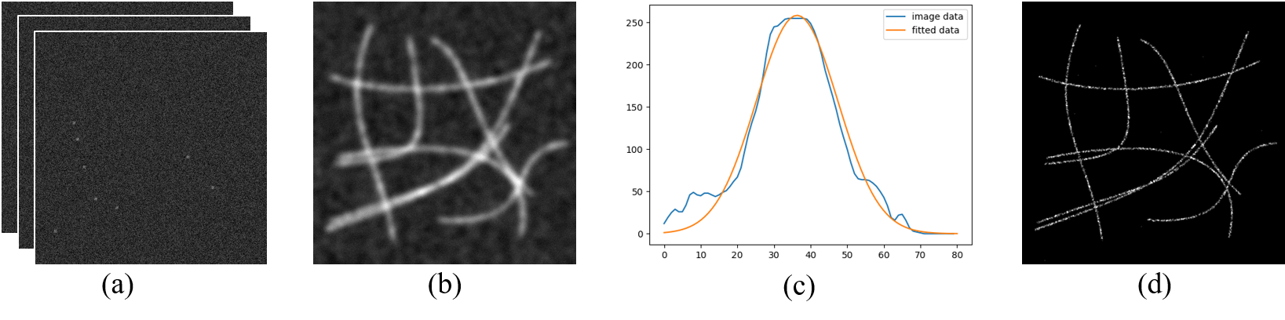

**References:**

1. Betzig, Eric, et al. "Imaging intracellular fluorescent proteins at nanometer resolution." *science* 313.5793 (2006): 1642-1645.
2. Huang, Bo, Hazen Babcock, and Xiaowei Zhuang. "Breaking the diffraction barrier: super-resolution imaging of cells." *Cell* 143.7 (2010): 1047-1058.
3. Mortensen, Kim I., et al. "Optimized localization analysis for single-molecule tracking and super-resolution microscopy." *Nature methods* 7.5 (2010): 377-381.