**Development of Interatomic Potentials using Structural and Thermodynamic Data**

**Padma K Padmanabhan, 1* Pujarini Mahapatra,2**

1Dept. of Physics, IIT Guwahati, Guwahati, India

2Dept. of Physics, IIT Guwahati, Guwahati, India

[*padmakumarp@iitg.ac.in](mailto:*padmakumarp@iitg.ac.in)

**ABSTRACT**

Molecular dynamics simulation is one of the most powerful computational techniques to study the desired physical systems at atomic level. However, the accuracy of simulated data mostly depends on the type of force field and the parameters used for the system. Among different interatomic potentials Lennard-Jones (L-J) potentials is the most widely used due to its simple functional form with fewer number of parameters. So, in this work our aim is to develop a new set of parameters of the L-J potential for argon system using structural and thermodynamic data by implementing Newton Raphson method. The accuracy of calculated potential parameters is verified by simulating the argon crystal in NPT ensemble using LAMMPS program. The results are in good agreement with the standard values. Later this method is extended to develop the potential parameters for other L-J structures like BCC and SC. The structural and thermodynamic properties for argon system are shown below.

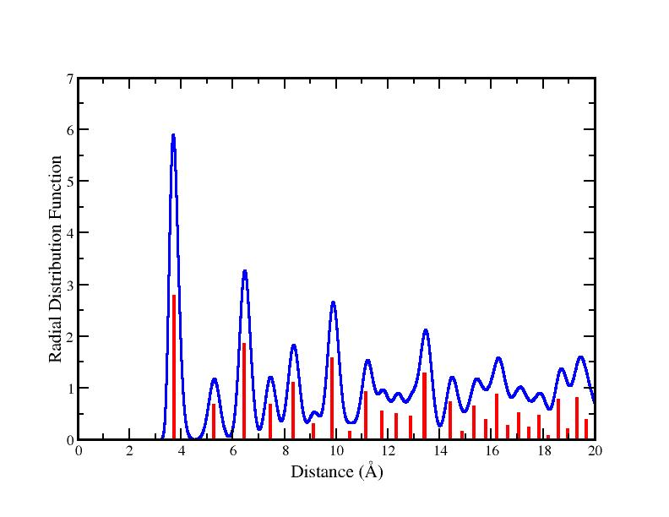 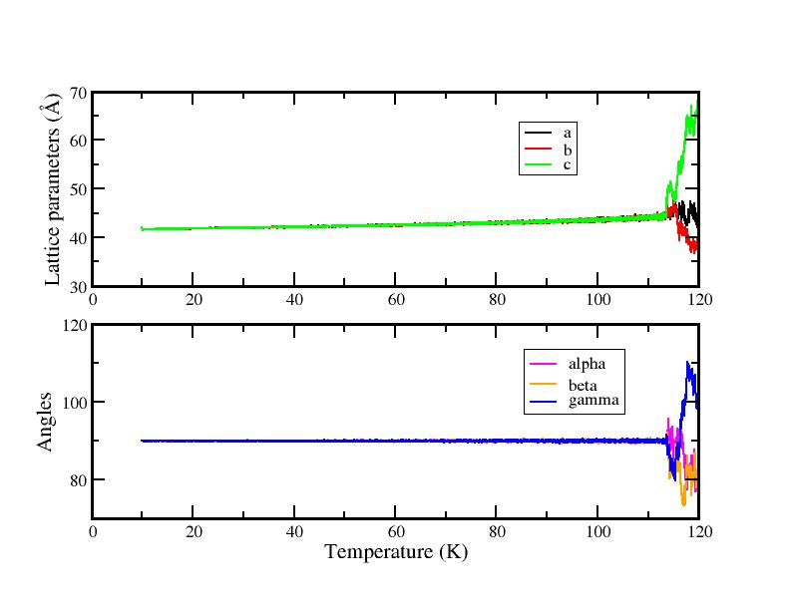

**Keywords:** Potential parameters, Molecular dynamics simulation, Thermodynamic properties, Newton Raphson method.

**Reference**

V.P. Filippova, S.A. Kunavin, and M.S. Pugachev, Materialovedenie, 2014, No. 6, pp. 3-6