**Generation of bio-electricity by indoor plant based microbial fuel cell (PMFC) to power electronic devices**

**Pranab Jyoti Sarma1*, Barasa Malakar1, Kaustubha Mohanty1,2**

*1School of Energy Science and Engineering, Indian Institute of Technology Guwahati, Guwahati - 781039, India*

*2Department of Chemical Engineering, Indian Institute of Technology Guwahati, Guwahati - 781039, India*

* *Corresponding author, e-mail:* [*s.pranab@iitg.ac.in*](mailto:s.pranab@iitg.ac.in)

**Abstract**

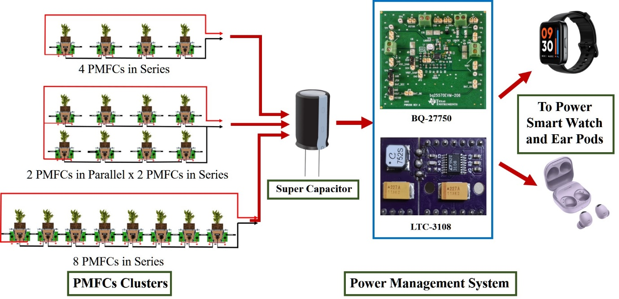

Plant based microbial fuel cell (PMFC) is an excellent way to generate sustainable bioelectricity. Different indoor plants viz., *Epipremnum aureum*, *Philodendron erubescens* and *Anthurium andreanum* were chosen for this study. Among all the PMFCs, *P. erubescens* showed highest performance, with the power density and current density of 32.21 mW m-2 and 63 mA m-2 respectively. However, the power output from individual PMFC is not sufficient for practical application. Therefore, the role of a power management system comes in to play to increase voltage output and deliver a stable power. PMFCs were arranged in two different cascades to increase power output and to understand the role of series parallel connections. Cascade I consist of 3 Parallel PMFCs × 3 series connected PMFCs whereas Cascade II has 2 Parallel PMFCs × 4 series connected PMFCs. Each module was first connected to a super capacitor (3.3 F, 2.7 V) which is then used to power the dc boost converter. The effects of charging and discharging times of super capacitors for each module were also investigated. The dc boost converter BQ25570 helps to step-up the voltage of stacked PMFCs while providing a regulated output voltage of 4.5 V to charge a Li-Polymer battery of 3.3V,300 mAh. The battery was further used to charge a smart watch and ear pod along with powering a LED bulb.

***Keywords:*** Bioelectricity; PMFC; Power management system; Renewable power source