**Effect of Production Rate on Oil Recovery from a 3D Heterogeneous Reservoir and Production Optimization Using Machine Learning Model**

Rupak Bhowmik1*, Anugrah Singh1

1Department of Chemical Engineering, IIT Guwahati, Assam-781039, India

*Email Id: [rprupak@iitg.ac.in](mailto:rprupak@iitg.ac.in)

**Abstract**

Improvement of the ultimate recovery of crude oil from a petroleum reservoir is critical to meet the growing energy demand of the World. Many secondary methods have been developed to improve recovery, and water flooding is one of the most widely used and economically reliable secondary recovery methods. The success of water flooding depends on how efficiently it can sweep the crude oil remaining in the reservoir. The demand and supply of crude oil are dynamic in the oil field due to pricing and production cut. Available literature gives us an idea of how one can enhance production by selecting well patterns and well configuration, controlling injection wells and rates, changing the location of wells, and smart water flooding. However, no literature is available on the economic improvement of water flooding by controlling the production rate at a particular injection rate. In the present work, simulations were performed at different injection and production flow rates for two-phase flow in a 3D heterogeneous reservoir with a five-spot scheme (Fig. 1(a)). The fundamental principle of the mass balance equation and Darcy's law for multiphase flow is employed to describe the two-phase oil-water flow. The governing equations are then solved for pressure and saturation in MATLAB Reservoir Simulation Toolbox (MRST), assuming steady, laminar, and Newtonian flow.

To investigate the effect of injection and production rate control, cumulative water and oil production, recovery factor, and net present value (NPV) were calculated. It was found that the economy of waterflooding can be improved by controlling the production rate at a particular injection rate, as shown in Fig. 1(b). The effect of injector location was also studied, and the variation in NPV at different injector locations is shown in Fig. 1(c). Overall, by controlling the production rate with an optimized well location, the economy of the water can be improved. Results from this study may help production cut or increase production without affecting the overall recovery of the process. The synthetic data from MRST at different production and injection flow rate combinations were trained using a Machine learning model for production optimization. The random search strategy of the algorithm combining with hyperparameter tuning of the Multilayer Perceptron model produces good results.

**Keywords:** Heterogeneous media, Reservoir simulation, Waterflooding, Optimization, Recovery factor, Net present value, Machine learning

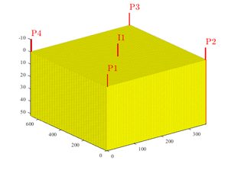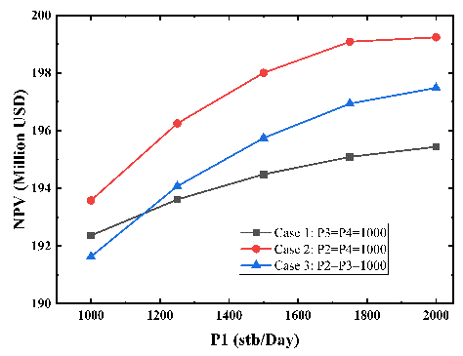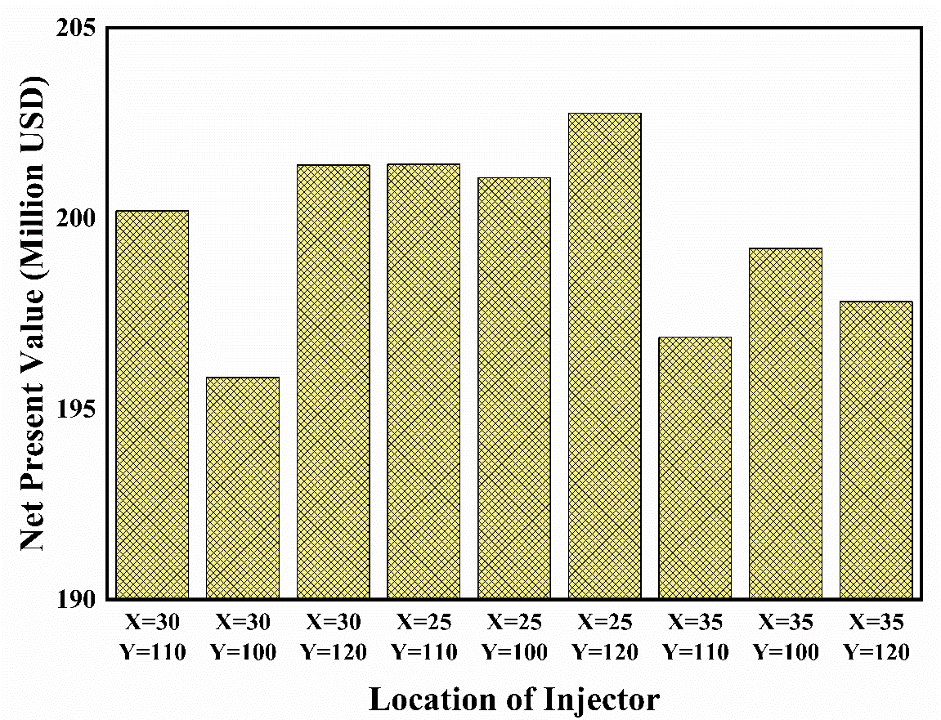

**(a)**

**(b)**

**(c)**

Figure : a) Schematic of Reservoir model, b) effect of production rate control on NPV at injection rate of 6000 stb/day,

c) effect of injector location at injection rate of 6000 stb/day

**References:**

1. Alhuthali, A. H., Oyerinde, D., & Datta-Gupta, A. (2006). Optimal Waterflood Management Using Rate Control. In *Proceedings - SPE Annual Technical Conference and Exhibition* (Vol. 3, 2053–2071). Society of Petroleum Engineers (SPE).
2. Ogbeiwi, P., Aladeitan, Y., & Dickson Udebhulu, (2018). An Approach to Waterflood Optimization: Case Study of the Reservoir X. *Journal of Petroleum Exploration and Production Technology*, ***8***, 271–289.
3. Dake, L. P. (1983). *Fundamentals of Reservoir Engineering* (First Edit.). Elsevier Science.