**Paper-Based Microfluidic Fuel Cell (PMFC) Technologies and their Applications**

Sarmistha Baruah1, Akshai Kumar1,2 and Nageswara Rao Peela*1,3

*1Centre for Nanotechnology, Indian Institute of Technology, Guwahati-781039, Assam, India*

*2Department of Chemistry, Indian Institute of Technology, Guwahati-781039, Assam, India*

*3Department of Chemical Engineering, Indian Institute of Technology, Guwahati-781039, Assam, India.*

*Email:* [*s.baruah@iitg.ac.in*](mailto:s.baruah@iitg.ac.in)*,* [*peelanr@iitg.ac.in*](mailto:peelanr@iitg.ac.in)

**Abstract**

The paper-based microfluidic fuel cells (PMFC), introduced in 2014 and utilized for point-of-care testing, diagnostics, and wearable electronics, have drawn a significant attention in recent years. By utilizing the inherent properties of paper substrate and microfluidic reactant stream fluxes, this fuel cell device takes away the requirement of any membranes or external pumps that is necessary in conventional FCs. In co-laminar flow, where PMFCs work, a unique diffusive mixing area serves as a pseudo-membrane by preventing convective mixing of two reactants. The reactants flow by capillary action with the aid of an absorbent pad due to the hydrophilicity and porosity of paper substrate. While the ions transport across the channel through the mixing zone. This not only makes the pumping of fluids into paper-based systems simpler, but also provide numerous other benefits such as low cost, simplicity in manufacturing, and easy disposal. However, these cells can only generate a few milliwatts of power because very low reactant flow rates can be produced on paper. Till now, a variety of fuels such as formic acid, borohydride, hydrazine, biofuels and hydrocarbons have been used in PMFCs. Recent studies demonstrate that suitable fuels in PMFCs boost the power density by three orders of magnitude. Stacking multiple cells raise the working voltage. Due to their capacity to produce adequate power suitable for micro-nano systems (MNS), these types of PMFCs have a lot of application potential in lab-on-a-chip, wearables, and sensors.

**Keywords:** Paper-based microfluidic fuel cells, diffusive mixing, point-of-care testing, co-laminar flow.

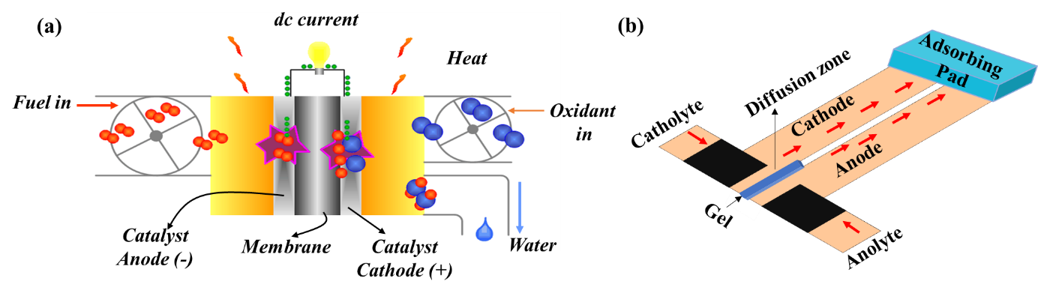

**Figure 1. (a)** Polymer electrolyte membrane-based fuel cells, and **(b)** Paper-based microfluidic fuel cells.

**References**

[1] S. Chandra, S. Lal, V.M. Janardhanan, K.C. Sahu, M. Deepa, Ethanol based fuel cell on paper support, J. Power Sources. 396 (2018) 725–733. https://doi.org/10.1016/j.jpowsour.2018.06.068.

[2] S. Lal, V.M. Janardhanan, M. Deepa, A. Sagar, K.C. Sahu, Low Cost Environmentally Benign Porous Paper Based Fuel Cells for Micro-Nano Systems, J. Electrochem. Soc. 162 (2015) F1402–F1407. https://doi.org/10.1149/2.0251514jes.