**Chemical Reaction mediated Patterning**

**Saurabh Dubey1, Prathu Raja Parmar2, Neeru Yadav2, Nafisa Arfa2, Dipankar Bandyopadhyay1,2,3**

1Centre for Nanotechnology, Indian Institute of Technology Guwahati, Assam, India

2Department of Chemical Engineering, Indian Institute of Technology Guwahati, Assam, India

3School of Health Sciences and Technology, Indian Institute of Technology Guwahati, Assam, India

E-mail: *dipban@iitg.ac.in*

**Abstract**

Chemically patterned nanostructures have great potential for a wide range of applications due to their unique properties and versatility. Chemically patterned nanostructures refer to materials that have been engineered to exhibit specific chemical patterns or structures at the nanoscale. These structures can be fabricated through various methods, such as lithography, chemical vapor deposition, or self-assembly techniques. The chemical patterns created on polymer surfaces using oxidation techniques can be used for a variety of applications, including the fabrication of microfluidic devices, biosensors, and tissue engineering scaffolds. By controlling the chemistry and morphology of the polymer surface, the behaviour of cells and biomolecules can be manipulated, leading to improved performance and functionality of the resulting devices. One of the primary applications of chemically patterned nanostructures is in the field of nanotechnology, where these materials are used to create highly sensitive sensors, high-performance electronics, and novel catalytic systems. For example, patterned nanostructures can be used to create highly selective and sensitive biosensors that can detect minute concentrations of biomolecules, such as proteins and DNA. In addition to their use in nanotechnology, chemically patterned nanostructures also have potential applications in fields such as photonics, optoelectronics, and energy storage. For instance, patterned nanostructures can be used to enhance the efficiency of solar cells by improving light absorption and reducing energy losses. In present study through treatment with hydrogen peroxide and alkali, a patterned texture was produced on a thin film coating of PS/PMMA. By adjusting the time of exposure and the composition of the PS/PMMA mixture, a variety of distinct patterns can be created, which are observable through AFM surface characterization.

**Keywords:** Chemical Reaction, Patterning, Reactive organisation.

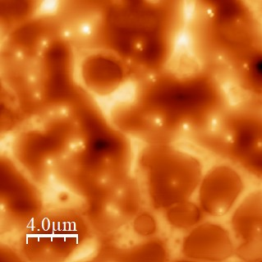 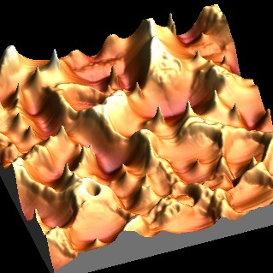 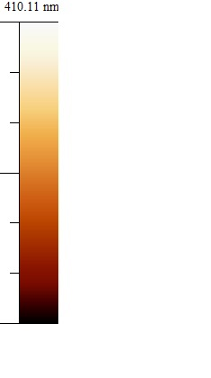

**Figure 1.** AFM image of chemically treated PS substrate.