**Hydrogel from a short tau-derived peptide**

Shubhangini Singh Verma1*, Nitin Chaudhary1

1Department of Biosciences and Bioengineering, Indian Institute of Technology Guwahati, Assam, India.

[shubhangini.sin@iitg.ac.in](mailto:shubhangini.sin@iitg.ac.in), [chaudhary@iitg.ac.in](mailto:chaudhary@iitg.ac.in)

*Corresponding author, Email: [shubhangini.sin@iitg.ac.in](mailto:shubhangini.sin@iitg.ac.in)

The formation of ordered structures from different building blocks got a lot of interest due to their applicability in various fields of chemistry and biology. Self-assembly is a reversible and spontaneous process that results in the formation of well-ordered structures from molecular units [1]. Chemical complementarity and structural compatibility are two crucial aspects of forming these ordered structures, which necessitate non-covalent interactions that can be intermolecular or intramolecular [2]. Proteins and peptides are more attractive than other self-assembly molecules since they are a component of the biological system. The presence of various groups on amino acid residues makes protein or peptide self-assembly more appealing. It assists proteins in folding and performing their functions [3].

The self-assembly aids in the gelation of peptides. Hydrogels are formed by the polymers of hydrophilic moieties (such as -NH2, -COOH, -CONH2, -OH, -SO3H, and -CONH) that hold a good amount of water by making networks between the polymer chains. They have good flexibility due to their high-water content. Hydrogels are more favorable in the biological field since they provide biocompatibility and biodegradability [4]. Hydrogels are typically formed from natural polymers with a high molecular weight as well as synthetic polymer molecules [5]. Because of their intrinsic biocompatibility and biodegradability, tiny synthetic hydrogelators based on amino acids or peptides are of particular interest [6]. Biopolymer hydrogels are widely employed in 3-D cell culture, tissue engineering, drug delivery, self-healing, and microfluidics, as well as in the food and pharmaceutical industries [7], [8]. These soft materials provide viscoelastic and mechanical qualities for the creation of biomaterials in addition to these biologically relevant properties [9].

Short peptides' hydrogelation characteristics and biological applications are the focus of this research. The use of short peptides can lower synthesis costs and make gelation feasible. Cell culture and drug delivery will benefit from the dense network's support media. It will serve as an excellent support medium for cell culture and drug delivery, which we will investigate further in the future. In this study we have seen the hydrogelation property of a short stretch of peptide named Peptide-6, identified from tau protein. The peptide fails to cause gelation of water and 50 mM NaCl solutions. However, transparent gel was obtained for phosphate-buffered saline (PBS). Gelation of PBS is an interesting aspect for the biomedical applications, the investigations for which are underway.

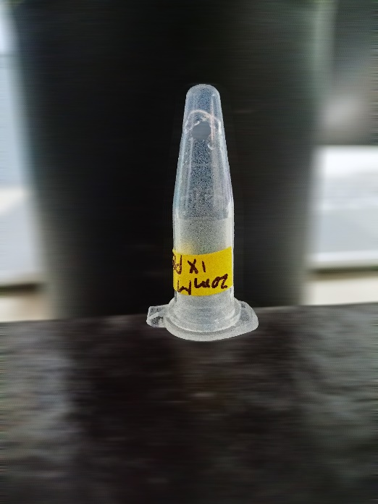

**1**

**Fig.1 Gelation of PBS caused by peptide-6.**

**References**

[1] D. Mandal, A. Nasrolahi Shirazi, and K. Parang, “Self-assembly of peptides to nanostructures,” *Org. Biomol. Chem.*, vol. 12, no. 22, pp. 3544–3561, 2014, doi: 10.1039/c4ob00447g.

[2] L. Ruan *et al.*, “Designed amphiphilic peptide forms stable nanoweb , slowly releases encapsulated hydrophobic drug , and accelerates animal hemostasis,” vol. 106, no. 13, pp. 1–6, 2009, doi: 10.1073/pnas.0900026106.

[3] C. A. E. Hauser and S. Zhang, “Designer self-assembling peptide nanofiber biological materials,” *Chem. Soc. Rev.*, vol. 39, no. 8, pp. 2780–2790, 2010, doi: 10.1039/b921448h.

[4] J. Y. Sun *et al.*, “Highly stretchable and tough hydrogels,” *Nature*, vol. 489, no. 7414, pp. 133–136, 2012, doi: 10.1038/nature11409.

[5] A. Dasgupta, J. H. Mondal, and D. Das, “Peptide hydrogels,” *RSC Adv.*, vol. 3, no. 24, pp. 9117–9149, 2013, doi: 10.1039/c3ra40234g.

[6] L. M. De Leon Rodriguez, Y. Hemar, J. Cornish, and M. A. Brimble, “Structure-mechanical property correlations of hydrogel forming β-sheet peptides,” *Chem. Soc. Rev.*, vol. 45, no. 17, pp. 4797–4824, 2016, doi: 10.1039/c5cs00941c.

[7] Q. Chai, Y. Jiao, and X. Yu, “Hydrogels for biomedical applications: Their characteristics and the mechanisms behind them,” *Gels*, vol. 3, no. 1, 2017, doi: 10.3390/gels3010006.

[8] “2019_Hydrogel Formation by an Aromatic Analogue of a β-Amyloid Fragment, Aβ16–22 - A Scaffold for 3D Cell Culture.pdf.” .

[9] D. T. Eddington and D. J. Beebe, “Flow control with hydrogels,” *Adv. Drug Deliv. Rev.*, vol. 56, no. 2, pp. 199–210, 2004, doi: 10.1016/j.addr.2003.08.013.