**Abstract for Research & Industrial Conclave 2023**

Suchismita Dhar1, Saswati Soumya Mohapatra3, Ashis Biswas3 and Rajiv K. Kar1,2,*

1Jyoti and Bhupat Mehta School of Health Sciences & Technology, 2Center for Nanotechnology, IIT Guwahati, India

3School of Basic Sciences, IIT Bhubaneswar, India

*E-mail: *rajivkar@iitg.ac.in*

**Understanding Molecular Basis of Insulin Fibrillation Inhibition by Bile Salts**

Insulin therapy for managing diabetes is often affected by insulin-induced amyloidosis, characterized by dispositioning of amyloid fibrils in the subcutaneous region, mainly at the injection site [1]. Amyloidosis refers to the abnormal accumulation of insoluble protein aggregates, also known as fibrils, which can disrupt normal cellular functioning. In our collaborative research, we examine the ability of two bile salts (taurocholic acid – TCA and taurodeoxycholic acid - TDCA) to suppress insulin fibrillation using low-resolution spectroscopic methods such as thioflavin-T (ThT) and 8-aniline-1-naphthalene sulfonate (ANS) fluorescence, circular dichroism (CD), dynamic light scattering (DLS), and transmission electron microscope (TEM). According to the biophysical measurements, both bile salts can reduce fibril formation by influencing various stages of the fibrillation process. In particular, it was found that TDCA inhibits more than 90%, whereas TCA inhibits tentatively 60% of fibril formation. Though these bile salts affected the kinetics of amyloidogenesis, their exact mechanism remains a puzzle. Herein, we used molecular docking to find significant residual contacts with TCA and TDCA ligands affecting insulin fibrillation.

We used docking simulation by tuning the exhaustiveness parameters (range from 8 to 32) to examine the binding pose of bile salts onto the insulin macromolecule [2]. The best conformation was chosen for insulin based on its binding affinity. Furthermore, the analysis of residual interaction between the bile acids and insulin is validated from the reported literature. Our simulation results indicate that both the bile salts are involved in polar and hydrophobic interactions. However, such contacts' strength is determined based on the tentative distance between interacting atoms between the protein and ligand. In particular, stable binding poses were found in TDCA compared to TCA (Figure 1). Furthermore, we found that most polar contacts between TDCA and insulin are more substantial (ca. ≤3 Å), which, however, are absent in the case of TCA. On the other hand, the magnitude of hydrophobic contacts is of the same strength (ranging between 3.5 to 4 Å). The theoretical results agree with the experimental evidence and give additional insights into the mechanism of insulin fibril inhibition by bile salts.

**Keywords:** insulin, bile salts, aggregation, inhibition, molecular docking.

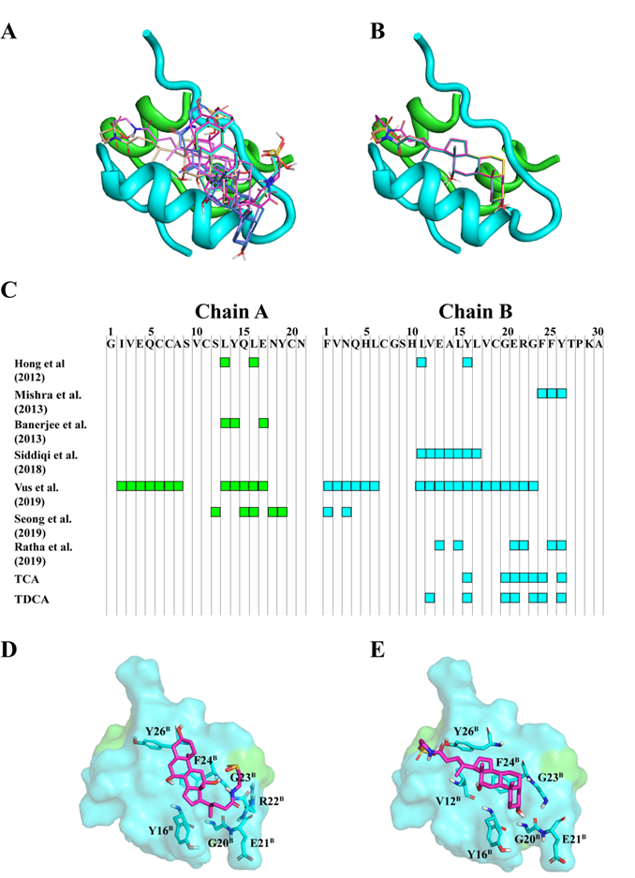

**Figure 1:** Docking pose of (A) TCA and (B) TDCA obtained from molecular docking simulation. The insulin macromolecule is shown in cartoon representation and ligands are shown in stick representation.

**References:**

[1] Fagihi and Battacharjee, ACS Pharmacology & Translational Science, 2022. DOI: <https://doi.org/10.1021/acsptsci.2c00174>

[2] Eberhardt et al. Journal of Chemical Information and Modeling, 2021. DOI: <https://doi.org/10.1021/acs.jcim.1c00203>