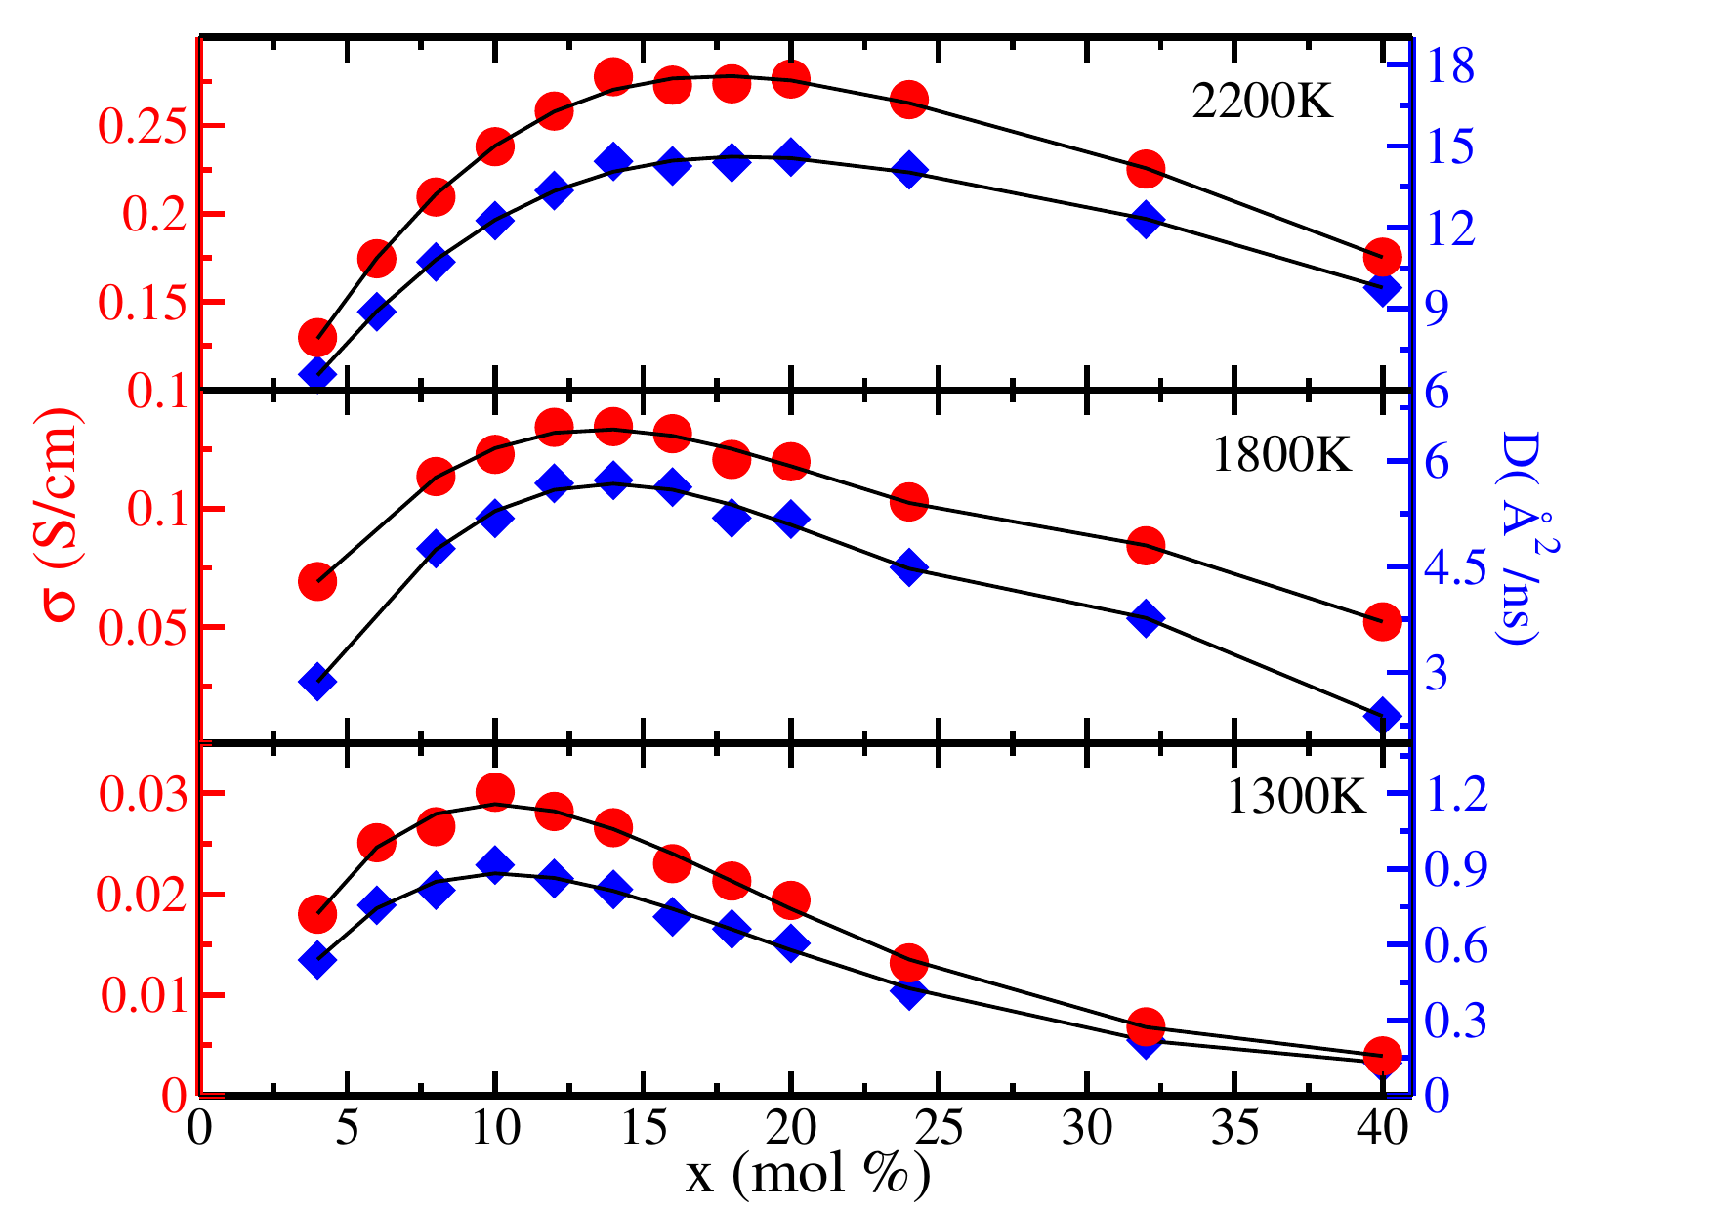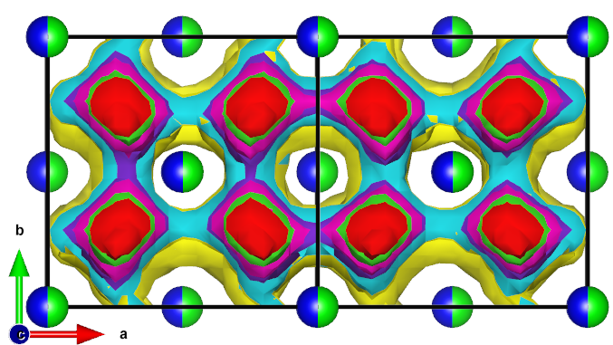**Molecular Dynamic studies on ZrO2  based SOFC Materials**

**Sudeshna Madhual,1 Krishnanjan Pramanik,2 Padma Kumar Padmanabhan3**

Dept. Of Physics, IIT Guwahati, Guwahati, India

padmakumarp@iitg.ac.in

**ABSTRACT**

For efficient performance of SOFCs, zirconia doped with various rare earth dopants like Y3+,Gd3+, Sm3+, Yb3+ are considered as a standard electrolyte material, to fulfill the requirement of oxygen ion conduction, where YSZ is the most promising electrolyte for SOFC at an operating temperature around 1300K. Here YSZ is investigated by molecular dynamics simulation in a temperature range over 800K– 2200K and concentration range over 4- 40% to probe the role of oxide ion conduction at the microscopic level. The self-diffusion constant (D) (related to ionic conductivity) increases with dopant concentration and is found to reach the maximum value at x=10%. Also, along with temperature, the ionic conductivity increases and gives a higher value at 2200K. The oxygen migration occurs along straight channels parallel to the crystallographic axes, connecting the tetrahedral holes of the fluorite lattice occupied by them. Analysis of oxygen environments (coordinated to Y 3+ and Zr 4+ cations) and the energetics of the channels connecting the tetrahedral holes and their contribution to overall oxygen transport, resolved in terms of the cationic edges bridging them, provides fresh insights on the oxygen migration mechanism in this system.[1,2]

Fig. *(Left):* Spacial distribution of oxygens over two unit cells are shown for a few iso-density values (increasing from yellow to red) in the fluorite structured YSZ, (for x =24 mol% from present MD simulations at 1300 K). The split-balls in blue/green colors indicate the cation sites, which may be occupied by the Zr4+ or Y 3+ ions.

*Fig. (Right) :* Oxygen ion self diffusivity (blue) and corresponding ionic self-diffusivity (red) in Yttria Stabilized Zirconia for concentration x, ranging over 4-40 mol %, at 1300 K, 1800K, and 2200K.

***Keywords* :**- *Solid Oxide Fuel Cell (SOFC), Yittria Stabilised Zirconia(YSZ), Molecular Dynamics(MD).*

**References:**

2. **Sudeshna madhual,** Krishnanjan Pramanik and P. Padma Kumar “*Understanding Oxide Ion Transport In Yttria Stabilized Zirconia: Fresh Insights from Molecular Dynamics Simulations*”*Phys. Chem. Chem. Phys*,24, 18281-18290 (2022)

3. **Sudeshna madhual** and P. Padma Kumar *“Insights on Oxide Ion Transport In Yttria Doped Ceria from Molecular Dynamics Simulation” .  J. Mater. Sci., 58, 4499-4512 (2023)*