**Atomistic investigations on mixed halide Li-rich anti-perovskites**

**($Li_{3}OCl_{1-x}Br_{x}$)** **employing** **metadynamics simulations**

**Sunil Kumar Moharana, and Padma Kumar Padmanabhan\***

Department of Physics, Indian Institute of Technology Guwahati, Guwahati, India.

$*$ Mailing address: [padmakumarp@iitg.ac.in](mailto:padmakumarp@iitg.ac.in)

**ABSTRACT**

Over the last few decades, lithium-ion batteries have gained great attention due their high energy density. The next-generation batteries are contemplated to use solid electrolytes instead of liquid/gel electrolytes, which would improve the energy density while ensuring better safety. Recently developed Li-rich anti-perovskite $Li_{3}OCl$ is a promising solid electrolyte due to its high ionic conductivity (0.85 mS/cm) and low activation energy at room temperature[1]. In fact, its mixed halide counterpart, $Li_{3}OCl_{0.5}Br_{0.5}$, shows even higher conductivity of 1.94 mS/cm [1]. In this work, molecular dynamics simulations augmented with metadynamics technique[2,3] is used to investigate $Li_{3}OCl_{1-x}Br_{x}$, where $x=0$ to 1. The study examines microscopic nature of ion transport in the systems, including the preferred migration channels in the system and energy barriers thereof, in an effort to understand the reasons behind the high Li-ion mobility in the matrix. 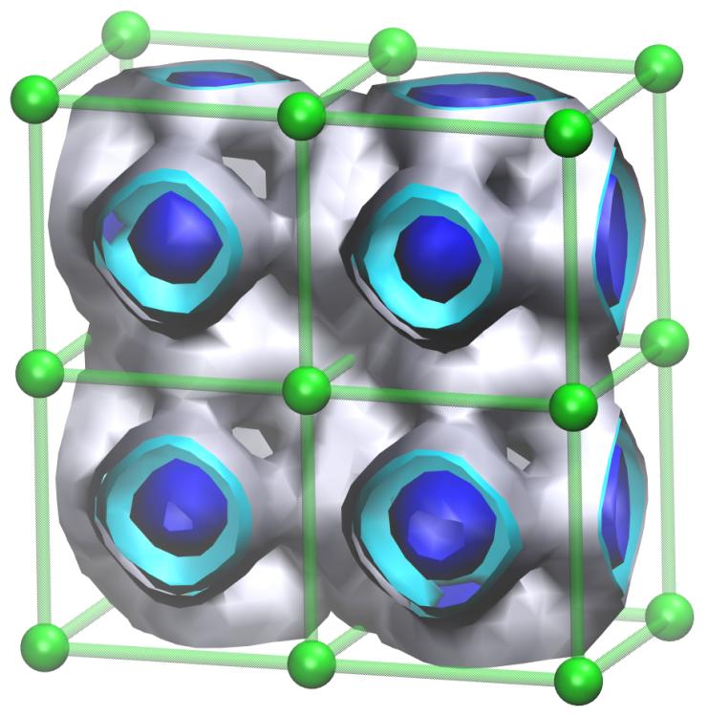 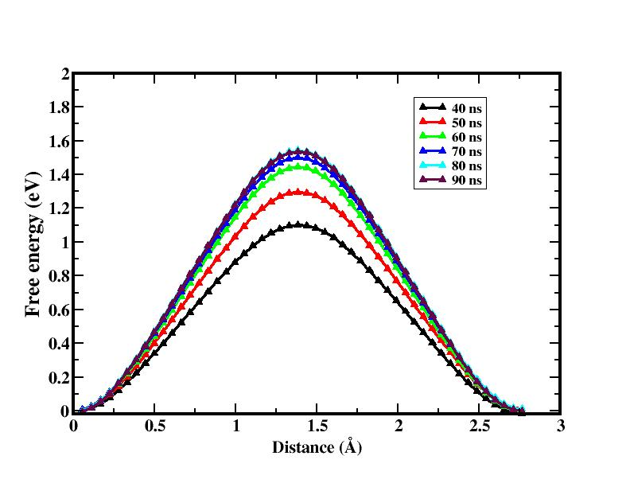 **Fig1.** (Left) Spatial distribution of Li-ions over 2×2×2 unit cells at two iso-density values (yellow < red). (Right) Convergence of microscopic energy barrier for Li-ion hops between two neighboring sites with time in $Li_{3}OCl$.

***Keywords:*** *Solid electrolytes, antiperovskites, molecular dynamics, metadynamics.*

**Reference**

1] Y. Zhao and L. Daemen, *J. Am. Chem. Soc.*, 134(2012), 15042.

2] A. Laio and M. Parrinello, *Proc. Natl. Acad. Sci. U. S. A.*, 99(2002), 12562.

3] K. Pramanik, S. Borah and P.P. Kumar, *Phys. Chem. Chem. Phys.*, 22(2020), 22796.

4] J. A. Dawson, H. Chen and M. S. Islam, *J. Phys. Chem. C, 122(*2018), 23978.