**Development Of MoS2 Decorated MA3Bi2I9 Photocatalyst-Cocatalyst System For Hydrogen Evolution Reaction Under Visible Light Irradiation**

Sushant Sharma1,Parameswar K. Iyer1,2

1Department of Chemistry, IIT Guwahati, India

2Centre for Nanotechnology, IIT Guwahati, India

*E-mail: *ssushant@iitg.ac.in* *and* *pki@iitg.ac.in*

**Abstract**

The high toxicity of lead-based perovskite photocatalyst and its material instability hinders its real time ability for H2 production application. MA3Bi2I9, a quasi 2D perovskite, is a good lead-free alternative as photocatalytic semiconducting material for solar hydrogen fuel production by haloacids splitting. In our work, we have developed a heterostructure photocatalyst-cocatalyst composite where a flower like MoS2 cocatalyst is embedded to MA3Bi2I9 photocatalyst crystal (MA3Bi2I9@MoS2) for hydrogen evolution reaction by photocatalytic splitting of aqueous hydrogen Iodide solution (HI) by visible light irradiation. The as synthesized MA3Bi2I9@MoS2 composite is characterized by using XRD, FT-IR, SEM, TEM, EDX, EIS, XPS and PL study. .

**Keywords:** lead free perovskite, MoS2, composite, photocatalysis, hydrogen evolution



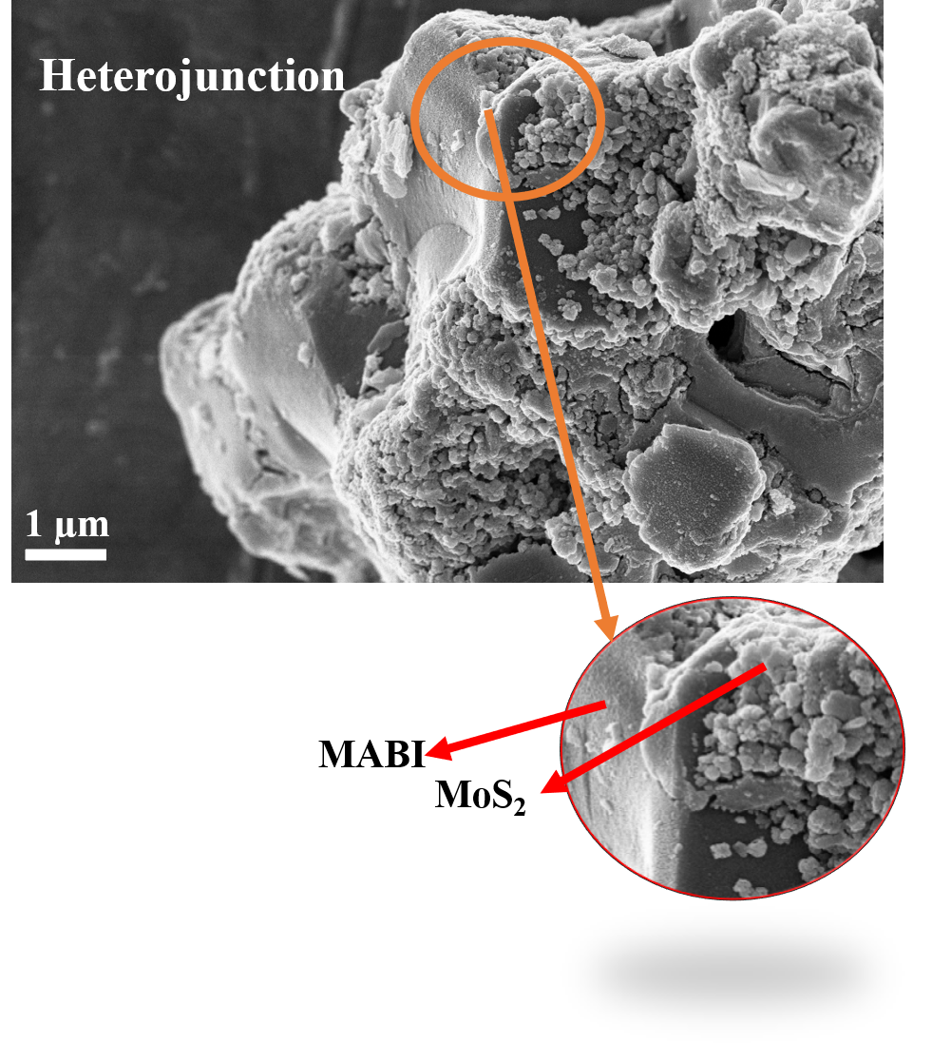

**Figure :** MA3Bi2I9/MoS2 heterojunction