**Thermal Transport Characteristics of Viscoelastic Fluids in a Soft Nano-fluidic Channel under AC electric field**

Subrata Bera* and Priyanka Koner

Department of Mathematics, National Institute of Technology Silchar, Silchar 788010, India

* E-mail address: subrata@math.nits.ac.in

**Abstract**

In this study, we have theoretically investigated the Joule heating-induced convective heat transfer for oscillating EOF of viscoelastic fluids in a cylindrical soft nanochannel, considering the ion partitioning effect under the imposed constant wall heat flux boundary conditions. A polyelectrolyte layer (PEL) with uniform thickness is grafted on the inner surface of the nanochannel wall where the charge density of the PEL and nanochannel wall surface potential are of opposite polarity. The PEL is treated as a semi-permeable interface, in which the electrolyte ions can be presented inside and outside the PEL. The ion partitioning effects develop due to the variation of permittivity between the electrolyte solution and PEL and are measured by the Born energy formula. Assuming the Debye-Huckel approximation for low surface potential, the linearized Poisson-Boltzmann equation gives the distribution of induced potential distribution within and outside PEL. The Cauchy momentum equation with the proper constitutive relation of Jeffery fluids provides the distribution of axial velocity in this system. The thermal transport characteristics related to the electrokinetic flow in a soft nanochannel with a constant heat flux situation are executed from the energy equation. It is assumed that the electroosmotically generated flow field is hydrodynamically and thermally fully developed. The analytic expressions for the solutions of induced potential, axial velocity, and energy equation within and outside of the PEL are presented in this study. Furthermore, for boundary conditions of constant wall heat flow, the Nusselt number has been calculated. The presence of the volumetric Joule heating effect generates a noticeable temperature gradient in the axial direction, which induces a considerable temperature increase within the channel. In this study, significant insights are also made out regarding the influence of scaled charge density, permittivity ratio between PEL and electrolyte region, and softness parameter on the fluid and the thermal transport to account for the effect of the ion partitioning. The results for velocity and thermal transport are also presented in terms of oscillating Reynolds number and normalized relaxation depicting the viscoelastic behaviour. Additionally, the Nusselt number results are shown and thoroughly discussed.

**Student Academic Board (SAB), Indian Institute of Technology Guwahati, Guwahati, Assam, India**

**Research & Industrial Conclave 2023 "An amalgamation of Academia, Industry & Start-up”**

**"**

**Keywords:** Ion partitioning effects, Soft nanochannel, Cauchy momentum equation, Energy equation.

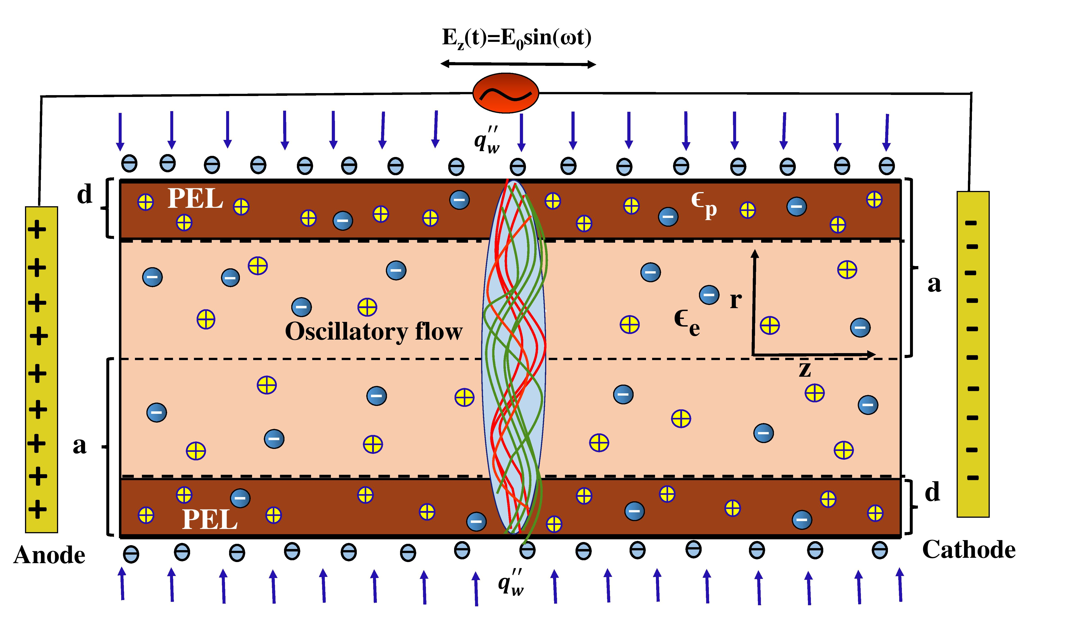

**Figure 1:** Schematic diagrams of the EOF through a soft nanofluidic channel under the AC electric field.

**References**

1. Probstein, RF. (2005) Physicochemical hydrodynamics: an introduction.Wiley, Hoboken
2. Born, Max. (1920) Volumen und hydratationsw¨arme der ionen. Zeitschrift f¨ur Physik, 1(1):45–48.
3. Poddar, A. Maity, D. Bandopadhyay, A. Chakraborty, S. (2016) Electrokinetics in polyelectrolyte grafted nanofluidic channels modulated by the ion partitioning effect. Soft Matter 12(27):5968–5978