**Effect of low-pressure Nitrogen plasma on surface wettability and ageing characteristics of cellulose nitrate membrane**

Tonmoi Hazarika1,2*, Bharat Kakati1, Rimlee Saikia1,2 and Manoj Kumar Mahanta3

1META Laboratory, Assam Science and Technology, University, Jalukbari, Guwahati-13, Assam, INDIA

2Department of Physics, Gauhati University, Jalukbari, Guwahati-14, Assam, INDIA

3Pragjyotish College, Santipur, Guwahati-09, Assam, INDIA

Email. tonmoihazarika@gauhati.ac.in / bkakati@astu.ac.in

**Abstract**

Fouling of polymeric membranes is a common problem due to its hydrophobic nature. Plasma assisted surface modification of polymeric membranes are immensely popular method in particular for the improvement of antifouling and adhesive properties. The time dependent hydrophilicity or ageing of polymer surfaces is the major challenges of plasma assisted surface modification process. The effect of low-pressure nitrogen plasma on surface hydrophilicity, permeate flux and ageing effect for the cellulose nitrate polymer membrane are studied in the present work. Wettability of membrane is studied as a function of plasma treatment time for treated and untreated membrane. From the contact angle measurement, it is found that the hydrophilicity of the plasma treated membranes increases with plasma treatment time. From gravity filtration process, the enhancement of permeate flux for both waste water and mud water are observed after plasma treatment. Whereas the rejection rate is found almost unaltered. The ageing mechanism of the treated membranes is investigated for 30 days for different plasma treatment time. The hydrophobic recovery of plasma treated membranes is significant for initial ageing period of 7 days, after that it has shown almost stable in nature.

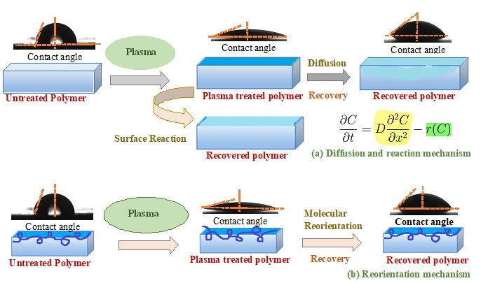

**Fig. 1:** Mechanisms of hydrophobic recovery (a) Diffusion and reaction mechanism (b) Reorientation mechanism.

**Keywords**: Cellulose nitrate membrane, N2 plasma, hydrophilicity, ageing, rejection.

**References.**

[1] D. Pal, S. Neogi, S. De. Surface modification of polyacrylonitrile co-polymer membranes using pulsed direct current nitrogen plasma. [Thin Solid Films](https://www.sciencedirect.com/journal/thin-solid-films) [Volume 597](https://www.sciencedirect.com/journal/thin-solid-films/vol/597/suppl/C), 31(2015) 171-182.

[2] D. Pal, S. Neogi, S. De. Hydrophilic surface modification of polyacrylonitrile based membrane: effect of low temperature radio frequency carbon dioxide plasma. Polym. Bull. (2018) 75:3567–3586.

[3] M. Mortazavi, M. Nosonovsky. A model for diffusion-driven hydrophobic recovery in plasma treated polymers. Applied Surface Science 258 (2012) 6876–6883