Enhancing early age hydration and carbon sequestration of dicalcium silicate using TiB2 derived nanosheets

Vikash Kumar Singh1, Kabeer Jasuja2 and Gaurav Srivastava1

1 Discipline of Civil Engineering, IIT Gandhinagar, India

2 Discipline of Chemical Engineering, IIT Gandhinagar, India

E-mail: vikash.singh@iitgn.ac.in

Abstract

Enhancing the proportion of dicalcium silicate (C2S) in portland cement is an effective method to mitigate the environmental impact of cement production. However, the early age strength development in C2S is insignificant when compared to that of tricalcium silicate (C3S). Mixing of additives during C2S synthesis has been known to stabilize C2S and enhance its hydration behaviour. There has been a growing interest in incorporating graphene, the pioneering 2D nanomaterial, as a sustainable additive in concrete. The superior mechanical and catalytic properties exhibited by graphene not only reinforces the composite but also influence the stabilization and hydration behaviour of C2S. The present work investigates the candidacy of a relatively new class of nanosheets derived from Titanium diboride (TiB2), a class of 2D materials recently discovered by us, as cement additives. We find that addition of 3% chemically modified TiB2 nanosheets increases the formation of β-C2S polymorph by ∼4 times. Isothermal calorimetry of the stabilized C2S reveals an increased peak heat and cumulative heat evolution during the early age hydration (24 hours) indicating that the TiB2 based nanosheets also enhance the rate of C2S hydration. Long-term hydraulic characterization (28 days) of C2S also indicates a higher degree of hydration in the nano-modified samples. TiB2 derived nanosheets also enhanced the carbon sequestration efficiency of the dicalcium silicate. Nano-modified C2S showed 3 times more carbon capture than the pure C2S samples. This unconventional, and yet rich, prospect offered by TiB2 derived nanosheets exemplifies the potential 2D materials have to offer in developing substantial cement additives and reducing the carbon footprints from atmosphere.

Keywords: Dicalcium silicate; TiB2 derived nanosheets; β phase stabilization; hydration; Rietveld refinement; carbon sequestration

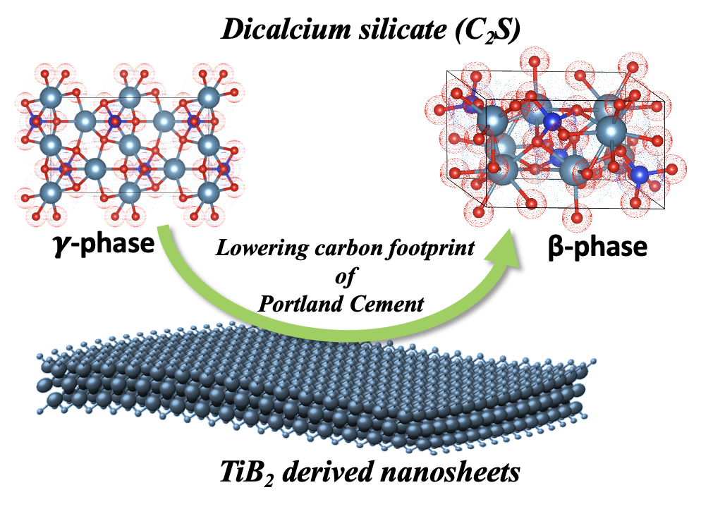

Fig.1 Conversion to water reactive phase of dicalcium silicate using TiB2 derived nanosheets