**Development of a non-reversal valve to prevent the backflow of blood into the existing IV tube**

Todupunuri Varun Sai

Department of Medical Devices, NIPER Guwahati, India

E-mail: *md22mt3027@niperguwahati.in*

# Abstract



**Student Academic Board**

**(**

**)**

**SAB**

**,**

**Indian**

**Institute**

**of**

**Technology Guwahati**

**,**

**Guwahati,**

**Assam,**

**India**

**Research**

**& Industrial**

**Conclave**

**20**

**23**

**"**

**An amalgamation of**

**Academia, Industry & Start**

**-**

**up**

**”**

In the hospital setting, drugs are administered through IV as it is the fastest route of administration and has the highest bioavailability when compared to other routes. But when the IV fluid in the bag completes, the blood from the blood vessels of the patient backflows into the IV tube due to the high BP of patient or due to the negative pressure developed in the IV bag and the blood backflow is visible in the transparent IV tube, especially at the cannula region. These unattended situations can lead to blood loss, swelling, infections, thrombosis, etc. This is a major concern which may be seen in hospitals and may lead to unnecessary complications for patient.

Although a few mechanisms are in the market to prevent these situations, they employ complicated solutions that use Raspberry Pi, IOTs (Internet of Things). Instead, we have developed a non-reversal valve (a ball valve) which can be used as a connector attachment to the existing IV tube at the junction of the cannula and IV tube and can provide a solution to the blood backflow and can save the patient from blood loss and avoid blood transfusions in the future.

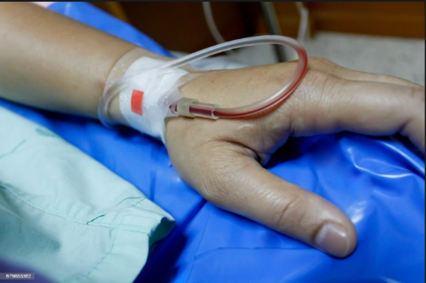 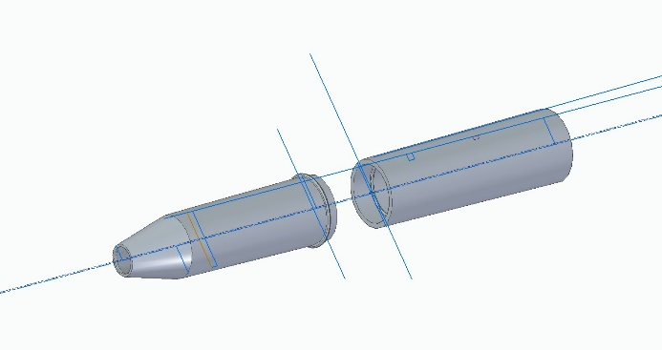

**Figure no-1 Backflow of blood into IV tube Figure no-2 Connector CAD model for prevention**

**after IV completion. of backflow.**

**Keywords:** blood backflow, thrombosis, non-reversal valve, connector.

**References:-**

1. Keerthi, N. S., Raju, A. R. I. S. H. E. L. A., Sowmya, N. A. N. D. A. V. A. R. A. M., & Krishna, D. (2020). Intravenous infusion monitoring system. *Int. J. Recent Develop. Sci. Technol*, *4*(03).
2. Oros, D., Penčić, M., Šulc, J., Čavić, M., Stankovski, S., Ostojić, G., & Ivanov, O. (2021). Smart intravenous infusion dosing system. *Applied Sciences*, *11*(2), 513.
3. Dharmale, A., Mehare, R., Bharti, A., Meshram, S., & Deshmukh, S. (2019). IOT-based saline level monitoring & automatic alert system. *International Journal of Advanced Research in Computer and Communication Engineering*, *8*(4), 72-6