**Effect of Al substitution on magnetic and dielectric properties of polycrystalline Gadolinium iron garnet**

Shalini Verma and S. Ravi

Department of Physics, Indian Institute of Technology Guwahati, Guwahati-781039, India

**Abstract**

A conventional solid-state reaction approach is used to synthesize the polycrystalline $Gd_{3}Fe_{5-x}Al_{x}O_{12}$ samples where $x$ ranges from $0.0$ to $0.6$. The XRD data of all the samples are Rietveld refined by using $Ia\overline{3}d$ space group. The refined plots revealed the single-phase formation and enabled us to determine various lattice parameters as well as the theoretical density of all the samples. The lattice constant, unit cell volume, bond length, bond-angle, average grain size are reduced with Al substitution because of smaller ionic radii of Al in comparison with Fe. These materials represent typical ferrimagnetic behavior and are converted to paramagnetic material at $561K (x=0.0)$ to $524K(x=0.6)$. Along with this transition, the parent sample undergoes magnetic compensation also at around $293K$ which disappears for the Al-doped samples. The saturation magnetization is increased significantly from $0.19 emu/g$ to $4.78 emu/g$ as for $x=0.0$ to $0.6$ samples, respectively. The Al-substituted Gadolinium iron garnet samples exhibited a dielectric constant in the lower frequency region of the order of ${10}^{4}$. This property makes them suitable for various applications, including microwave devices, energy storage devices, and capacitors. Moreover, the ac conductivity increased with Al substitution and followed the Jonscher Power Law accurately.

**Keywords:** Saturation magnetization, magnetic compensation, dielectric constant, ac conductivity

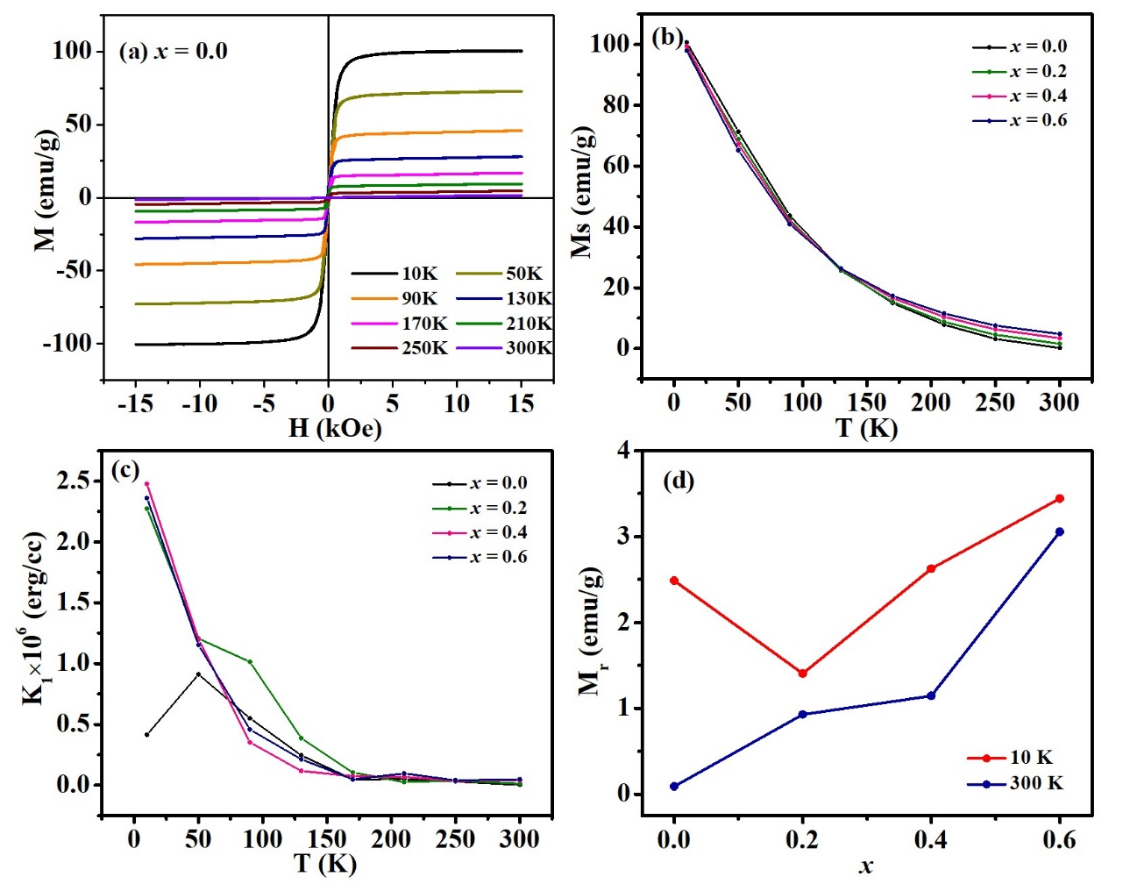

**Fig. 1.** (a) M-H loops at different temperatures, (b,c) variation of saturation magnetization and anisotropy constant with temperature and (d) remnant magnetization of all the samples of Al-GdIG series.

**References**

[1] D. T. T. Nguyet J. of Manet. Mag. Mater. 332 180-185 (2013)

[2] M. A. Dar J. of All. And Comp. 493 553-560 (2010)