

**Indium Tin Oxide (ITO) Glass based Laparoscopic Lens Warmer as a solution for Laparoscopic Lens Fogging**

Harsh Manish Varia

Department of Medical Devices, NIPER-Guwahati, India

E-mail: md22mt3026@niperguwahti.in

**Abstract**

Laparoscopic surgery is a minimally invasive surgical procedure that involves the insertion of a fiber optic cable or a rigid rod into the abdomen and pelvic cavity through small incisions made on the patient’s body. One of the key issues concerning laparoscopic surgery is the fogging of lens that hinders the surgical field-of-vision thus delaying the time for surgical procedures. Laparoscopic Lens Fogging (LLF) is the condensation of water in the form of droplets on the lens surface which arises due to the difference in temperature and relative humidity of lens surface and the abdominal cavity [1]. One of the measures to avoid lens fogging is to warm the scope up to body temperature (37.5°C). This reduces the dew point and avoids condensation upon insertion into the body cavity [2].

We have developed a scope warmer consisting of ITO glass (see Figure 1) as a heating element and a thermocouple for temperature sensing and temperature controlling is a possible solution for LLF [3]. The ITO element heats based on Joules Heating phenomena and the thermocouple measures the lens temperature and shuts off the heating on reaching the desired temperature thus saving precious surgical time duration.

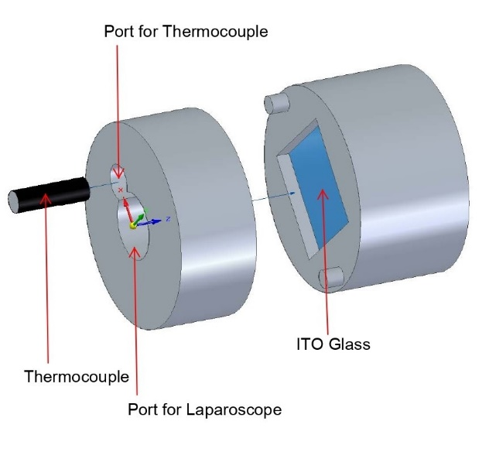

Figure 1: ITO based scope warmer

Keywords: Laparoscopic Lens Fogging, scope warmer, ITO glass, thermocouple.

References:

1. Manning TG, Perera M, Christidis D, Kinnear N, McGrath S, O'beirne R, Zotov P, Bolton D, Lawrentschuk N. Visual occlusion during minimally invasive surgery: a contemporary review of methods to reduce laparoscopic and robotic lens fogging and other sources of optical loss. Journal of endourology. 2017 Apr 1;31(4):327-33.
2. Flemming E, Bessell JR, Kunert W, Eibl H, Buess G. Principles determining optical clarity in endoscopic surgery. Minimally Invasive Therapy & Allied Technologies. 1996 Jan 1;5(5):440-4
3. Fayad R, Hajj-Hassan H, Hajj-Hassan M. Transparent ITO-based heater for prevention of laparoscopic lens fogging. In2019 Fifth International Conference on Advances in Biomedical Engineering (ICABME) 2019 Oct 17 (pp. 1-4). IEEE.