**Nutritional and functional constituents of Ahu Kalogoria Germinated rice of three districts in Assam,**

Laky Khatun1* Dr. Subhajit Ray2

1. Ph.D. Scholar, Department of Food Engineering &Technology, Central Institute of Technology Kokrajhar, Kokrajhar, BTAD, Assam:783370, India

2. Associate Professor. Department of Food Engineering &Technology, Central Institute of Technology Kokrajhar, Kokrajhar, BTAD, Assam:783370, India

*Email: lakykhatun16@gmail.com

**Abstract**

Rice is considered to be one of the most important and widely consumed staple food in Asia. It contains significant nutritional and functional constituents both in the germinated and non-germinated form. Whole grain cereals have been found to be a good source of nutritionally valuable substances, such as antioxidants, minerals, vitamins, and dietary fiber. In the present investigation Ahu Kalogoria variety rice ( AKR) (germinated) and their Husk (AKRH) were selected and their nutritional and functional constituents were examined, which are from three different districts i.e. Goalpara(G), Kokrajhar(K), Chirang (C). AKRG contains high calorific value 356.35 kcal/100gm respectively. Magnesium is the most abundant minerals among all the sample. Total flavonoid content of AKRG is 324.75 mg QE/100g and phenolic contents is 353.7 mg GAE/100g. The DPPH scavenging activity 63.25% in AKRG. Both the Ahu Kalogoria rice and their Husk are rich in Nutrition, minerals and phytochemical content , hence it can be consume as a whole rice and to prepare fermented product and also the husk can be use as a suppliment.

Keywords : Ahu Kalogoria rice (AKR), Husk (AKRH) ,Nutritional value, phenolic content, flavonoid content,

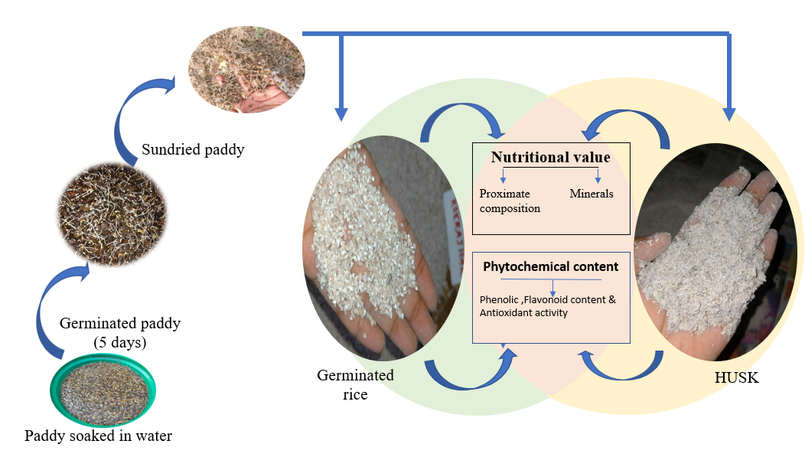

Figure 1: Graphical Abstract