Research & Industrial Conclave­ ­­­



**AUGUST**

**2024**

09-11

­­­­-INTEGRATION’ 2024

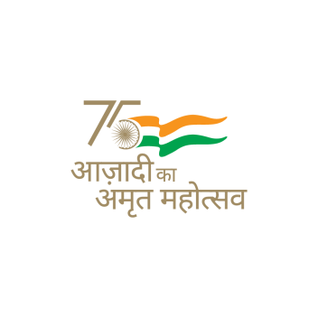­­­­

**PATRON**

**Prof. Devendra Jalihal**

Director, IIT Guwahati &

Chairperson, BoG,

IIT Guwahati Research Park

**EVENTS**

**Scientifique**

Oral, Poster, Model &

3 Minute Thesis Presentation

**Atelier**

Workshops & Hands-on Sessions

**Conaissance**

Lecture Series: Academicians and Industrialists

**Discutir**

Panel Discussions

**Start-Up Pitching**

Start-Up fund raising

**Hackathon**

Thinkers and Makers

**Innovation Exhibit**

Product Display

**CONVENER**

**Prof. Pankaj Kalita**

**Co-CONVENER**

**Prof. RB Sharmila**

**STUDENT CONVENER**

**Mr. Shubham Singh**

# Respected Prof. Abiy,

We hope this letter finds you in good health and spirit!

It gives us immense pleasure to invite you to the 9th edition of **Research & Industrial Conclave - Integration 2024,** during **August 09 - 11, 2024**, It is a flagship event of IIT Guwahati jointly organized by the Students’ Academic Board and IIT Guwahati Research Park.

The event provides a unique platform to nurture young minds toward research, innovation, and entrepreneurship. It promises a wonderful opportunity for budding researchers to interact with eminent personalities from the academic and industrial research fields. Further, Research and Industrial Conclave is designed to catalyze cross-disciplinary interactions, as well as to promote industry-academia collaborations.

With the utmost respect and admiration for your leadership and contributions to our world, we extend to you a heartfelt invitation to serve as a **keynote speaker** at our upcoming conclave. Your dedication to peace and progress, coupled with your visionary initiatives, has inspired countless individuals globally. We believe that your insights and wisdom will greatly enrich our gathering, fostering dialogue and understanding among diverse perspectives.

We eagerly look forward to a talk from you during the conclave where the audience can get motivated and learn from your experiences and ideas. The IIT Guwahati fraternity, as well as the participants from across the country, will be greatly benefited from interacting with you.

We will be very happy to cover all your travel expenses to IIT Guwahati, as well as arrange local hospitality. Please let us know your availability on the aforementioned dates.

Thank you in advance for your kind consideration and we really look forward to hearing from you.

For any queries, you may kindly contact us at:

+91-8920217431 | [shubham.energy@iitg.ac.in](mailto:shubham.energy@iitg.ac.in)

+91-9033551761 | [ahitesh@iitg.ac.in](mailto:ahitesh@iitg.ac.in)

+91-7367088245 | [nikhil1996@iitg.ac.in](mailto:nikhil1996@iitg.ac.in)

­ ­­­

**Mr. Shubham Singh**

Student Convener

Research & Industrial Conclave 2024

­­­­

­­­

­­­­



**Prof. Pankaj Kalita**

Faculty Convener

Research & Industrial Conclave 2024



**Prof. RB. Sharmila**

Faculty Co-convener

Research & Industrial Conclave 2024

**www.linkedin.com/company/rc-iitg**

**www.instagram.com/ric_iitg**

**www.facebook.com/ric.iitg**

**www.ric.iitg.ac.in**

**research_conclave@iitg.ac.in**













**Mr. Nikhil Mishra**

Student Co-Convener

Research & Industrial Conclave 2024