Investigation of photoluminescence modulation of monolayer WS₂ sandwiched between SiO₂ layers: Doping effect vs. quantum well effect

Aalekhya Saha1 , Abhilasha Bora*2 and P.K. Giri*1,2

1 Department of Physics, IIT Guwahati, India
2 Centre for Nanotechnology, IIT Guwahati, India

E-mail: s.aalekhya@iitg.ac.in

Abstract

The advent of graphene led to an ever-increasing search for two dimensional (2D) materials in the scientific community owing to their excellent mechanical, optical and electrical properties. One such class of 2D materials are transition metal dichalcogenides (TMDs), which gained popularity due to their tuneable non-zero band gaps and excellent optoelectronic properties in the monolayer regime. Monolayer (1L) WS₂ is an n-type semiconductor. In this report, we have grown 1L-WS₂ using Chemical Vapour Deposition (CVD) on SiO₂ substrate. An SiO₂ film was deposited on top of the as-grown 1L-WS₂ film via Plasma-Enhanced CVD (PECVD) process. Due to the higher bandgap of SiO₂ layer surrounding the 1L-WS₂, the sandwiched structure would behave like a quantum well. Raman spectroscopy analysis indicated an increase in the overall crystallinity of the 1L-WS₂ due to heat treatment during the PECVD process. The Raman spectra (Fig. 1(a)) indicated strain in the sandwiched 1L-WS₂ given by the redshift in the E_{2g} mode. The shift in A_{1g} mode pointed towards a resultant p-type doping in the sandwiched system. We investigated the modulation of the photoluminescence (PL) in the SiO₂ sandwiched 1L-WS₂. A net quenching of the PL was observed, accompanied by a redshift, which can be reasoned by the conversion of excitons to biexcitons in the SiO₂ sandwiched 1L-WS₂ (Fig. 1(b)). UV-Vis absorbance studies reveal the lowered band gap of ~4 eV of the PECVD grown SiO₂, which indicated the growth of a semiconducting SiO_{x} top layer. Investigative studies into the underlying mechanism behind the interesting PL emission features of the sandwiched structure, SiO₂/WS₂/SiO₂, will be discussed in detail.
(a) (b)
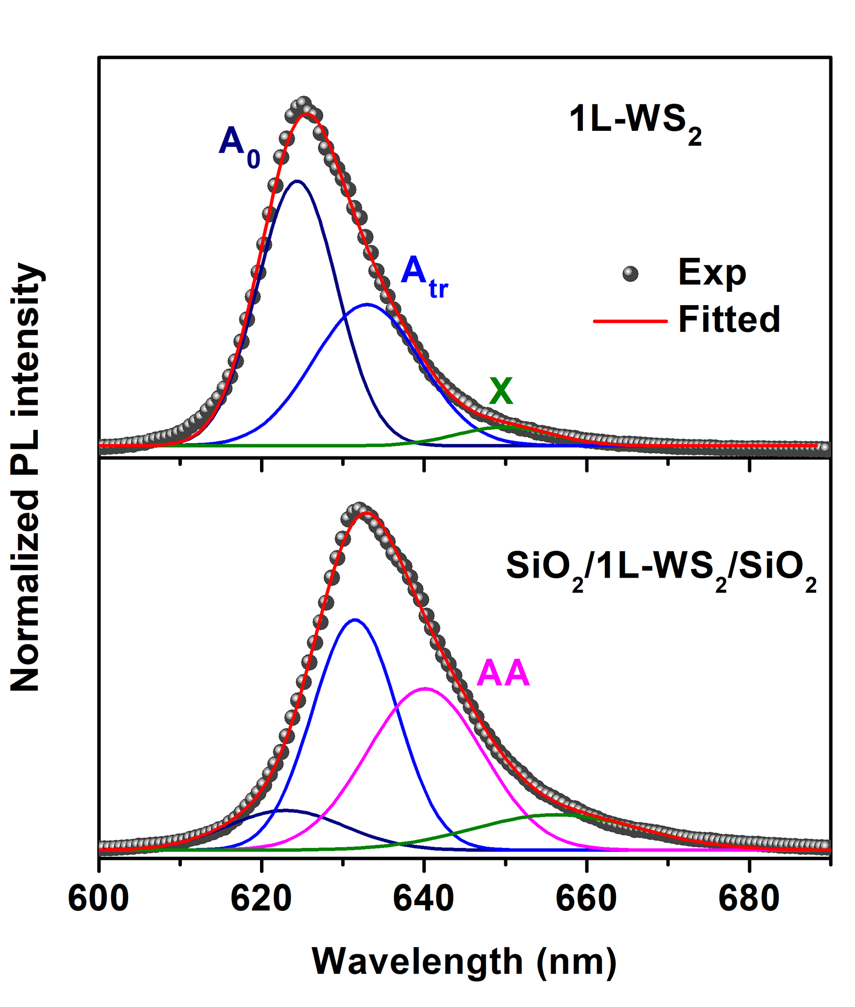
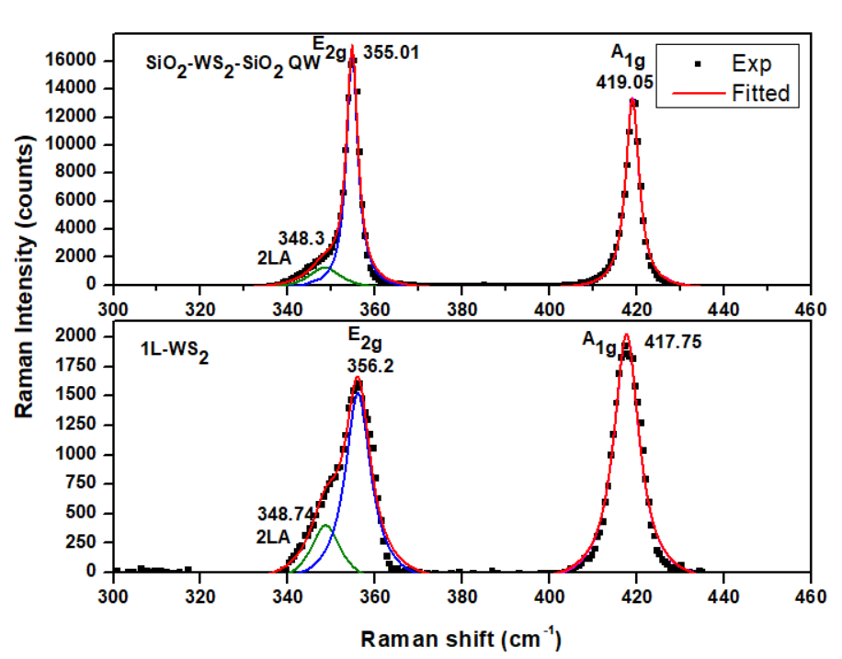
Figure 1. (a) Comparison of Raman spectra between 1L-WS₂ and SiO₂/WS₂/SiO₂ sandwiched layer. (b) Deconvoluted normalized PL spectra of the 1L-WS₂ and SiO₂/WS₂/SiO₂.

