Real time detection of S. Aureus bacteria using aptamer functionalized silicon field effect transistor

Abdul Kaium Mia1 , Swapnil Sinha 2 and P. K. Giri 1,3

1Centre for Nanotechnology, IIT Guwahati, India
2BioNEST, IIT Guwahati, India
³Department of Physics, IIT Guwahati, India
E-mail: k.abdul@iitg.ac.in

Abstract

Student Academic Board (SAB), Indian Institute of Technology Guwahati, Guwahati, Assam, India
Antibiotic resistance has increasingly become one of the biggest global health threats today. A growing number of infections are harder to treat, as the antibiotics used to treat them are less effective now. This has increased the demand for selective detection of bacteria for targeted drugs. Staphylococcus Aureus (S. Aureus) is one such harmful gram-positive spherical-shaped human pathogenic bacterium commonly associated with various kinds of contagious clinical infections. Herein we have fabricated Si-microstructure between two gold electrodes by top-down method, by using conventional photolithography and reactive ions etching. Small size aptamers were used as biorecognition elements, the small size aptamers ensure that the analytes are within Debye length limit. To immobilize the aptamer to Si surface, we have utilized the strong covalent bond between thiol and Au nanoparticles (NPs). The transfer characteristics show p-type nature of the Si, as at negative gate bias, the channel was on, but with the positive gate bias, it was in off state. The addition of AuNPs on the Si surface was confirmed by the field emission scanning electron microscope (FESEM) image as shown in Figure 1 as well as from the transfer characteristics, as the conductance increases after the addition of AuNPs. The output characteristics were carried out with the contact addition of 3 μL of bacteria solutions. The electrical measurements shown the detection limits from 10² to 10⁷ colony forming unit (cfu) per ml. This result demonstrates uses of aptamer for real time bacteria detection by integrating microscale Si circuits.
Research & Industrial Conclave 2023 "An amalgamation of Academia, Industry & Start-up”
"

Keywords: Staphylococcus aureus, Field effect transistor, Si-Ribbons, Aptamers, AuNPs

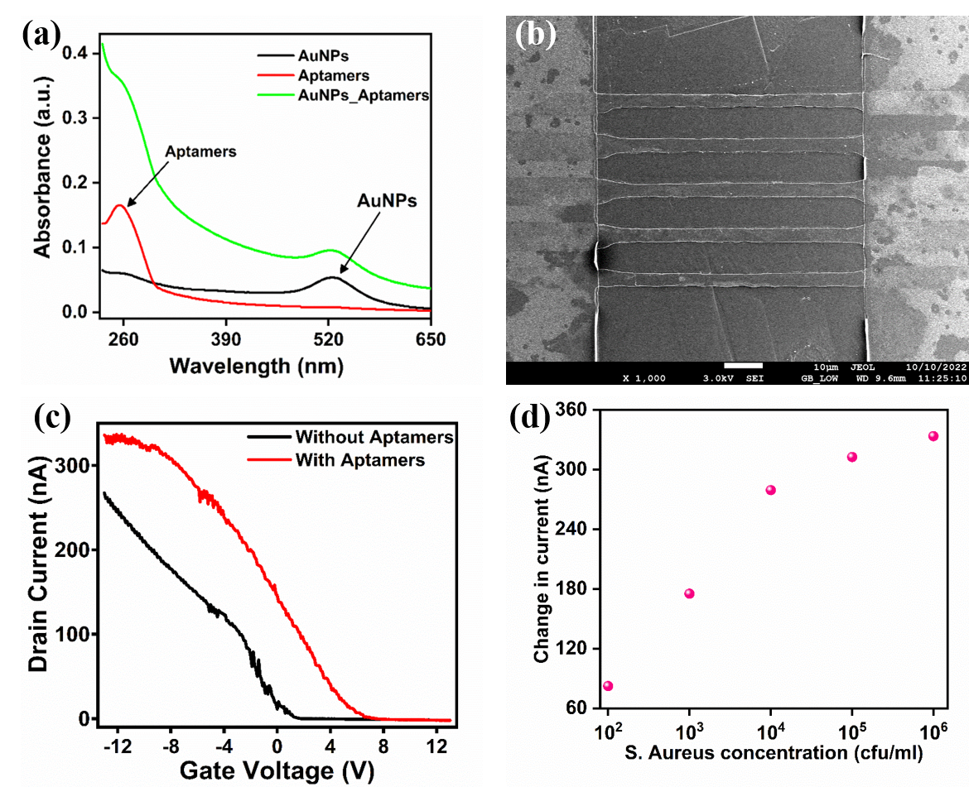
Figure 1: (a) UV-Vis absorbance of different components, (b) FESEM image of the Si micro-ribbons between gold contact pads, (c) Transfer characteristics of the Si FETs with before and after aptamer immobilization, (d) Sensing response of the aptamer functionalized Si FETs towards S. Aureus

