Real time detection of S. Aureus bacteria using aptamer functionalized silicon field effect transistor

Abdul Kaium Mia1 , Swapnil Sinha 2 and P.K. Giri 1,3

1 Centre for Nanotechnology, IIT Guwahati, India
2 CEO, BioNEST, IIT Guwahati
³ Department of Physics, IIT Guwahati, India
E-mail: k.abdul@iitg.ac.in

Abstract

Student Academic Board (SAB), Indian Institute of Technology Guwahati, Guwahati, Assam, India
Antibiotic resistance has increasingly become one of the biggest global health threats today. A growing number of infections are harder to treat as the antibiotics used to treat them are less effective now. This has increased the demand for selective detection of bacteria for targeted drugs. Staphylococcus aureus (S. Aureus) is one such harmful gram-positive spherical-shaped human pathogenic bacterium commonly associated with various kinds of contagious clinical infections. Herein we have fabricated Si-microstructure between two gold electrodes by top-down method, by using conventional photolithography and reactive ions etching. Small size aptamers were used as biorecognition elements, small size aptamers ensure the analytes within Debye length. To immobilized to aptamer to Si surface, we studied strong covalent bond between thiol and AuNPs have used. The transfer characteristics show p-type nature of the Si as, at negative gate bias channel was on but was at off state on positive gate bias. The addition of AuNPs on the Si surface was confirmed by the field emission scanning electron microscope (FESEM) image as well as from the transfer characteristics as the conductance increases after the addition of AuNPs. The output characteristics were carried out with the contact addition of 3 μL of bacteria solutions. The electrical measurements shown the detection limits from 10² to 10⁷ colony forming unit (cfu) per ml. this result demonstrates uses of aptamer for real time bacteria detection by integrating conventional Si circuits.
Research & Industrial Conclave 2023 "An amalgamation of Academia, Industry & Start-up”
"

Keywords: Staphylococcus aureus, Field effect transistor, Si-Ribbons, Aptamers, AuNPs

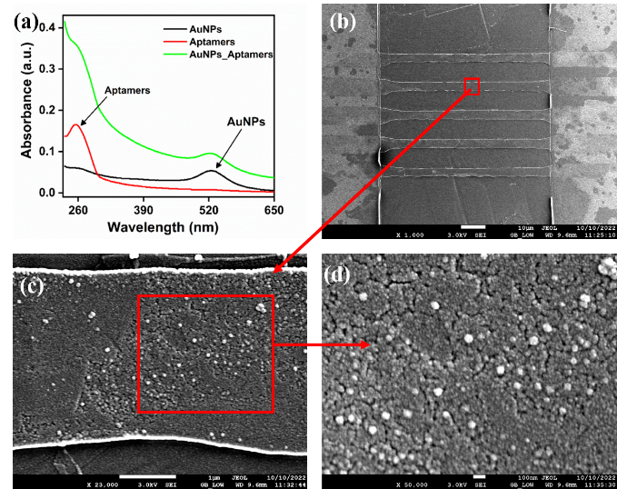
Figure 1: (a) UV-Vis absorbance at different conditions (b) FESEM image of the micro-ribbons between gold contact pads (c) Zoomed image of single rod, drop cased with AuNPs (d) magnified views of AuNPs on Si rods surface.

