Synthesis of Biodiesel from Thevetia Peruviana Oil

Aditya Sawant¹ and Pankaj Tiwari¹
Student Academic Board (SAB), Indian Institute of Technology Guwahati, Guwahati, Assam, India
1 Department of Chemical Engineering, Indian Institute of Technology Guwahati, India

E-mail: aditya.sawant@iitg.ac.in

Abstract

The rise in urban population and development of the industrial section can be noted as the major reasons for the increasing temperature of the globe. The industrial sector growth has led to a strain on our limited resources. In an attempt to slow the increase in temperature, non-conventional resources such as wind, solar, tidal and biomass energy are introduced. Biodiesel is the most promising biofuel in the industry. Biodiesel is used directly and as a blend with other conventional fuels as it is non-toxic in nature. Biodiesel used directly has been known to reduce CO emissions by 24 % and NOX emissions by 16% in comparison with diesel. [1] As of now, the biodiesel market is competing with the food industry as the feedstock usually used are edible oils such as Sunflower oil, Soya bean oil, Palm oil, Castor oil, and Rapeseed oil. Hence, non-edible feedstock oils are being researched for the production of biodiesel. Important factors that are considered while selecting feedstock are low free fatty acid content, low viscosity and low impurities like gum, water content, sulphur content etc. The present non-edible oils that are used for biodiesel production are Rubber seed oil, Jatropha oil etc. But the problem arises as the feedstock requirements are not met in the market as these seeds have alternate high-value uses. Thevetia Peruviana, also known as yellow oleander is a small, perennial and evergreen plant which can be considered for the production of biodiesel. The plant provides fruits throughout the year, providing a good supply of seeds for oil extraction. The seed has 60 to 65% oil and the cake contains 30 – 37% protein but remains inedible because of the presence of cardiac glycoside. [2] The plant as of now has no economic value, and is underutilized, which makes it a good source for biodiesel production. The seeds were procured from the Indian Institute of Technology Guwahati campus and Neel Kanth Agro-Forestry (Lucknow) and oil was extracted from the seeds using solvent soxhlet extraction. The obtained oil was degummed and water was removed to make it suitable for biodiesel production. Due to high acid value of the oil, a two-step procedure was followed as shown in Figure 1. In the first step, H2SO4 was used as a catalyst with methanol and the resulting product was reacted with methanol using NaOH as a catalyst. A yield of 78.11% was obtained for the following conditions - molar ratio – 1: 9, reaction temperature – 65 ℃, NaOH catalyst – 0.5 wt.%, stirring frequency – 350 rpm, reaction time of 120 mins. The resulting product, Biodiesel underwent characterizations like Nuclear Magnetic Resonance and Fourier Transform Infrared Spectroscopy.
Research & Industrial Conclave 2023 "An amalgamation of Academia, Industry & Start-up”
"
Keywords: Biodiesel, Thevetia peruviana, cardiac glycoside, Nuclear Magnetic Resonance, Fourier Transform Infrared Spectroscopy.
.

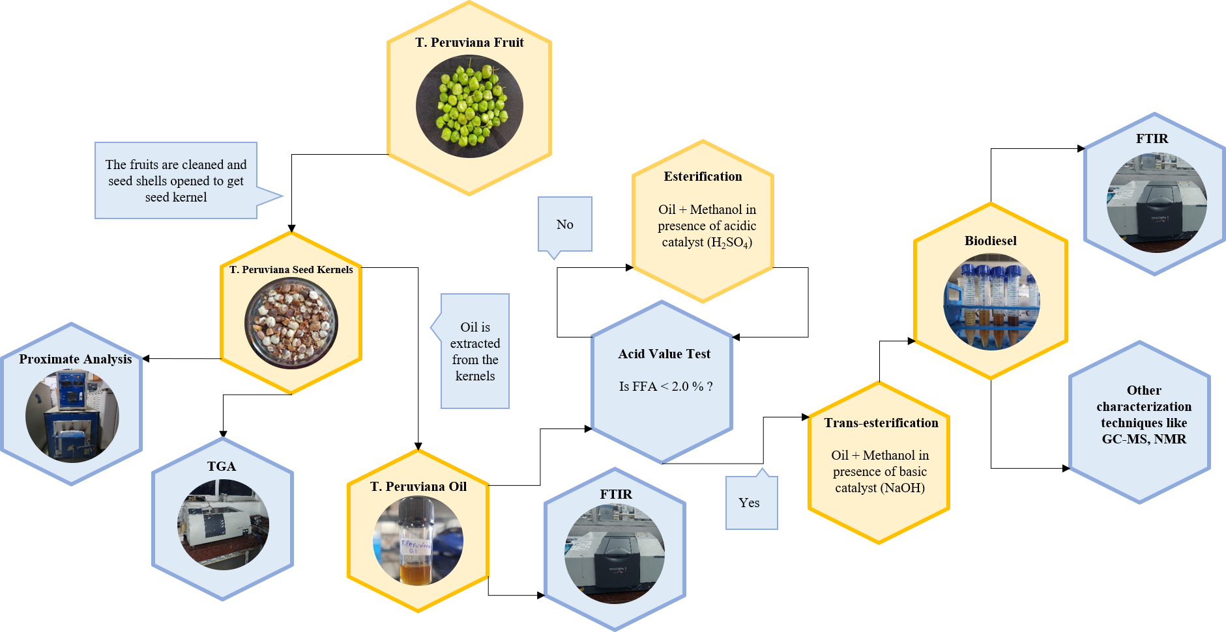

Fig. 1. Procedure of Biodiesel Synthesis from Thevetia Peruviana Fruits.

References:
- Comparison of the performance and emissions of different biodiesel blends against petroleum diesel, McCarthy P, Rasul M,Moazzem S, International Journal of Low-Carbon Technologies, (2011), 255-260, 6(4)
- O. O. Oluwaniyi and S. A. Ibiyemi, “Extractability of Thevetia peruviana glycosides with alcohol mixture,” Afr J Biotechnol, vol. 6, no. 18, pp. 2166–2170, 2007, [Online]. Available: http://www.academicjournals.org/AJB

