Copper-catalyzed regioselective S-alkylation and C-H activation at the position C-3
of 4-hydroxydithiocoumarin: Easy access to 4-methyl-3,4-dihydrothiopyran derivatives

A. Ahmad Ali1 and C. Abu Taleb Khan

1 Department of Chemistry, IIT Guwahati, India

E-mail: atk@iitg.ac.in

Abstract

A simple efficient synthetic route is accomplished for the synthesis of 4-methyl-3,4-dihydrothiopyran derivatives from 4-hydroxydithiocoumarin¹ and a vinyl ether/sulfide by employing a 10 mol% Cu (I) iodide catalyst using a pseudo-three-component reaction.² The present methodology involves the formation of two new C-C bonds and one C-S bond via S-alkylation and C-3 activation of 4-hydroxydithiocoumarin in a single step at the expense of one C-O/ C-S bond. The current procedure has several characteristic features such as a wide substrate scope, high regioselectivity,³ moderate to good yields, good atom economy, and shorter reaction time and it will be presented.

Keywords: regioselectivity, atom economy, and pseudo-three-component reaction.
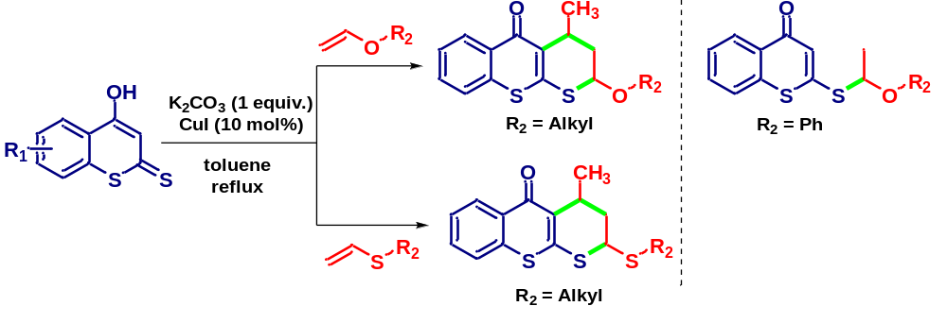
- J. E. Anderson McKay, A. J. Liepa, Aust. J. Chem., 1987, 40, 1179.
- P. C. Montevecchi, M. L. Navacchia, J. Org. Chem., 1995, 60, 6455-6459.
- S. Mondal, S. Yashmin and A. T. Khan, Org. Biomol. Chem., 2021, 19, 9223-9230.

