Trend Monitoring Analysis of Aviation Flight Recorder Data Using Cauchy Gaussian Mixture Model

Akash Kashyap, Prof. Debanga Raj Neog, Prof. A. Rajesh

Department of Electronics & Electrical Engineering, IIT Guwahati, India
Research & Industrial Conclave 2023 "An amalgamation of Academia, Industry & Start-up”
"
E-mail: akash.kashyap@iitg.ac.in, dneog@iitg.ac.in, rajesha@iitg.ac.in

Abstract

The avionics field has seen a drastic use of technology in its evolution. These inventions not only include cockpit instruments but also advanced post-flight analysis of the aircraft parameters. The Flight Data Recorder is one such instrument which assists technicians on the ground to analyse the abnormal behaviour of aircraft sensors and instruments which could have resulted into fatal accidents. However, the trend of parameters recorded in flight data is still analysed manually in avionics field which may cause human error and unsatisfactory observation of abnormality in recorded parameters. This thesis aims to resolve the manual analysis of the avionics data and provides the automated solution to distinguish the abnormal values in the large data volume of flight parameters using Cauchy Gaussian Mixture Model (CGMM). In a large dataset, where the abnormal values lie far from the mean of the dataset, Gaussian Mixture Model (GMM) fails to capture the heavy tail of the distribution[1]. GMM with two components will assign a relatively low weight to the component with the larger mean and variance indicating that the model has not accurately captured the true distribution. There are two ways to address this issue: (a) We need to increase the number of components which will increase the computation time and make the model more complex, (b) Use a different type of probability distribution that can capture the heavy tail of data. Research has been carried out on the different type of distribution e.g. Laplacian Gaussian Mixture Model[2] which is mostly used in improvement to GMM.
Student Academic Board (SAB), Indian Institute of Technology Guwahati, Guwahati, Assam, India
The pdf of Gaussian Distribution decays exponentially in its tails which means that the probability of a tail parameter decays rapidly as that parameter moves further away from the mean. We now move to Laplacian distribution in comparison with Cauchy distribution as they both are heavy tailed distributions but they differ in tail behaviours. The Laplacian distribution has exponential tail while the Cauchy distribution has power-law tail. CGMM outperforms GMM and LGMM has been proved using performance metrics in Estimation Theory which are ROC curve, AUC-ROC, F-1 score, confusion matrix. These all performance metric has been simulated in Python and shown below.
Hence, Cauchy Gaussian Mixture Model is proposed and explained in this thesis to provide an application for analysing the trend of flight data of Avionics FDR. This thesis will show the effectiveness of CGMM over the existing GMMs using the estimation theory for evaluating the performance of these binary classification models.

Keywords: GMM, Tail Distribution, Cauchy, Laplacian, Fisher Information, ROC, Confusion Matrix
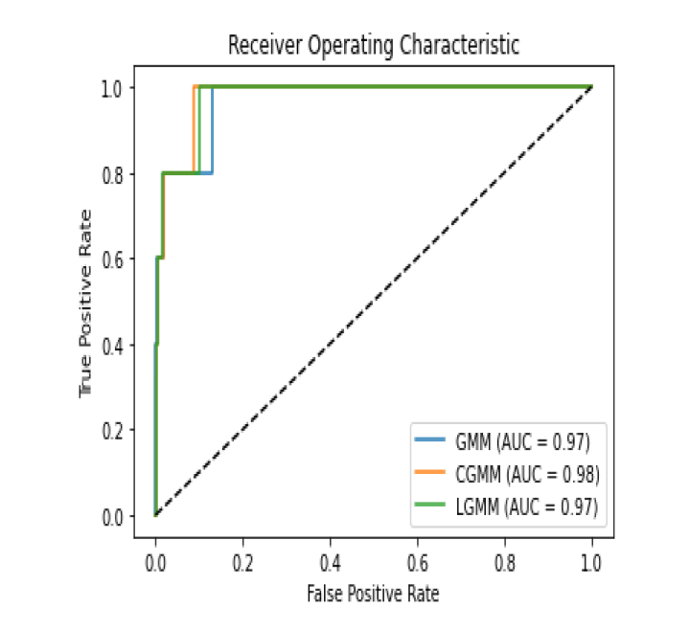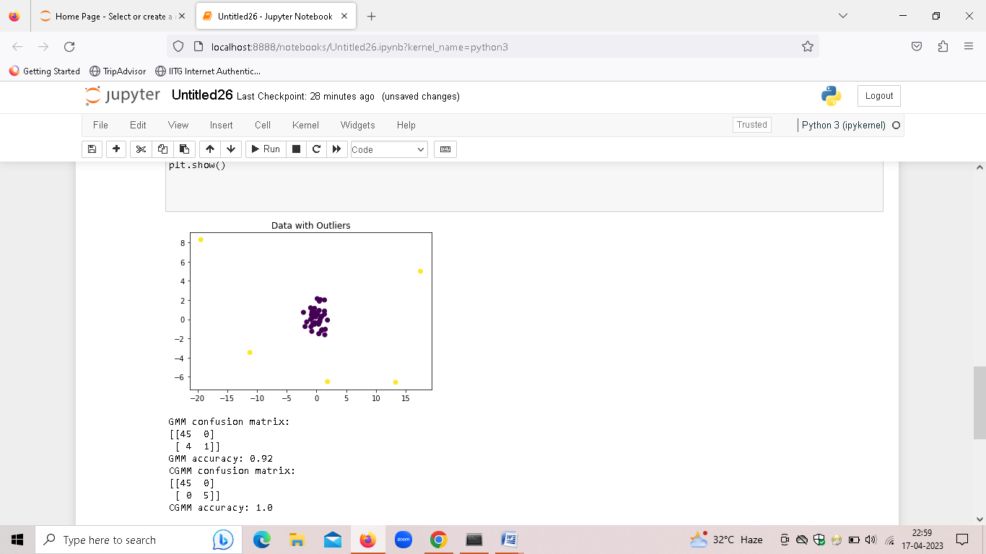
Fig 1. ROC for GMM, LGMM and CGMM Fig 2. Confusion Matrix of CGMM and GMM

References:
[1] Y. Kim, J. Lee, and K. Kim, "Anomaly Detection in Time Series Data Using Gaussian Mixture Models," in IEEE Transactions on Cybernetics, vol. 48, no. 12, pp. 3533-3546, Dec. 2018

[2] "Anomaly Detection in Surveillance Videos using Laplacian Gaussian Mixture Model" by Haroon Idrees and Ibrar Hussain, published in the IEEE International Conference on Emerging Technologies in 2018

