A Design and Analysis of Passive Knee Brace for Assistance in Osteoarthritis During Sit-To-Stand Activity

Saranyaa RT¹, Shreya Singh¹ and Aman Singh², Akshay Daydar*¹, Dr. Subramani Kanagaraj^{1 ,2}

1 Department of Mechanical Engineering, IIT Guwahati, India
2 School of Innovations in Biomedical Devices and Systems and Inter-institutional Biodesign Center (SIBDS-IIBC) , IIT Guwahati, India

E-mail: adaydar@iitg.ac.in

Abstract
Research & Industrial Conclave 2023 "An amalgamation of Academia, Industry & Start-up”
"

Knee osteoarthritis (OA), also known as the degenerative joint disease of the knee, is typically the result of wear and tear and progressive loss of articular cartilage. Knee OA is the second most common rheumatologic problem, and it is the most frequent joint disease with a prevalence of 22% to 39% in India as reported by the national health portal of India [1]. Specifically, in Assam, the prevalence of knee OA is found to be 24.1%, with a higher incidence in women (29.3%) than men (18.6%) in adults aged 40 years [1]. One of the most painful activities for knee OA disorder is Sit-to-Stand (STS) due to its requirement of faster energy transfer from hip extensors to the knee extensors which was found to be slower in subjects with knee OA. However, in such conditions knee bracing is recommended solution by various guidelines [2] to slow the progression of knee OA. In the present study, a torsional spring-based passive knee brace design is proposed to work as a shock absorber and reduce the load transmitted through the knee joint. The brace consists of 3D-printed housing, three torsional springs and an axle to assist in extension movement during STS as shown in figure1. The brace is conceptualized considering subject-specific anthropometry of a subject that is captured using a 3D scanner, modelled using Fusion 360 and 3D printed using a FDM printer. The analysis of spring is performed to determine force during STS activity as shown in Figure2. The straps are also attached in a brace which is tailored into the clothing part to provide required thigh and shank support during STS movement.
Student Academic Board (SAB), Indian Institute of Technology Guwahati, Guwahati, Assam, India
The findings suggest that the proposed knee brace is expected to provide 25 percent assistance to the most contributing extensor muscle, the Vastus Laterateris (VL) of knee OA subjects while performing STS activity.

Keywords: Knee Osteoarthritis, Knee Brace, Sit-To-Stand Activity, Mechanical Energy

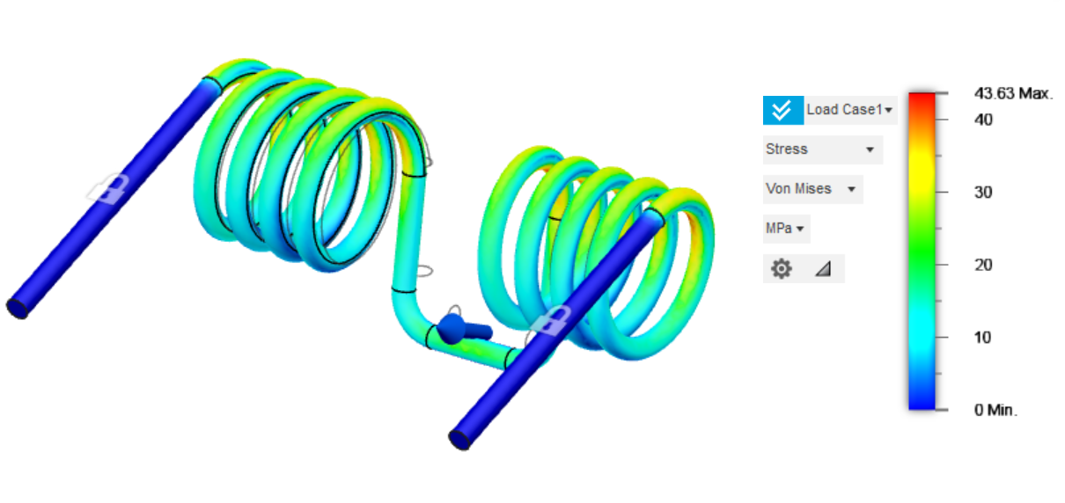
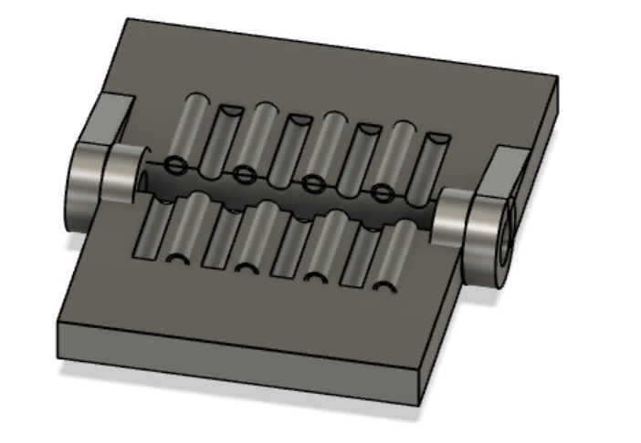
Figure1: CAD model of housing designed for placement of springs Figure2: Analysis of the Torsional Spring

References:
[1] Pal, Chandra Prakash, et al. "Epidemiology of knee osteoarthritis in India and related factors." Indian journal of orthopaedics 50 (2016): 518-522.
[2]“Osteoarthritis of the Knee - Clinical Practice Guideline (CPG).” Aaos.org, https://www.aaos.org/quality/quality-programs/lower-extremity-programs/osteoarthritis-of-the-knee/. Accessed 20 Apr. 2023.

