Comparison of Efficient Machine Learning Methods for Fetal Health Classification

K. Sanjana Reddy1, Ch. Vishal1,
Akshay Daydar*1, Subhojit Jash², Dr. Vijay Anand Ismavel³, Dr. S. Kanagaraj1,2

1 Department of Mechanical Engineering, IIT Guwahati, India
2 Centre for Intelligent Cyber-Physical Systems, IIT Guwahati, India
3 Consultant Surgeon, Makunda Christian Hospital, Assam, India

E-mail: adaydar@iitg.ac.in

Abstract

Cardiotocography (CTG) is a popular non-invasive, low-cost technique for monitoring the fetal heart and the mother's uterine contraction pressure to assess the fetus's well-being as shown in Figure1. Manual interpretation of CTG results is helpful in accurately differentiating between different types of fetal distress, such as hypoxia, or infection but this can result in delays in appropriate interventions and assignment of clinical care priority. These constraints are overcome by using machine-learning approaches. Baseline, acceleration, deceleration, variability, and uterine contractions are some of the important features from CTG data to predict fetal health. Open source data was taken from the UCI Machine Learning Repository [1], where 2126 records of features were extracted from cardiotocography exams. This study presents nine classification algorithms and their performance is evaluated using the following metrics: accuracy, confusion matrix, precision, recall, and F-1measure. A correlation-based feature selection technique is applied over the dataset to improve the performance of the classifiers. The results revealed that Gradient Boosting Machine achieved 94.92% accuracy, 0.93 precision, 0.90 recall and 0.91 F-1measure. The same algorithm is applied to data containing the features extracted using “MATLAB” from the raw data received from the “Makunda Christian Hospital”, Assam. The results revealed that Light GBM achieved 84.21% accuracy, 0.69 precision, 0.65 recall and. 0.67 f-1measure.
Student Academic Board (SAB), Indian Institute of Technology Guwahati, Guwahati, Assam, India
Research & Industrial Conclave 2023 "An amalgamation of Academia, Industry & Start-up”
"
The conclusion of the study finds Gradient Boost is the best-performing model, and acceleration is the most significant feature which is computed from the XAI (Explainable Artificial Intelligence) based SHAP method. A drop of only 10% in accuracy has been observed when only 3 fetal heart rate features are being considered in place of 21 features.

Keywords: Cardiotocography, Fetal Heart Rate, uterine Contractions, Machine Learning. SHAP
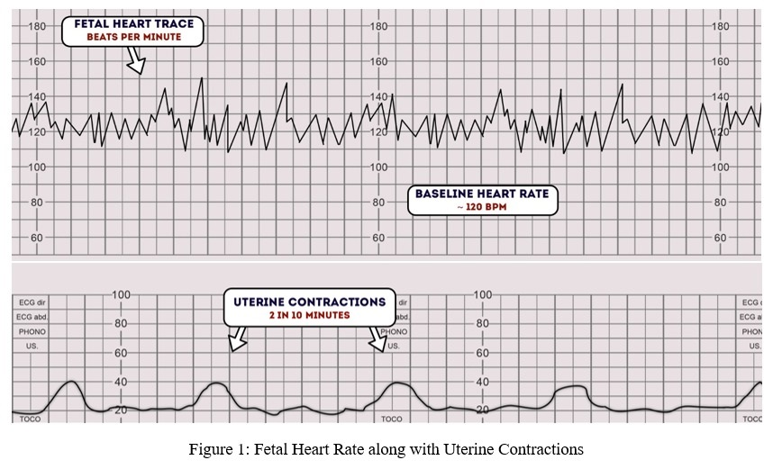

References:
[1] Ayres de Campos et al. (2000) SisPorto 2.0 A Program for Automated Analysis of Cardiotocograms. J Matern Fetal Med 5:311-318

