Construction, expression, purification and biochemical characterization of a chimeric cellulase (AtGH1-L1-AtGH8) of β-glucosidase (AtGH1) and β-1,4-endoglucanase (AtGH8) from thermophilic bacterium Acetivibrio thermocellus ATCC 27405
for lignocellulosic bioethanol production
Akshita Kanwar ^{1,} *, Parmeshwar Vitthal Gavande ², Arun Dhillon ² Arun Goyal ^{1,2}
¹ Centre for the Environment,
²Carbohydrate Enzyme Biotechnology Laboratory, Department of Biosciences and Bioengineering,
Guwahati-781039, Assam, India.
*Corresponding author E-mail akshita.kanwar@iitg.ac.in

Abstract

Glycoside hydrolases (GHs) are enzymes with high specificity possessing the ability to cleave the glycosidic bonds present in the polysaccharides of complex nature such as cellulose, hemicellulose and lignin constituting the lignocellulosic biomass (LCB). Cellulases belong to the family of GHs. Glycoside hydrolases which hydrolyse the β-1,4 glycosidic bonds present between the cellobiose units in the cellulose are classified as cellulases. Three types of cellulases are Endoglucanases, Exogluanases and Beta-glucosidases. The LCB can be used to produce bio-ethanol by employing GHs, which is an environment-friendly approach. The present research focuses on the construction of a bi-functional cellulosic chimera and its biochemical characterization. The genes encoding β-glucosidase from GH family 1 (AtGH1) and endoglucanase from GH family 8 (AtGH8) were fused by using a natural linker (L1) from Acetivibrio thermocellus. Chimera, AtGH1-L1-AtGH8 showed maximum endoglucanase activity of 55 U/mg at 72°C, reaction time 1 min and enzyme concentration 50 µg/mL at pH 5.8 (Sodium phosphate buffer) using carboxymethyl cellulose (CMC-Na) as substrate, while the maximum β-glucosidase activity of 27 U/mg was observed at 68°C, reaction time 6 min and enzyme concentration of 80 µg/mL at pH 5.8 (Sodium phosphate buffer) against cellobiose as the substrate. The thermal stability of both modules of the chimera was determined by incubating 100 µL of enzyme (0.05 mg/mL for endoglucanase and 0.08 mg/mL for beta glucosidase) for 90 min at a temperature range of 5°C-70°C.The thermal stability profile of AtGH1-L1-AtGH8 showed that AtGH1 is stable up to 60°C, while AtGH8 is stable up to 50°C. The chimera AtGH1-L1-AtGH8 has the potential for bioethanol production.
Student Academic Board (SAB), Indian Institute of Technology Guwahati, Guwahati, Assam, India
Keywords: Glycoside hydrolase, endoglucanase, β-glucosidase, chimera, lignocellulose, Acetivibrio thermocellus.
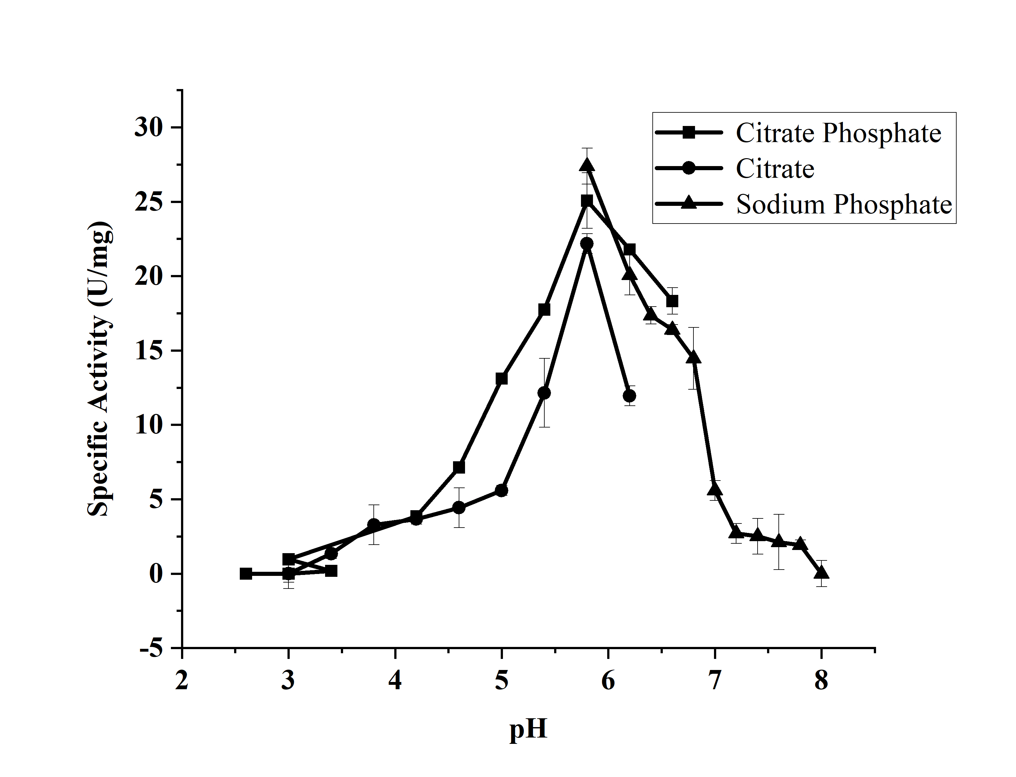
Fig. 1 Beta-glucosidase activity of chimera AtGH1-L1-AtGH8.
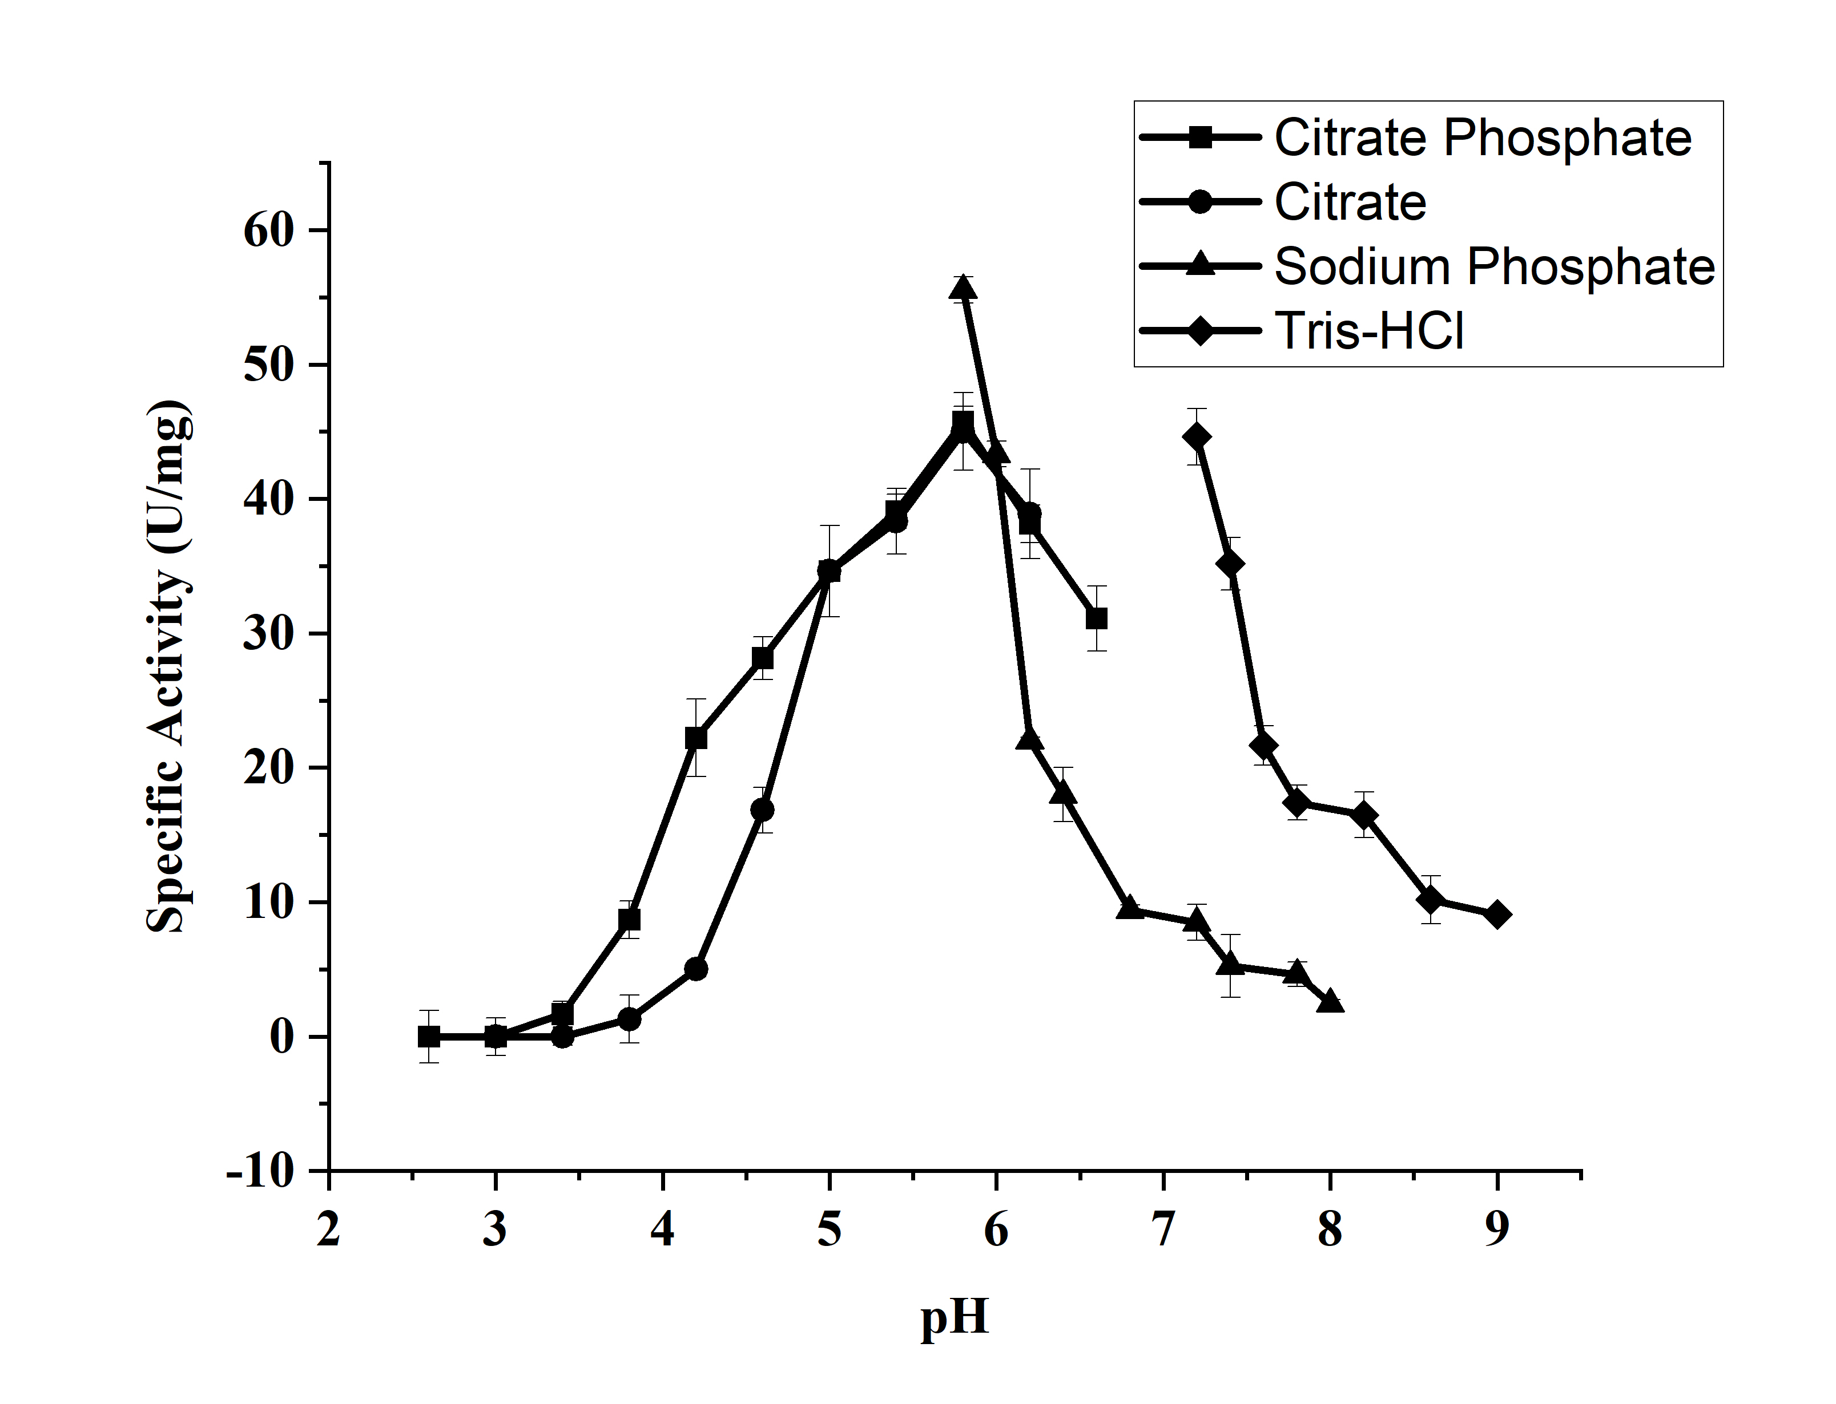
Fig. 2 Endoglucanase activity of chimera AtGH1-L1-AtGH8.

