Numerical and experimental analysis of the Localized electrodeposition (LED) based micro additive manufacturing process

Anand Mohan Pandey¹*,Sajan Kapil ¹, and Manas Das¹

¹ Department of Mechanical Engineering, Indian Institute of Technology Guwahati, Assam, India

*E-mail: amohan@iitg.ac.in

Abstract
The localized electrodeposition process (LED) is a non-thermal additive manufacturing process that uses the combination of the electrochemical deposition principle and additive manufacturing. It is capable of producing complex 3D parts directly from the CAD model. The deposition is localized by the use of a micro tool of a diameter much smaller than the substrate. This process can produce sub-micrometer features size components using materials including metal, alloys, and polymers. In this study numerical modeling was performed to study the effect of applied voltage, and interelectrode gap on the deposition rate for the nickel-based electrolyte. The numerical study of the micro electrochemical additive manufacturing process was studied using COMSOL® Multiphysics software. The boundary conditions were set according to the process parameters of the localized electrodeposition process. The simulation results are in good agreement with the output of the experimental result obtained from the developed LED setup.
Research & Industrial Conclave 2023 "An amalgamation of Academia, Industry & Start-up”
"

Keywords: Additive manufacturing, Electrochemical, Microdevices, Residual stress, Localized deposition, Simulation.

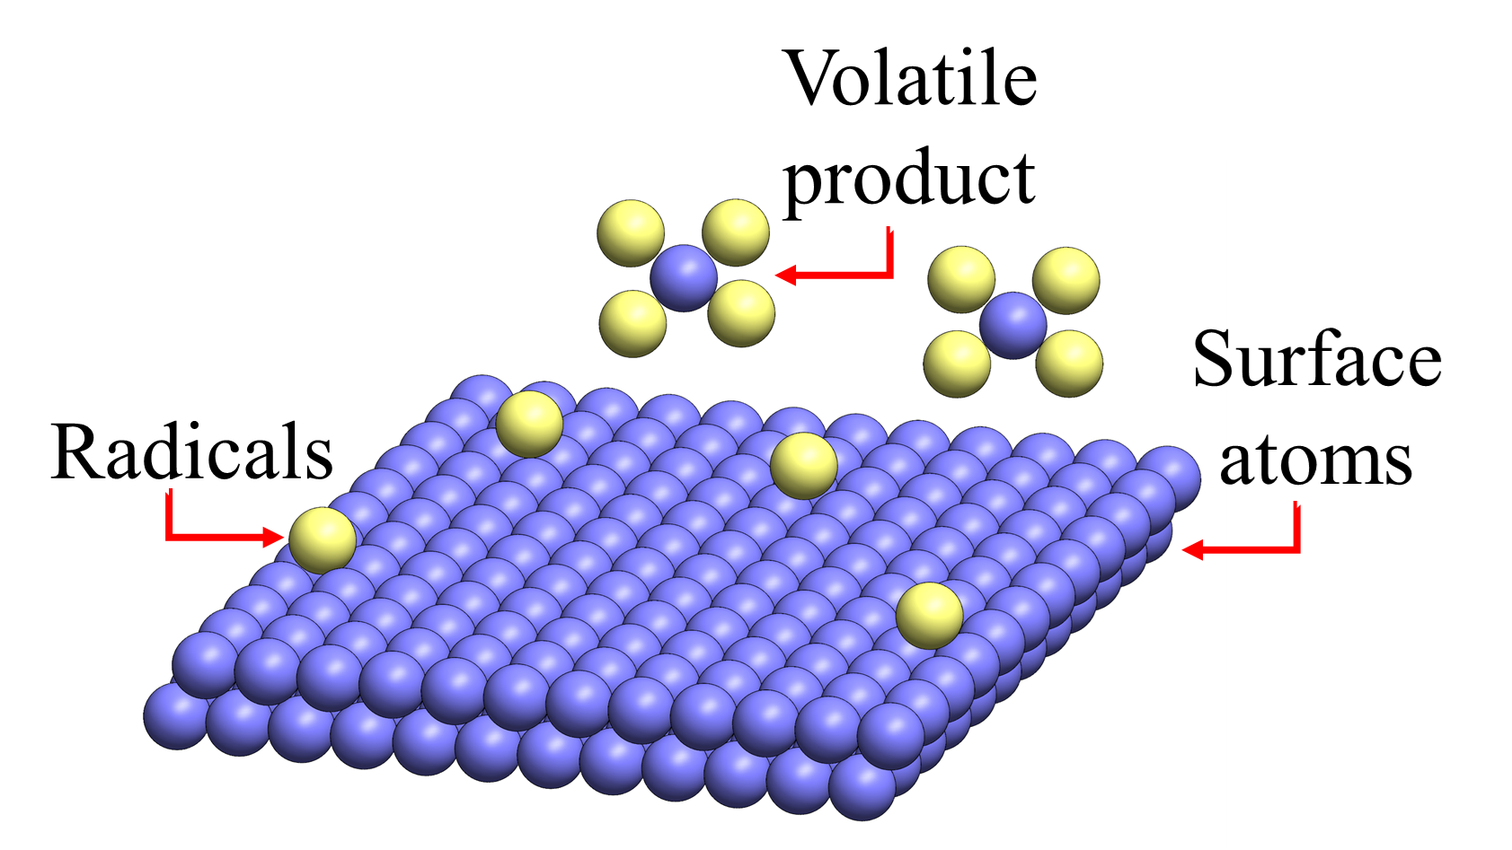
Student Academic Board (SAB), Indian Institute of Technology Guwahati, Guwahati, Assam, India

