Toroidal Excitations in Metasurfaces and their Terahertz Applications

Angana. Bhattacharya1 , Gagan Kumar1

1 Department of Physics, IIT Guwahati, India

E-mail: angana18@iitg.ac.in

Abstract

Toroidal excitations are a new type of electromagnetic excitation that are excited when magnetic dipole moments are arranged in a head-to-tail configuration. The toroidal dipole moments have sharp resonant features but are masked in natural materials by the domineering electric and magnetic moments. Artificially designed material surfaces termed as meta-surfaces can result in domineering effect of toroidal resonances and hence, utilize the excitation to its full potential. The terahertz (THz) range of frequencies, lying between the microwave and infra-red frequencies provides a new arena of research. The focus of my thesis is to study toroidal excitations in metasurfaces and their applications in terahertz frequencies.
Student Academic Board (SAB), Indian Institute of Technology Guwahati, Guwahati, Assam, India
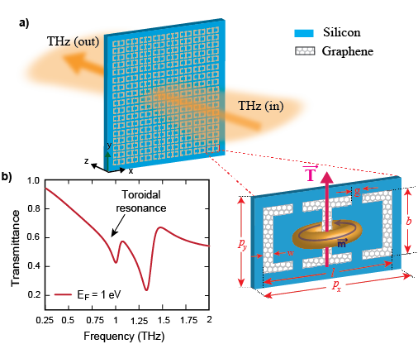
Keywords: Terahertz, Metasurface, Toroidal excitations

Fig1: Metasurface demonstrating active tuning of toroidal excitation in the terahertz frequency range [1]

References:
[1] Bhattacharya, Angana, et al. "Actively tunable toroidal excitations in graphene based terahertz metamaterials." Optics Communications 459 (2020): 124919.

